RITON TEAMS UP WITH DAVID GUETTA & JOZZY
ON NEW SINGLE “WHERE YOU WANT”

LISTEN HERE

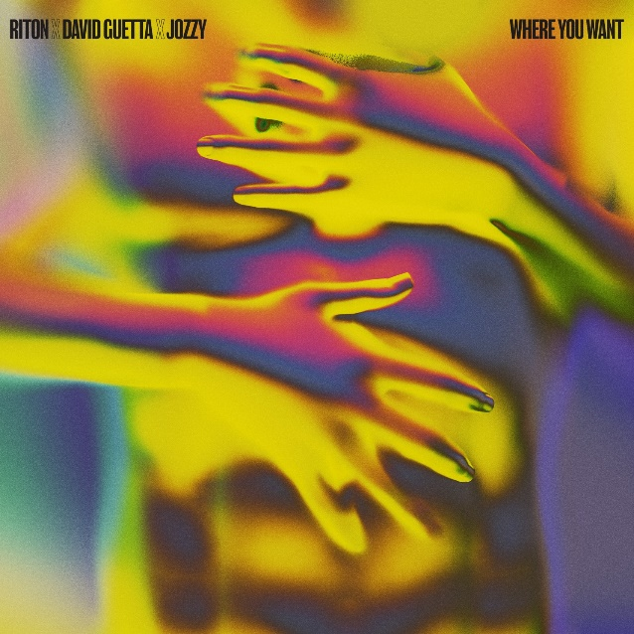
DOWNLOAD ARTWORK HERE

BRIT-nominated DJ/producer Riton is back with new single “Where You Want” – a three-pronged collaboration with legendary dance hit-maker, David Guetta, and Jozzy; writer behind Lil Nas X’s iconic 2019 smash, “Old Town Road.”

Listen to “Where You Want” HERE.

Landing as the latest in a series of singles leading into the release of a brand new Riton mixtape later this summer, “Where You Want” serves up a slice of peak-time club heat. Deep, locked grooves and bubbling, lo-slung bass – hallmarks of both classic Riton and David Guetta records – meet Jozzy’s smooth, soulful vocals on a record built to make people move.

Already teased to rapturous approval by both Riton and David Guetta during DJ sets in Sydney, Bali and New York over the last few weeks, “Where You Want” feels primed to soundtrack summers all over the globe.

With lots of new music on the horizon, look out for more from Riton soon.

Riton x David Guetta x Jozzy – “Where You Want” is out now: https://riton.lnk.to/whereyouwant

About Riton
Riton has been at the vanguard of UK dance music for over 20 years. A legendary and vastly influential producer straddling both the underground (Ed Banger, Soul Wax, Ministry Of Sound) and the mainstream, he boasts collaborations with everyone from Fat Boy Slim, The Chemical Brothers and Diplo to Tame Impala and M.I.A., racking up over 2 billion global streams in the process. He also shared co-production on Silk City’s 2018 GRAMMY-winning smash “Electricity” ft. Dua Lipa, as well as earning a 2017 GRAMMY nomination for “Rinse & Repeat” ft. Kah-Lo and a BRIT nomination for 2021 UK #4 single “Friday” ft. Mufasa and Hypeman.

CONNECT WITH RITON:
INSTAGRAM / TWITTER / TIK TOK / FACEBOOK / YOUTUBE

