SAM AUSTINS RELEASES COSMIC, RETRO-FUTURISTIC EP BOY TOY VIA ATLANTIC RECORDS

HEAR THE UNSHAKEABLE HOOKS ON NEW TRACK “SWEET TOOTH” HERE

BUY/STREAM BOY TOY HERE

“A surging slice of energy that fuses 00 indie – think the Strokes, or the Walkmen – with his own patent brand of ultra-individual pop music” – CLASH
“Spearheading Detroit’s musical renaissance” – NME
“Chic…90s-inflected alternative and R&B grooves…melds past experience and future fantasy into powerful sonic motifs” – THE LINE OF BEST FIT
Photo by Devon Williams

Today, Detroit-born and LA-based Sam Austins releases EP BOY TOY via Atlantic Records. The project is Austins’ most sophisticated work to date, showcasing his unparalleled growth with an enthrallingly catchy blend of alt-rock and psych-pop, reflecting on his tumultuous past that saw a period of homelessness. Austins has named Radiohead, Outkast and D’Angelo as some of his sonic influences on the EP and Michigan’s rich musical history is woven throughout. BOY TOY’s guitars are reminiscent of Jack White’s, while his vocals exude Prince’s swagger.

The EP release comes with “Sweet Tooth,” a buoyant and glittering track with a glossy guitar-led soundscape that’s juxtaposed with the poignant lyrics about feeling rejected.

Of the EP release, Austins says, “The creation of BOY TOY has been a deeply personal and transformative experience for me as an artist. For the first time, I challenged myself to write about love in a candid way, owning my mistakes, impulses, and sharing this deep, personal experience of heartbreak…It's a piece of my heart, and a reflection of my personal growth as an artist - I hope that BOY TOY will resonate with anyone who has ever experienced the pain of a broken heart, and that it will inspire them to heal, grow, and find love again.”

The release of BOY TOY follows recent singles “Oatmeal Pancakes,” “Keep You Company,” “Dancing With The Devil” and “Matador,” which follow his 2021 debut LP HOMELESS STAR. Austins’ sound morphs with the malleability of a living and breathing entity, reforming to reflect his emotions and, ultimately, reshaping what alternative music can be with a series of independent releases. He earned placements on major television shows like HBO’s Euphoria, and shared stages with Vince Staples, Danny Brown, and Playboi Carti, to name a few. He released HOMELESS STAR in 2021, his debut for Atlantic Records that gathered millions of streams and landing looks from Vogue, HYPEBEAST, and Pigeons & Planes.

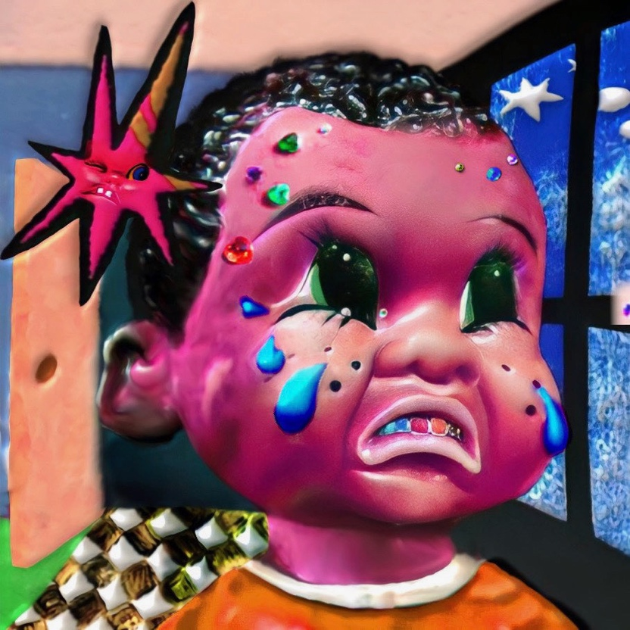

BOY TOY Tracklisting:
- Pretend Friend
2. Keep You Company
3. Oatmeal Pancakes
4. Sweet Tooth
5. Matador

CONNECT WITH SAM AUSTINS
WEBSITE | FACEBOOK | INSTAGRAM | TWITTER | YOUTUBE

PRESS CONTACTS
Fairley McCaskill | Fairley.McCaskill@atlanticrecords.com
Katy Carmichael (Tour) | Katy.Carmichael@atlanticrecords.com
Alison Smith | Alison@tcbpr.com
Claire Marcus | Claire@tcbpr.com

