FOR IMMEDIATE RELEASE
JUNE 2, 2023

RISING ALT-COUNTRY STAR TANNER USREY SHARES EMOTIONAL NEW SINGLE “LAST GOODBYE”

NON-STOP LIVE SCHEDULE INCLUDES HEADLINE SHOWS,
FESTIVAL PERFORMANCES, AND MORE

LISTEN TO “LAST GOODBYE” | WATCH OFFICIAL MUSIC VIDEO

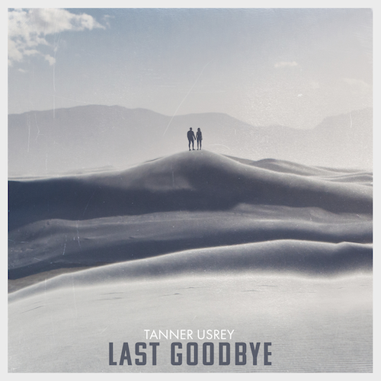
DOWNLOAD HI-RES ARTWORK

“If there is one artist set up for a major explosion over the next year or so, it has to be Tanner Usrey.” – WHISKEY RIFF

Rising country troubadour Tanner Usrey has shared his latest single, “Last Goodbye” - Listen HERE. Produced by Beau Bedford (Jonathan Tyler, The Texas Gentlemen) and co-written by Usrey with top Nashville songwriter Kendell Marvel (Chris Stapleton, Jamey Johnson), the emotional track is joined by an official visualizer streaming now at YouTube HERE.

“Hey guys, y’all loved the video we posted, so we decided to get it out to y’all,” shared Tanner. “I wrote this song with my buddy Kendell Marvel, and it’s probably one of my favorites on the album, so I hope you like it too!”

“Last Goodbye” follows the recent arrival of Usrey’s label debut single, “Give It Some Time,” available now at all DSPs and streaming services. Co-written by Usrey and producer Beau Bedford, the track arrived alongside a major signing announcement in Billboard as well as a companion music video streaming now at YouTube HERE. The release also garnered attention from PEOPLE, Entertainment Tonight, Variety, and ore.

An electrifying and energetic live presence who played over 180 shows in 2022 alone, Usrey will continue his non-stop touring with an upcoming live schedule that will see him on the road through the summer. Highlights include headline shows, festival appearances, and dates alongside such like-minded artists as The Steel Woods. For complete details and ticket availability, please visit www.tannerusreymusic.com/tour-dates.

ABOUT TANNER USREY
Tanner Usrey has earned national applause for channeling a classic spirit from a personal perspective, blending straight-shooting storytelling with country grit, rock ‘n’ roll energy, and Americana eloquence. Inspired by a range of influences – spanning George Strait, Tom Petty, Lynyrd Skynyrd, and The Rolling Stones to his favorite band Whiskey Myers – Usrey grew up in the small town of Prosper, TX, where he worked as a skip tracer while honing his signature style by writing countless songs and performing gigs anywhere that had a stage. In 2019, he quit his job and unveiled the Medicine Man EP, followed in 2021 by the SÕL Sessions EP, earning tens of millions of streams and featured placement on the highly rated Yellowstone Season 4 finale Usrey kicked off 2023 with “Take Me Home,” drawing over 10M streams thus far. Now, as the latest member of the world-renowned Atlantic Records roster, Tanner Usrey is poised to bare it all with “Last Goodbye” and more new music to come.

“I hope you hear what you want to hear, enjoy it, resonate with it, and know it’s real,” Usrey says. “It’s been a wild ride. I’ve busted my ass. I started off doing all of this on my own, so it’s crazy to see how this and the team around me have grown. People are going after real music right now, and that’s great. I’m looking forward to seeing where it goes next.”

TANNER USREY
ON TOUR 2023

JUNE
2 – Gardnerville, NV - BackCountry Festival *
3 – Folsom, CA – Folsom Saloon
4 – Fresno, CA – Strummer’s [SOLD OUT]
5 – Los Angeles, CA – The Moroccan Lounge
8 – San Diego, CA – Casbah
9 – Morro Bay, CA – The Siren
10 – Felton, CA – Felton Music Hall
11 – Petaluma, CA – Mystic Theatre
15 – Salmon, ID – Sweet Water Hollow ^
16 – Sandpoint, ID – The Hive
17 – Spokane, WA – Martin Woldson Theater at the Fox ^
18 – Seattle, WA – Tractor Tavern ^
21 – Bend, OR – Domino Room ^
22 – Pendleton, OR – Jackalope Jamboree *
23 – Great Falls, MT – Beacon Icehouse
24 – Filer, ID – Gordy’s HWY 30 Music Festival *

JULY
2 – Greeley, CO – Greeley Stampede*
12 - Tyler, TX - Cowboys
13 – Marble Falls, TX – Putters & Gutters
14 – Dallas, TX – Granada Theater
15 – Tulsa, OK – Cain's Ballroom
16 – Houston, TX – White Oak Music Hall
20 – Lubbock, TX – The Blue Light
21 – Gatesville, TX – Bare Bones BBQ
22 – New Braunfels, TX – Whitewater Amphitheater #
29 – Ft. Smith, AR – Peacemaker Festival *

AUGUST
7 – Sturgis, SD – Kickstands Campground & Venue
8 – Sturgis, SD – Kickstands Campground & Venue
12 – Hattiesburg, MS – Bulls, Bands, and Barrels *
18 – Salt Lake City, UT – Soundwell
19 – Helena, MT – Dess Fest 2023 *
24 – Omaha, NE – The Waiting Room
26 – Henriette, MN – Northwoods Jam *

SEPTEMBER
3 – Lake View, IA – Stone Pier Summer Concert Series *
13-16 – Pryor, OK – Born & Raised 2023 *
28 – Cape Girardeau, MO – Show Me Center $
29 – Rogers, AR – Walmart AMP $
30 – Oklahoma City, OK – Paycom Center $

OCTOBER
1 – Ashland, KY – Foxfire Music Festival *
5 – Corpus Christi, TX – American Bank Center $
6 – San Antonio, TX – AT&T Center $
7 – Lubbock, TX – United Supermarkets Arena $
6-8 – Austin, TX – Austin City Limits Music Festival *
13-15 – Austin, TX – Austin City Limits Music Festival *
21 – Fort Worth, TX – Gordy's HWY30 Texas Edition *

NOVEMBER
30 – Nashville, TN – Ryman Auditorium % [SOLD OUT]

* Festival Performance
^ w/ The Steel Woods
# w/ Read Southall Band
$ w/ Koe Wetzel
% w/ Shane Smith & The Saints

# # #

DOWNLOAD HI-RES PRESS IMAGE
PHOTO CREDIT: TRENTON JOHNSON

# # #
CONNECT WITH TANNER USREY
OFFICIAL | FACEBOOK | INSTAGRAM | TWITTER | YOUTUBE
N”

