ED SHEERAN RELEASES SIXTH STUDIO ALBUM ‘-ʼ
(PRONOUNCED SUBTRACT)
DOWNLOAD/STREAM HERE
THE GLOBAL PREMIERE OF ALL 14 OFFICIAL MUSIC VIDEOS
BEGINS TODAY AT 11AM EST VIA ED’S OFFICIAL YOUTUBE
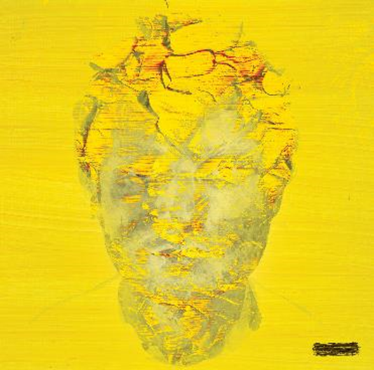
NEW DOCUMENTARY ‘ED SHEERAN: THE SUM OF IT ALL’
STREAMING NOW ON DISNEY+
OFFICIAL TRAILER

“+ - = ÷ x TOUR”
(PRONOUNCED “MATHEMATICS TOUR”) HITS STADIUMS ACROSS THE COUNTRY STARTING MAY 6TH

INTIMATE “ – “ TOUR (PRONOUNCED “SUBTRACT TOUR”)
COMING TO THEATERS AND AUDITORIUMS IN 14 CITIES BEGINNING MAY 19TH IN CLEARWATER, FL
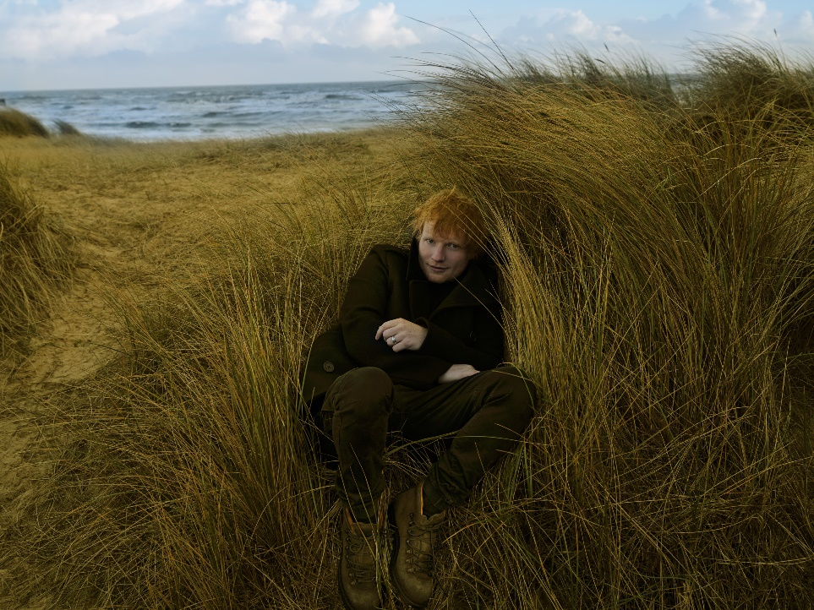
ED SHEERAN PHOTOGRAPHED BY ANNIE LEIBOVITZ
DOWNLOAD NEW PRESS PHOTO & ALBUM ARTWORK
DOWNLOAD HERE
Global superstar Ed Sheeran’s highly-anticipated sixth studio album, ‘-‘ (pronounced subtract) arrives everywhere today via Atlantic Records. DOWNLOAD/STREAM HERE
An album that revisits Ed’s singer/songwriter roots, and one that was written against a backdrop of personal grief and hope, ‘-,’ presents one of the biggest stars on the planet at his most vulnerable and honest. The album is ushered in by first single “Eyes Closed” and the recently released, “Boat.”
To celebrate the release of ‘-ʼ, Ed will premiere the visual album consisting of 14 official music videos beginning at 11am EST today via Ed’s official YouTube page. Following the premiere, fans will be able to go to Ed’s After Party on YouTube, where he will be delivering an exclusive acoustic performance of “Eyes Closed.” Additionally, the official music video for the track “Curtains” will make its global broadcast premiere on MTV Live, MTVU, MTV Biggest Pop and across MTV’s global network of channels, as well as on the Paramount billboards in New York City’s Times Square.
‘-‘ is the result of Sheeran pushing the boundaries of his songcraft, as he delivers the most profound songwriting of his career. Teaming-up with Aaron Dessner (The National) on writing and production after the pair joined forces following an introduction from mutual friend Taylor Swift, Ed and Aaron began crafting the album in February last year. Writing over 30 songs during their month-long studio stint in Kent, UK, the album’s fourteen tracks are seamlessly tied together by exquisite production from paired back, folk-leaning textures to bolder, full-band/orchestral arrangements.
Next Wednesday, May 10th Ed will kick off the second season of Apple Music Live. In the intimate live performance, he'll showcase ‘-' in full for the first time alongside a 12-piece band including Aaron Dessner. Fans around the world can stream the performance on demand on both Apple Music and Apple TV+ beginning at 1 p.m. PST on May 10. Watch a trailer HERE.
Ed recently announced the "- TOUR", which features an intimate run of dates in theaters and auditoriums across 14 cities in North America. These shows coincide with the previously announced "+ - = ÷ x TOUR", his massive stadium tour which kicks off at AT&T Stadium in Arlington, TX, on May 6 (see full itinerary below).
“I had been working on Subtract for a decade, trying to sculpt the perfect acoustic album, writing and recording hundreds of songs with a clear vision of what I thought it should be. Then at the start of 2022, a series of events changed my life, my mental health, and ultimately the way I viewed music and art.
Writing songs is my therapy. It helps me make sense of my feelings. I wrote without thought of what the songs would be, I just wrote whatever tumbled out. And in just over a week, I replaced a decade’s worth of work with my deepest darkest thoughts.
Within the space of a month, my pregnant wife got told she had a tumour, with no route to treatment until after the birth. My best friend Jamal, a brother to me, died suddenly and I found myself standing in court defending my integrity and career as a songwriter. I was spiralling through fear, depression and anxiety.
I felt like I was drowning, head below the surface, looking up but not being able to break through for air.
As an artist I didn’t feel like I could credibly put a body of work into the world that didn’t accurately represent where I am and how I need to express myself at this point in my life. This album is purely that. It’s opening the trapdoor into my soul. For the first time I’m not trying to craft an album people will like, I’m merely putting something out that’s honest and true to where I am in my adult life.
This is last February’s diary entry and my way of making sense of it. This is Subtract.”

‘-‘ (Subtract) Tracklist:
Boat
Salt Water
Eyes Closed
Life Goes On
Dusty
End Of Youth
Colourblind
Curtains
Borderline
Spark
Vega
Sycamore
No Strings
The Hills of Aberfeldy

“+ - = ÷ x TOUR” NORTH AMERICA 2023
“ – TOUR” in italics
May
6 Arlington, TX AT&T Stadium + ×
13 Houston, TX NRG Stadium + ×
19 Clearwater, FL Ruth Eckerd Hall * (- TOUR)
20 Tampa, FL Raymond James Stadium + ×
26 Atlanta, GA Tabernacle * (- TOUR)
27 Atlanta, GA Mercedes-Benz Stadium + ×

June
2 Philadelphia, PA The Met Philadelphia * (- TOUR)
3 Philadelphia, PA Lincoln Financial Field + ×
10 East Rutherford, NJ MetLife Stadium + ×
11 East Rutherford, NJ MetLife Stadium + ×
16 Toronto, ON HISTORY * (- TOUR)
17 Toronto, ON Rogers Centre + ·
18 Toronto, ON Rogers Centre + ·
24 Landover, MD FedExField + ·
29 Boston, MA Boch Center Wang Theatre *
30 Foxborough, MA Gillette Stadium + ·

July
1 Foxborough, MA Gillette Stadium + ·
8 Pittsburgh, PA Acrisure Stadium + ·
14 Royal Oak, MI Royal Oak Music Theatre # (- TOUR)
15 Detroit, MI Ford Field + ·
21 Nashville, TN Ryman Auditorium * (- TOUR)
22 Nashville, TN Nissan Stadium + %
28 Chicago, IL The Chicago Theatre * (- TOUR)
29 Chicago, IL Soldier Field + %

August
5 Kansas City, MO GEHA Field at Arrowhead Stadium + %
11 Minneapolis, MN State Theatre * (- TOUR)
12 Minneapolis, MN U.S. Bank Stadium + %
18 Denver, CO Paramount Theatre * (- TOUR)
19 Denver, CO Empower Field at Mile High + %
25 Seattle, WA Paramount Theatre # (- TOUR)
26 Seattle, WA Lumen Field + ≠

September
1 Vancouver, BC Queen Elizabeth Theatre * (- TOUR)
2 Vancouver, BC BC Place + ≠
9 Las Vegas, NV Allegiant Stadium - ≠
15 Oakland, CA Fox Theater * (- TOUR)
16 Santa Clara, CA Levi’s® Stadium - ≠
22 Los Angeles, CA Shrine Auditorium *
23 Inglewood, CA SoFi Stadium - ≠
Support from:
+ Khalid
- Russ
× Dylan
· Rosa Linn
% Cat Burns
≠ Maisie Peters
* Ben Kweller
# TBA

FOR MORE ON ED SHEERAN:
OFFICIAL WEBSITE | INSTAGRAM | FACEBOOK | TWITTER | YOUTUBE
PRESS CONTACTS:
Glenn Fukushima – GlennFukushima@300Elektra.com
Jason Davis – Jason.Davis@atlanticrecords.com

