RELEASES NEW MUSIC VIDEO FOR
“PARADISE CALLING”

PLAYING EXCLUSIVE US ALBUM RELEASE SHOWS THIS FALL
IN NYC, LA + SAN FRANCISCO

TICKETS ON SALE NEXT FRIDAY, JULY 28

NEW ALBUM PORTRAITS
OUT AUGUST 18, 2023

WATCH THE VIDEO FOR “PARADISE CALLING” HERE
PRE-ORDER PORTRAITS HERE

photo credit: Thibault Theodore | download hi-res here

Today – July 21, 2023 – Birdy releases the music video for new single “Paradise Calling” (watch here), directed by Max McLachlan. The visual arrives one week after Birdy first debuted the track, which was immediately praised by Clash as “puls[ing] with energising creativity, anticipation and unbridled joy – all signifiers of what Portraits has to offer… cleverly crafted and timeless lyricism is infused with freshness and an innate sense of nostalgic pop melody.”

Also today, Birdy announces a string of exclusive US dates set for this October, bringing her highly-anticipated new album Portraits to intimate rooms in New York City, Los Angeles, and San Francisco, where she will perform this new music stateside for the very first time. Tickets will go on sale next Friday, July 28.

Throughout the spring and early summer, Birdy has released standout songs – “Paradise Calling,” “Heartbreaker,” “Raincatchers,” and “Your Arms” – in advance of her upcoming album Portraits, which is set for release on Friday, August 18, 2023.
On “Paradise Calling,” Birdy continues her musical renaissance as she creates yet another alt-pop anthem, shifting away from her customary stripped-back motifs and stepping into a world laden with polished and gleaming aesthetics.

In her most confident album yet, Portraits sees Birdy take a liberated leap into the unknown – her timeless songwriting style now infused with a fresh, exuberant rush of energy and inventive, off-kilter production flourishes. It’s the sound of a creative stepping into a new world and, thrillingly, finding her true voice.

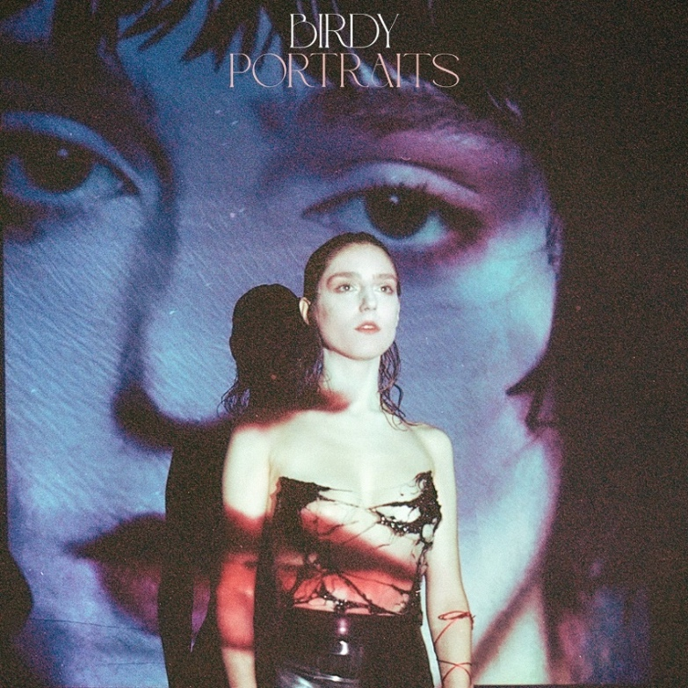
download hi-res artwork here

In 2023, Birdy is back with her fifth studio album, Portraits, ushering in a new chapter and marking a confident change in direction for an artist who has achieved an unbelievable amount since releasing her debut album, Birdy. At just 26 years old, Birdy has solidified herself as one of the UK’s leading homegrown talents; her incredible achievements to date include 3 top 5 albums and countless Platinum and Gold certifications, exceeding sales of 8 million records globally. Whether featuring on blockbuster soundtracks for the likes of Pixar, Netflix, and Amazon, collaborating with leading artists across genres, or motivating a generation with a viral TikTok sound, Birdy is forever finding new ways to engage new audiences. On DSPs, Birdy’s committed fanbase has helped her to surpass an incredible 5 billion streams and counting; she counts 18 million followers across all streaming services.

Birdy continues to be an unmissable draw in the live arena, too. Her rich, multi-layered stage productions have seen her sell out three consecutive nights at The Sydney Opera House, play to over 10,000 people across two nights at London’s Eventim Apollo, and reach many more milestones on global world tours. She has also headlined festivals across Europe and Asia, performed at the UK’s famed Glastonbury Festival, and has earned both BRIT and GRAMMY® Award nominations.

UPCOMING TOUR DATES:

OCTOBER
20 – New York, NY @ Irving Plaza
22 – San Francisco, CA @ August Music Hall
24 – Los Angeles, CA @ Belasco Theater

***

CONNECT WITH BIRDY:
WEBSITE | INSTAGRAM | TWITTER | FACEBOOK | TIKTOK

For more information on Birdy, please contact:
Libby Kober | Libby.Kober@atlanticrecords.com

