RELEASES NEW SINGLE
“PARADISE CALLING”

TAKEN FROM HER UPCOMING NEW ALBUM
PORTRAITS
OUT AUGUST 18, 2023

BUY/STREAM “PARADISE CALLING” HERE
PRE-ORDER PORTRAITS HERE

photo credit: Thibault Theodore | download hi-res here

Today – July 12, 2023 – Birdy releases her sensational new single, “Paradise Calling,” out now via Atlantic (buy/stream here). Following the release of “Heartbreaker,” “Raincatchers,” and “Your Arms” earlier this year, “Paradise Calling” is the latest offering from Birdy’s upcoming album, Portraits, which is set for release on Friday, August 18, 2023.
On “Paradise Calling,” Birdy continues her musical renaissance as she creates yet another alt-pop anthem, shifting away from her customary stripped-back motifs and stepping into a world laden with polished and gleaming aesthetics.

In her most confident album yet, Portraits sees Birdy take a liberated leap into the unknown – her timeless songwriting style now infused with a fresh, exuberant rush of energy and inventive, off-kilter production flourishes. It’s the sound of a creative stepping into a new world and, thrillingly, finding her true voice.

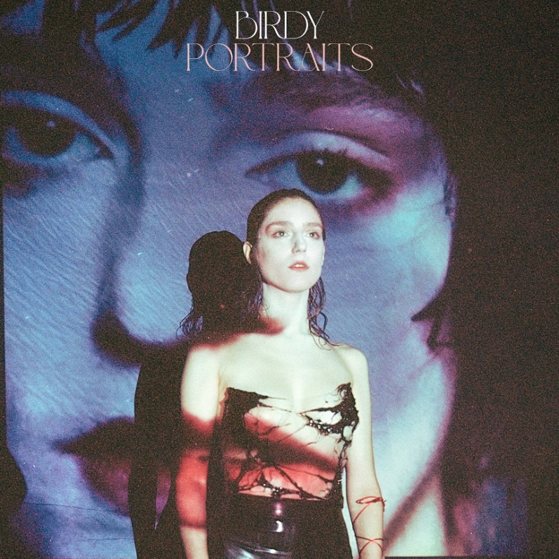
download hi-res artwork here

In 2023, Birdy is back with her fifth studio album, Portraits, ushering in a new chapter and marking a confident change in direction for an artist who has achieved an unbelievable amount since releasing her debut album, Birdy. At just 26 years old, Birdy has solidified herself as one of the UK’s leading homegrown talents; her incredible achievements to date include 3 top 5 albums and countless Platinum and Gold certifications, exceeding sales of 8 million records globally. Whether featuring on blockbuster soundtracks for the likes of Pixar, Netflix, and Amazon, collaborating with leading artists across genres, or motivating a generation with a viral TikTok sound, Birdy is forever finding new ways to engage new audiences. On DSPs, Birdy’s committed fanbase has helped her to surpass an incredible 5 billion streams and counting; she counts 18 million followers across all streaming services.

Birdy continues to be an unmissable draw in the live arena, too. Her rich, multi-layered stage productions have seen her sell out three consecutive nights at The Sydney Opera House, play to over 10,000 people across two nights at London’s Eventim Apollo, and reach many more milestones on global world tours. She has also headlined festivals across Europe and Asia, performed at the UK’s famed Glastonbury Festival, and has earned both BRIT and GRAMMY® Award nominations.

***

CONNECT WITH BIRDY:
WEBSITE | INSTAGRAM | TWITTER | FACEBOOK | TIKTOK

For more information on Birdy, please contact:
Libby Kober | Libby.Kober@atlanticrecords.com

