BURNA BOY RELEASES EAGERLY AWAITED NEW SINGLE “BIG 7” AND
OFFICIALLY ANNOUNCES 7TH STUDIO ALBUM, ‘I TOLD THEM…” ALONG WITH A TRAILER

‘I TOLD THEM…’, AVAILABLE FOR PRE-ORDER NOW, TO COME ON AUGUST 24TH IN THE U.S.

TO INCLUDE “BIG 7” AS WELL AS THE PREVIOUSLY RELEASED “SITTIN’ ON TOP OF THE WORLD” FEATURING 21 SAVAGE

“BIG 7” OFFICIAL MUSIC VIDEO INCLUDES CAMEOS FROM WU-TANG CLAN, BUSTA RHYMES, JUNIOR MAFIA, SHAMEIK MOORE & MORE

HISTORY-MAKING LONDON STADIUM SHOW NOW AVAILABLE TO WATCH ON APPLE MUSIC LIVE

DOWNLOAD/STREAM “BIG 7”
WATCH OFFICIAL VIDEO HERE
PRE-ORDER ‘I TOLD THEM…’
WATCH ALBUM TRAILER
FIND ADDITIONAL ASSETS HERE (lyrics, social clips, etc.)

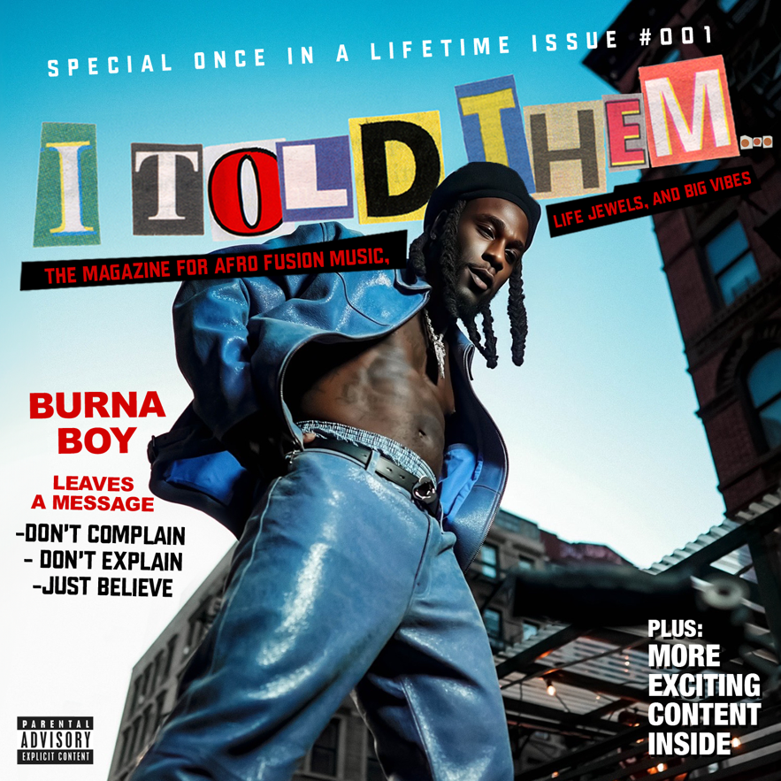
DOWNLOAD HI-RES ARTWORK HERE

GRAMMY® Award-winning global superstar Burna Boy releases his eagerly awaited single “Big 7” and officially announces the release date for his 7th studio album, ‘I Told Them…’, set to come on August 24th (in the U.S.) via Spaceship/Bad Habit/Atlantic Records. ‘I Told Them…’ is now available for pre-order HERE. “Big 7,” which has already amassed more than 12-million listens of an early snippet on TikTok, was produced by MDS (“Last Last,” “Cloak & Dagger,” and “LOVE, DAMINI”) and comes with an official music video directed by the legendary Benny Boom. Shot in New York City, the video features cameos from Burna’s inner crew (the 7G’s) as well as RZA (Wu-Tang Clan), Busta Rhymes, Junior Mafia, actor Shameik Moore (Spiderman), and others – Watch HERE.

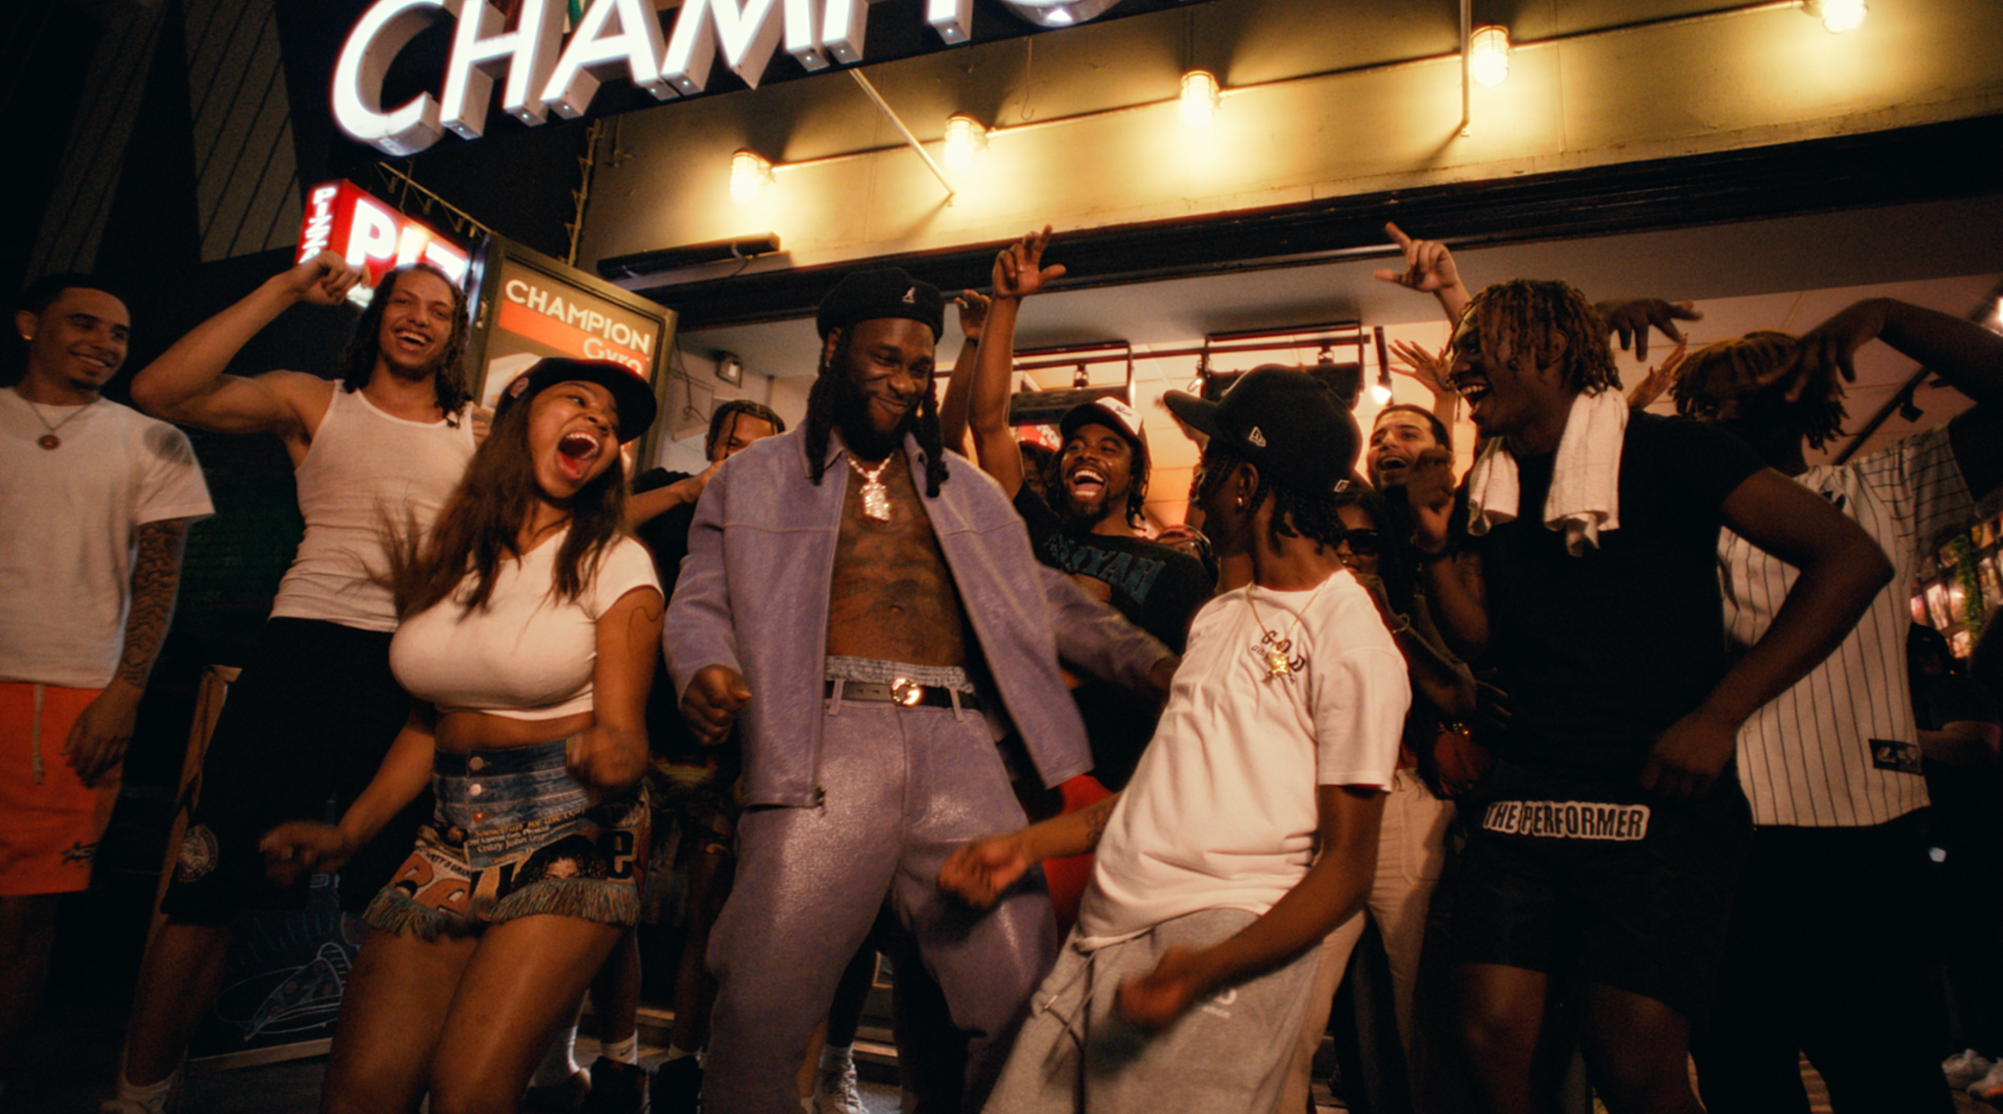

"Big 7” is a melodic tribute to embracing new heights in my musical journey,” said Burna Boy. “The title represents a symbolic aspiration to reach greater horizons, with the number seven embodying an attainable and harmonious growth."

On "Big 7," Burna conveys a message of setting ambitious yet realistic goals, embracing personal growth, and conquering challenges. It signifies the pursuit of excellence, both as an artist and an individual, without being overwhelmed by unrealistic expectations. The focus is on celebrating every step forward, every endeavor accomplished, and the positive momentum gained.

Through uplifting melodies and inspiring lyrics, "Big 7" becomes a harmonious anthem that encourages listeners to aim high while appreciating the journey's joys and triumphs. The title serves as a reminder that each milestone, no matter how seemingly small, contributes to the grand symphony of success and fulfillment.

“Big 7” follows “Sittin’ On Top Of The World” featuring multi-platinum artist, 21 Savage. Produced by Skread, the single features a sample of Brandy’s 1998 hit "Top Of the World" ft. Mase and comes alongside the visual for the summer anthem. The visual, directed by Troy Roscoe, gives a timeless 90’s/early 00’s feel, complete with a flurry of beautiful women, classic cars, and strikingly fun graphics - Watch HERE. Both tracks come off Burna Boy’s 7th studio album, “I Told Them…” which is heavily inspired by the 90 Hip Hop era/Wu-Tang Clan's unity/Busta Rhymes creative eye.

Earlier this month, Burna Boy made history once again with his sold-out show at New York City’s Citi Field stadium. Becoming the first African artist in history to sell out a stadium in the U.S., the Nigerian showman commanded a crowd of more than 40,000 fans, including celebs like Busta Rhymes, SZA, NBA star Mo Bamba, NFL star Larry Ogunjobi, and British rapper Dave, who also joined Burna on stage for a special performance of their hit song “Location.” Highlights included a performance of his newest single, “Sittin’ On Top Of The World," a sneak peak of his unreleased track “Big 7,” and an explosive finale where the crowd belted every word to the star’s massive hit “Last, Last” while fireworks lit up the sky. This history-making performance shortly followed after his landmark London stadium performance where he became the first African to headline a stadium in the U.K. Viewers were able to enjoy this monumental show via an exclusive Apple Music Live stream.

Burna Boy reached new heights with his sixth studio album “LOVE, DAMINI,” marking his highest U.S. debut to date on the Billboard Top 200 and his RIAA-certified platinum single “Last Last” topping the Billboard U.S Afrobeats Songs chart for 8 weeks before later claiming the #1 spot at Urban radio. The album also went on to become the #1 album on Apple Music in 47 countries while finishing at #2 in the UK and Netherlands, becoming his highest charting album in those territories. LOVE, DAMINI was selected as a The New York Times’ Critics Pick with additional praise from Rolling Stone, Billboard, Vulture, Variety, and many more.

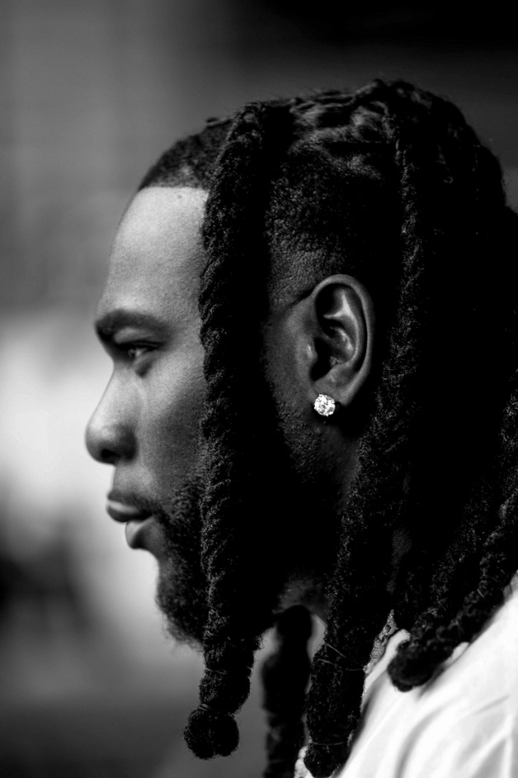
DOWNLOAD HI-RES PRESS PHOTO
Credit: Emmanuel Agbeble (IG: @apmworldmag)
CONNECT WITH BURNA BOY
TWITTER | FACEBOOK | INSTAGRAM | YOUTUBE |TIKTOK
PRESS CONTACTS
Corey Brewer | Corey.Brewer@atlanticrecords.com
Selam Belay | Selam.Belay@atlanticrecords.com

