CHARLOTTE CARDIN RELEASES NEW TRACK “JIM CARREY”

SOPHOMORE ALBUM 99 NIGHTS OUT AUGUST 25

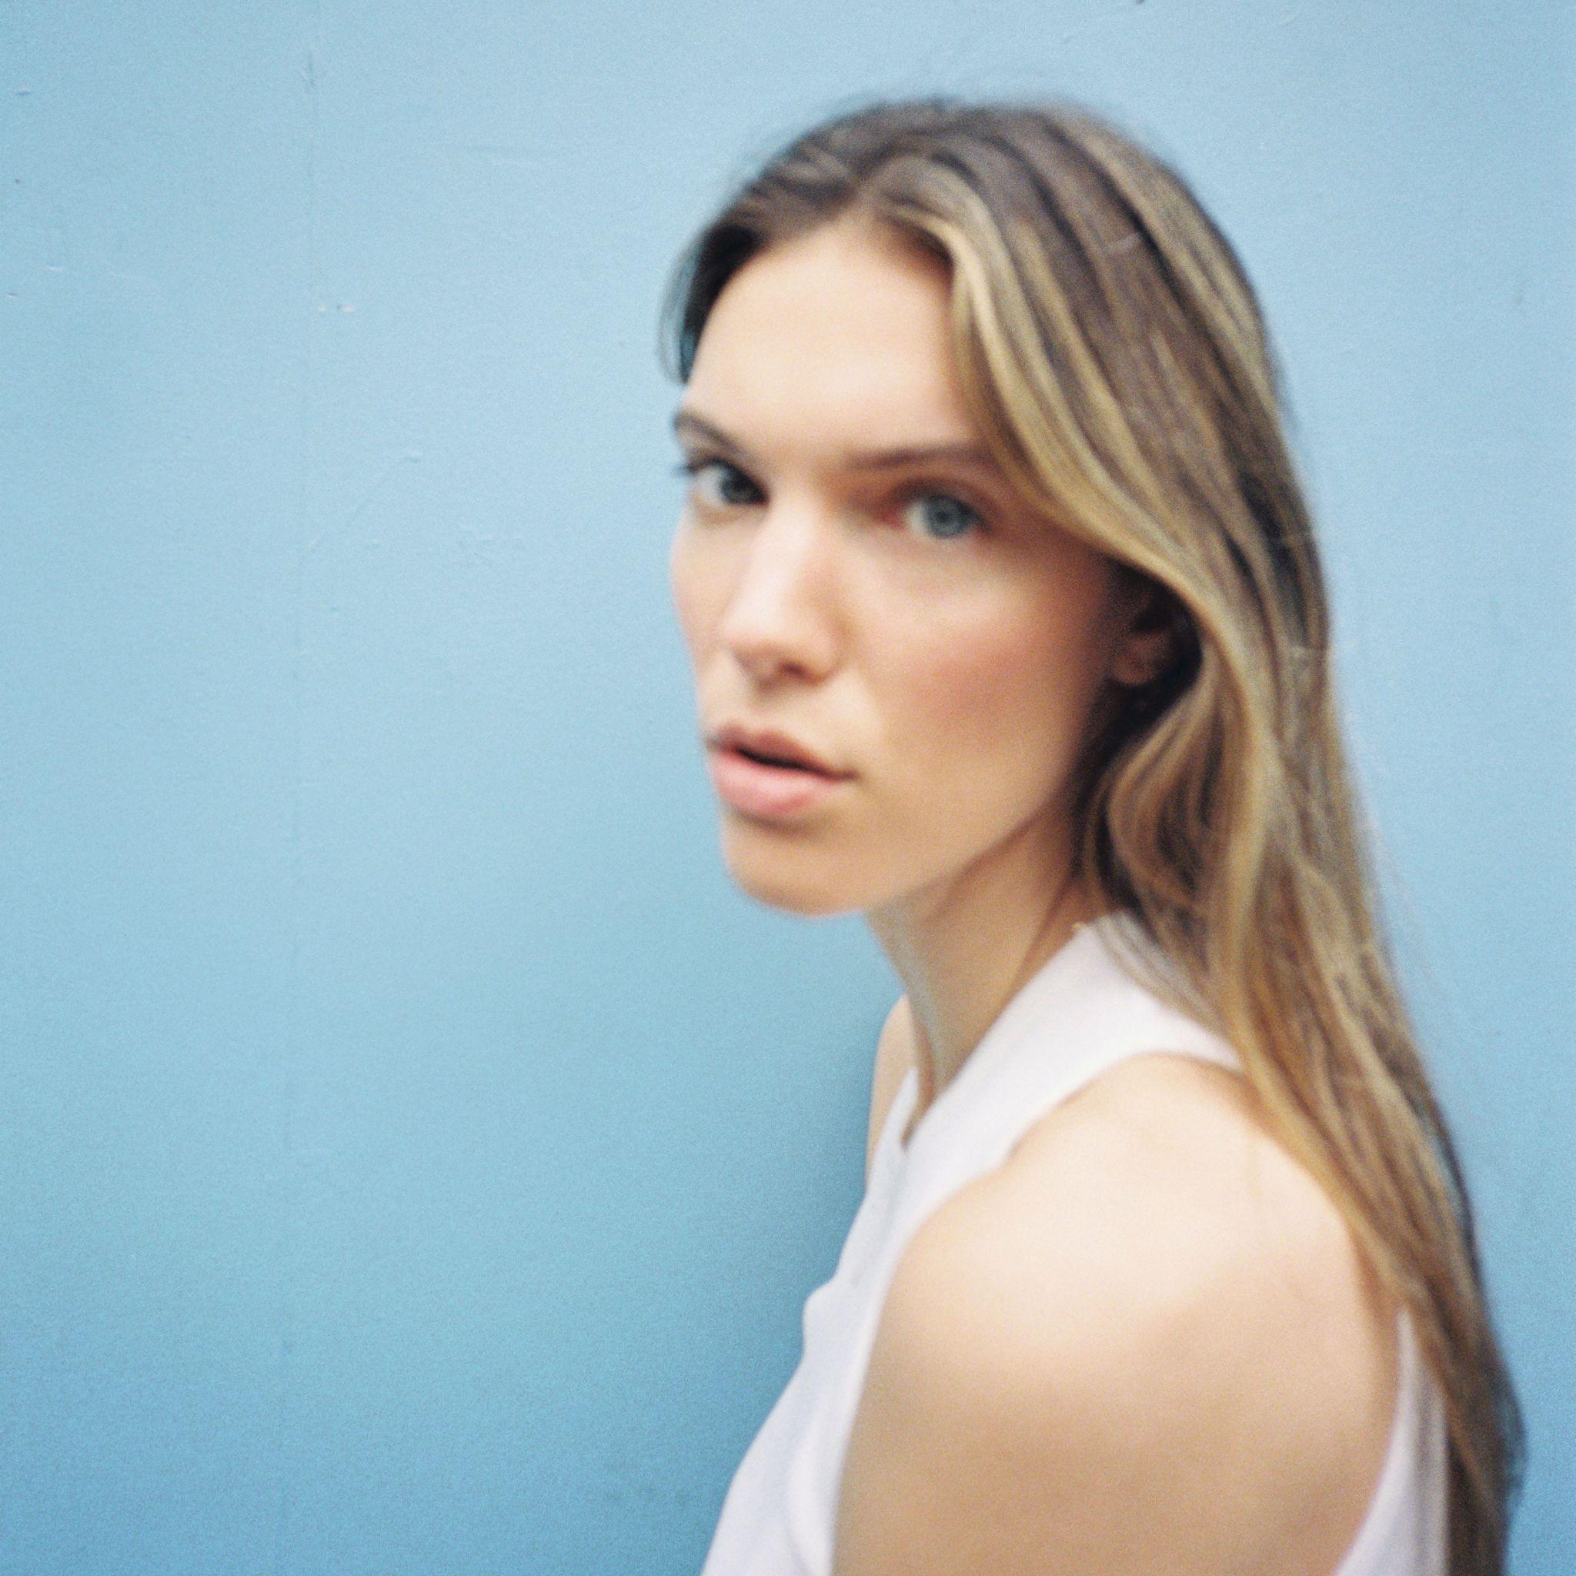
(Download Press Photo HERE | Credit: Aliocha Schneider)

Multi JUNO-winning Canadian singer/songwriter Charlotte Cardin has released “Jim Carrey,” the fourth offering from her stellar sophomore album 99 Nights (out August 25 via Cult Nation/Atlantic Records). The playful, upbeat track, partially inspired by the acclaimed actor of its title, is a love letter to personal freedom as Charlotte repeats in the anthemic chorus, “Goodbye my worthless ego / Without you I'm finally free, oh.”

STREAM “JIM CARREY” HERE
WATCH VISUALIZER FOR “JIM CARREY” HERE

On the new track, Cardin says, “It’s a special one. I went into this rabbit hole of Jim Carrey interviews. He discusses ego in an interesting way. In his perspective, our need for acceptance holds us back from embracing who we really are. The track explores getting rid of your ego. You can decide what your destiny is if you take a risk and accept to be who you really are at the fullest. It’s a metaphor, but marrying Jim Carrey is a good way to start the inner work.”

“Jim Carrey” follows a string of impressive singles, “99 Nights,” “Confetti” and “Looping,” all of which garnered widespread excitement and praise from the likes of Billboard, V Magazine, UPROXX and more. She will be taking the album on the road for an international headline tour kicking off August 30th with stops in New York City at Irving Plaza, Boston at Brighton Music Hall, Los Angeles at the El Rey Theatre and London at KOKO. Tickets are available to purchase now - find HERE.

Cardin carefully assembled what would become 99 Nights while on the road in 2021. After initial sessions in Montréal, she wrote and recorded in London, Los Angeles, and Toronto to “fuel a creative free flow.”

She shares, “We called it 99 Nights, because it was a big journey through all of these worlds I needed to explore in order to touch base with the most important things in my life. I realized I needed to get the fuck out of where I was. The 99 Nights are a symbol of one chapter closing and another beginning. It’s nostalgic because there’s an ending, but it’s very hopeful since I’m starting over. The first few months of the process traced a path for the sound, emotion, and stories I would be sharing, hence the title.”

Cardin released her debut full-length album Phoenix in 2021 to immense acclaim (and platinum certification in Canada) including a sweep of 2022 Juno Awards that included wins for Artist, Album, Pop Album and Single of the Year and a 2022 Polaris Music Prize nomination. Praised by HYPEBAE for its “rippling melodies” and “stunningly raw vocals,” the album held the #1 spot in Canada for two weeks and boosted Cardin to over 400m global career audio streams. The album was celebrated with an elaborate and immersive ticketed livestream performance dubbed “The Phoenix Experience,” in addition to an expanded deluxe edition. The stunning body of work features stand-out singles “Meaningless” and “Sex To Me,” the latter of which was featured on the second season of Netflix’s hit show Sex/Life.

Following the success of her Big Boy EP across Canada, Cardin made waves worldwide with her major label and US debut Main Girl EP in 2017. Featuring the standout title track and breakthrough “Dirty Dirty,” Main Girl quickly gained critical acclaim from the likes of The FADER, Harper’s BAZAAR, Interview, NYLON, PAPER, W Magazine & more. The release simultaneously sparked a whirlwind two-year journey around the globe that saw Cardin support the likes of Nick Murphy and BØRNS, in addition to selling out headline shows on multiple continents (including 29 shows on her 2022 North American Phoenix Tour) and gracing the stages of festivals such as Bonnaroo, Lollapalooza, Austin City Limits, Osheaga & Festival d’Été de Québec.

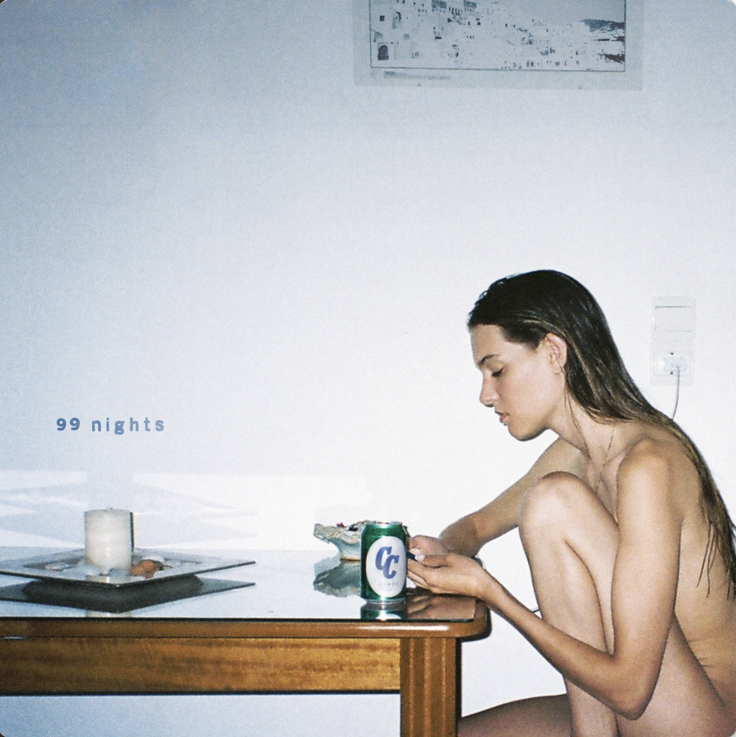
PRE-ORDER 99 NIGHTS HERE

Charlotte Cardin – “99 Nights Tour”
8/30 – Trois-Rivières, QC @ Amphithéâtre Cogeco
8/31 – Trois-Rivières, QC @ Amphithéâtre Cogeco
9/7 – Quebec City, QC @ l'Agora - Port du Québec (Sold Out)
9/8 – Quebec City, QC @ l'Agora - Port du Québec (Sold Out)
9/13 – London, UK @ KOKO
9/14 – Manchester, UK @ Band on the Wall
9/15 – Bristol, UK @ Thekla
9/21 – Brussels, BE @ La Madeleine
9/22 – Amsterdam, NL @ Tolhuistuin
9/23 – Cologne, DE @ Club Volta
9/26 – Munich, DE @ Ampere
9/27 – Berlin, DE @ Columbia Theater
9/28 – Hamburg, DE @ Kent Club
9/30 – Istanbul, TR@ Zorlu PSM
10/24 – Washington, DC @ Union Stage
10/25 – Boston, MA @ Brighton Music Hall
10/27 – New York, NY @ Irving Plaza (Sold Out)
10/28 – Philadelphia, PA @ The Foundry at the Fillmore
10/30 – Chicago, IL @ Lincoln Hall
11/4 – Phoenix, AZ @ Crescent Ballroom
11/5 – San Diego, CA @ House of Blues - Voodoo Room (Sold Out)
11/7 – Los Angeles, CA @ El Rey Theatre
11/9 – San Francisco, CA @ The Independent
11/11 – Portland, OR @ Mission Theater
11/12 – Seattle, WA @ Neumos
11/16 – Vancouver, BC @ Commodore Ballroom
11/17 – Vancouver, BC @ Commodore Ballroom (Sold Out)
11/18 – Victoria, BC @ Capital Ballroom (Sold Out)
11/22 – Edmonton, AB @ Midway Music Hall
11/23 – Calgary, AB @ The Palace Theatre
11/24 – Saskatoon, SK @ Coors Event Centre
11/25 – Winnipeg, MB @ Park Theatre (Sold Out)
1/23 – Strasbourg, FR @ La Laiterie
1/24 – Paris, FR @ L’Olympia (Sold Out)
1/26 – Bordeaux, FR @ Krakatoa
1/27 – Toulouse, FR @ Le Métronum
1/30 – Lille, FR @ Théâtre Sébastopol
1/31 – Caen, FR @ Big Band Café
2/2 – Rennes, FR @ L’antipode
2/3 – La Roche Sur Yon, FR @ Quaim
2/8 – Laval, QC @ Place Bell
2/9 – Laval, QC @ Place Bell (Sold Out)
2/10 – Laval, QC @ Place Bell (Sold Out)

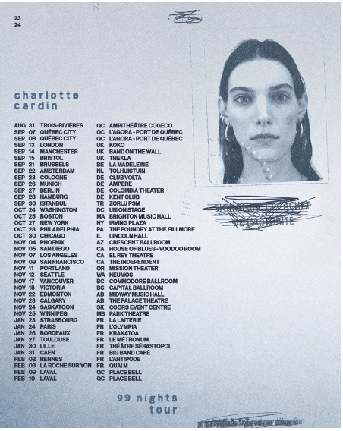

KEEP UP WITH CHARLOTTE CARDIN:
CHARLOTTECARDIN.COM | TIKTOK | INSTAGRAM | TWITTER | YOUTUBE | FACEBOOK | PRESS ASSETS

FOR MORE INFORMATION ON CHARLOTTE CARDIN:
Chloë Walsh: chloe@theoriel.co
Amy Fennie: amy@theoriel.co
Ted Sullivan | Ted.Sullivan@atlanticrecords.com
Christina Kotsamanidis | Christina.Kotsamanidis@atlanticrecords.com

