MAREN MORRIS & MARCUS MUMFORD’S REIMAGINED VERSION OF
“LOOK AT US NOW (HONEYCOMB)” OUT NOW EVERYWHERE – LISTEN HERE

WATCH A “BEHIND THE SCENES” VIDEO OF THE RECORDING PROCESS HERE

CO-WRITTEN BY GRAMMY® AWARD WINNERS MUMFORD & BLAKE MILLS, WITH PRODUCTION FROM MILLS

“LOOK AT US NOW (HONEYCOMB)” LIFTED OFF AURORA –
DEBUT ALBUM FROM DAISY JONES & THE SIX

BUY/STREAM AURORA HERE | PURCHASE ON VINYL HERE

LIMITED SERIES ADAPTATION OF NEW YORK TIMES BESTSELLING LITERARY PHENOMENON OUT NOW ON PRIME VIDEO – PRODUCED BY AMAZON STUDIOS AND HELLO SUNSHINE

“The song, an embodiment of the love-hate relationship between lead singers Daisy Jones (Riley Keough) and Billy Dunne (Sam Claflin), doubles as a feel-good anthem with its soaring harmonies and timeless guitar chords. Mumford was so enamored with the track that he decided to put his own twist on it.” – VARIETY

“Stillwater walked so Daisy Jones & The Six could stage-dive… the harmonies on ‘Look At Us Now (Honeycomb)’ are infectious… you can imagine that The Six really were the biggest band in the world for a minute.” – ROLLING STONE

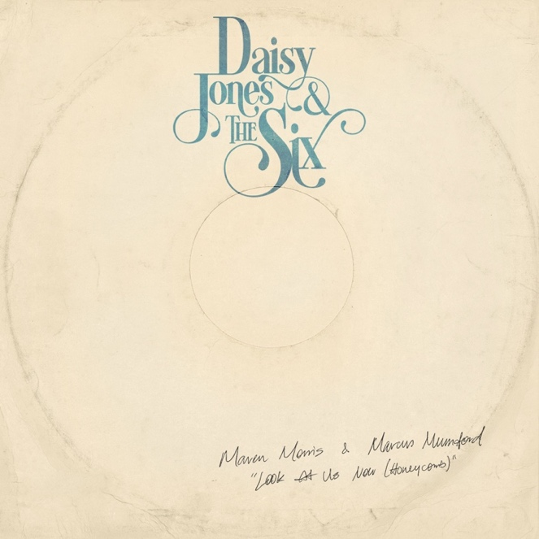
download hi-res artwork here

June 23, 2023 – Atlantic Records is proud to share Marcus Mumford & Maren Morris’ stunning version of “Look At Us Now (Honeycomb),” available now on all DSPs (buy/listen HERE).

First released in March as an Amazon Original, the duet marks a reimagined version of the hit single from Daisy Jones & The Six – subjects of the eponymous limited series which debuted this spring on Prime Video – off their debut album Aurora.

Mumford co-wrote the original version of the track, alongside GRAMMY®-winning songwriter, producer, and multi-instrumentalist Blake Mills (Bob Dylan, Fiona Apple, Alabama Shakes, John Legend, Perfume Genius). Mills served as producer for the original track, as well as today’s reimagined version.

Also released wide today is a “behind the scenes” mini-doc showcasing Mumford, Morris, and Mills recording the rework, alongside footage of the cast of Daisy Jones & The Six captured during production of the series (watch HERE).

Aurora has been met with tremendous acclaim, with Daisy Jones & The Six debuting at #1 on Billboard’s Emerging Artists chart – becoming the first act from a scripted series or film to do so. (They also became the first such act to hit #1 on the iTunes Top Albums chart).

The album itself debuted at #1 on Billboard’s Soundtracks chart, #4 on the Billboard Vinyl Albums & Americana/Folk Albums charts, #9 on Top Current Albums, #10 on Top Albums, and more.

Aurora was produced in its entirety by Mills, with additional production from renowned producer Tony Berg (Phoebe Bridgers, Andrew Bird). Taken from page to screen to recording studio, it marks the storied debut album from the titular band of Taylor Jenkins Reid’s beloved, New York Times bestselling novel Daisy Jones & The Six.

The groundbreaking limited series adaptation, ‘Daisy Jones & The Six,’ is streaming now on Prime Video (watch here). Starring Riley Keough, Sam Claflin, Suki Waterhouse, the highly-anticipated show arrived via Amazon Studios and Reese Witherspoon’s media company Hello Sunshine, who optioned Reid’s work in 2018 – before Daisy Jones & The Six ever even hit bookshelves. Upon the novel’s release in early 2019, it received coveted recognition as a ‘Reese’s Book Club Pick.’

###

ABOUT DAISY JONES & THE SIX – THE LIMITED SERIES:
Based on the best-selling novel by Taylor Jenkins Reid, Daisy Jones & The Six is a limited musical-drama series detailing the rise and precipitous fall of a renowned rock band. In 1977, Daisy Jones & The Six were on top of the world. Fronted by two charismatic lead singers—Daisy Jones (Riley Keough) and Billy Dunne (Sam Claflin)—the band had risen from obscurity to fame. And then, after a sold-out show at Chicago's Soldier Field, they called it quits. Now, decades later, the band members finally agree to reveal the truth. This is the story of how an iconic band imploded at the height of its powers.

The series stars Riley Keough as Daisy Jones, Sam Claflin as Billy Dunne, Camila Morrone as Camila Dunne, Will Harrison as Graham Dunne, Suki Waterhouse as Karen Sirko, Josh Whitehouse as Eddie Roundtree, Sebastian Chacon as Warren Rhodes, Nabiyah Be as Simone Jackson, and Tom Wright as Teddy Price, with a special guest appearance by Timothy Olyphant as Rod Reyes.

From Amazon Studios and Hello Sunshine, Daisy Jones & The Six is executive produced by Reese Witherspoon and Lauren Neustadter for Hello Sunshine and Brad Mendelsohn for Circle of Confusion. Scott Neustadter and Michael H. Weber created the series based on the novel by Taylor Jenkins Reid, who also produces. Scott Neustadter is executive producing and co-showrunning with Will Graham, who also serves as an executive producer. James Ponsoldt directed the first five episodes and serves as an executive producer, Nzingha Stewart directed four of the remaining episodes, and Graham directed one.

Daisy Jones & The Six premieres March 3, with new episodes released every Friday through March 24, exclusively on Prime Video in more than 240 countries and territories worldwide. For more information, visit the Amazon Studios Press Site.

###

CONNECT WITH DAISY JONES & THE SIX
WEBSITE | FACEBOOK | TWITTER | INSTAGRAM | YOUTUBE | TIKTOK

###

Atlantic Records Press Contact:
Libby Kober | Libby.Kober@atlanticrecords.com

Marcus Mumford + Maren Morris Press Contact:
Carla Sacks | carla@sacksco.com

Prime Video Press Contacts:
Melissa Armstrong | Melissa.Armstrong@amazonstudios.com
Kevin McAlpine | Kevin.McAlpine@amazonstudios.com
Reegan Smyth | Reegan.Smyth@amazonstudios.com

