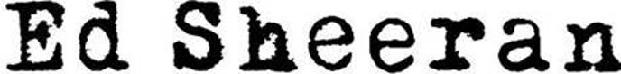

ED SHEERAN ANNOUNCES THE “ – “ TOUR

ONE-OF-A-KIND INTIMATE THEATER SHOWS COINCIDE WITH
SELECT STOPS DURING UPCOMING STADIUM TOUR

THE “ – “ TOUR (PRONOUNCED “SUBTRACT TOUR”) WILL HIT
14 CITIES ACROSS NORTH AMERICA BEGINNING MAY 19TH IN CLEARWATER, FL

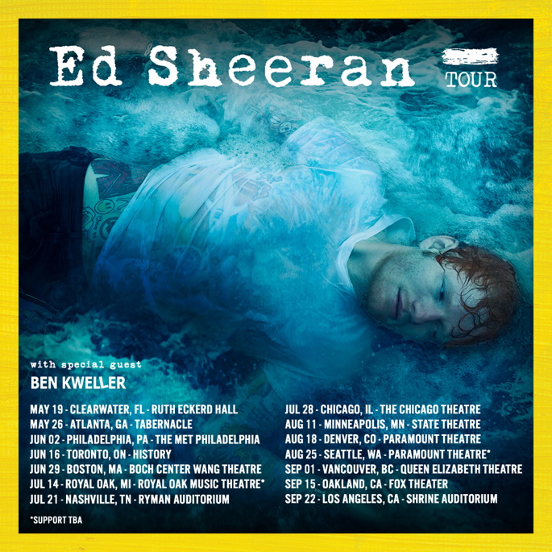
DOWNLOAD PRESS ASSETS HERE

REGISTRATION BEGINS APRIL 28TH THROUGH APRIL 30TH
VIA TICKETMASTER’S VERIFIED FAN TECHNOLOGY

FANS CAN REGISTER HERE

VERIFIED FAN ONSALE BEGINS TUESDAY, MAY 2ND
AT 10AM LOCAL TIME

FOUR-PART DOCUMENTARY “ED SHEERAN: THE SUM OF IT ALL” BEGINS STREAMING MAY 3RD ON DISNEY+
WATCH OFFICAL TRAILER HERE

“+ - = ÷ x TOUR”
(PRONOUNCED “THE MATHEMATICS TOUR”) HITS STADIUMS ACROSS THE COUNTRY STARTING MAY 6TH

NEW ALBUM “ – “ (SUBTRACT)
ARRIVES EVERYWHERE MAY 5
(PRE ORDER HERE)

Global superstar Ed Sheeran has announced details for the “- Tour” (pronounced “Subtract Tour”), a very special run of dates set to take place in theaters and auditoriums in 14 cities across North America. Singer-songwriter Ben Kweller supports on most dates. These intimate performances - which kick off at the Ruth Eckerd Hall in Clearwater, FL, on May 19th, and wrap up at the Shrine Auditorium in Los Angeles, CA, on September 22 (see full itinerary below) - coincide with the massive stadium shows of Sheeran’s previously announced “+ - = ÷ x Tour” (pronounced “Mathematics Tour”).
To ensure more tickets get into the hands of fans who want to go to his shows, Ed Sheeran is using Ticketmaster’s Verified Fan technology for his “ - Tour.” Verified Fan uses a registration system to help filter out buyers looking to resell tickets. Registration opens on Friday, April 28th at 10:00am ET and closes on Sunday, April 30th at 11:59pm ET. Fans can register HERE. The Verified Fan Onsale is set to begin on Tuesday, May 2nd at 10:00am local venue time.
The newly announced tour supports Sheeran’s forthcoming, soul-baring, new album “ – “ will be released on May 5 via Atlantic Records and is available for pre-order here. Written against a backdrop of grief and hope, Ed wrote and recorded the fourteen-track record with Aaron Dessner (of The National) in February last year after a series of hard-hitting events impacted his life. Last week saw the arrival of the album’s poignant opening track “Boat,” following lead single “Eyes Closed,” which marked Ed’s 14th #1 in the UK, earning him the 3rd most chart toppers in UK history, behind only Elvis Presley and the Beatles.
To coincide with the arrival of “ – “, the all-new, four-part documentary “Ed Sheeran: The Sum of It All” will begin streaming on Disney+ starting May 3. Blending never-before-seen personal archive, interviews and performances, the intimate documentary explores how his personal experiences have shaped him to become the artist he is today. Watch the emotional, official trailer here.
Ed will begin the North American leg of his worldwide “+ - = ÷ x Tour,” hitting stadiums across the continent starting May 6 at AT&T Stadium in Arlington, TX (full itinerary below). The trek marks his first stateside tour since the history-making “Divide Tour” in 2018, which officially became the most-attended and highest-grossing tour of all time by its completion. Ed closed 2022 topping Billboard’s Top Ticket Sales chart after wrapping the UK/European leg of the “+ - = ÷ x Tour,” performing in front of over 3 million people in 6 months, highlighted by a five-night stand at London’s Wembley Stadium.

“ – “ TOUR

Support from Ben Kweller
(except where noted)

May
19 Clearwater, FL Ruth Eckerd Hall -
26 Atlanta, GA Tabernacle -

June
2 Philadelphia, PA The Met Philadelphia -
16 Toronto, ON HISTORY -
29 Boston, MA Boch Center Wang Theatre -

July
14 Royal Oak, MI Royal Oak Music Theatre (*Support TBA)
21 Nashville, TN Ryman Auditorium -
28 Chicago, IL The Chicago Theatre -

August
11 Minneapolis, MN State Theatre -
18 Denver, CO Paramount Theatre -
25 Seattle, WA Paramount Theatre (*Support TBA)

September
1 Vancouver, BC Queen Elizabeth Theatre -
15 Oakland, CA Fox Theater -
22 Los Angeles, CA Shrine Auditorium -

“+ - = ÷ x TOUR”
NORTH AMERICA 2023
May
6 Arlington, TX AT&T Stadium + ×
13 Houston, TX NRG Stadium + ×
20 Tampa, FL Raymond James Stadium + ×
27 Atlanta, GA Mercedes-Benz Stadium + ×

June
3 Philadelphia, PA Lincoln Financial Field + ×
10 East Rutherford, NJ MetLife Stadium + × SOLD OUT
11 East Rutherford, NJ MetLife Stadium + ×
17 Toronto, ON Rogers Centre + · SOLD OUT
18 Toronto, ON Rogers Centre + · SOLD OUT
24 Landover, MD FedExField + ·
30 Foxborough, MA Gillette Stadium + ·

July
1 Foxborough, MA Gillette Stadium + · SOLD OUT
8 Pittsburgh, PA Acrisure Stadium + ·
15 Detroit, MI Ford Field + ·
22 Nashville, TN Nissan Stadium + %
29 Chicago, IL Soldier Field + %

August
5 Kansas City, MO GEHA Field at Arrowhead Stadium + %
12 Minneapolis, MN U.S. Bank Stadium + %
19 Denver, CO Empower Field at Mile High + %
26 Seattle, WA Lumen Field + ≠

September
2 Vancouver, BC BC Place + ≠
9 Las Vegas, NV Allegiant Stadium - ≠
16 Santa Clara, CA Levi’s® Stadium - ≠
23 Inglewood, CA SoFi Stadium - ≠
Support from:
+ Khalid
- Russ
× Dylan
· Rosa Linn
% Cat Burns
≠ Maisie Peters

FOR MORE ON ED SHEERAN:
OFFICIAL WEBSITE | INSTAGRAM | FACEBOOK | TWITTER | YOUTUBE
PRESS CONTACTS:
Glenn Fukushima – glenn.fukushima@300elektra.com
Jason Davis – jason.davis@atlanticrecords.com

###

