FOR IMMEDIATE RELEASE
JUNE 9, 2023

JANELLE MONÁE UNVEILS THE AGE OF PLEASURE

AWARD-WINNING SUPERSTAR TO CELEBRATE NEW ERA WITH THE AGE OF PLEASURE TOUR,
GETTING UNDERWAY AUGUST 30 IN SEATTLE

HUGELY ANTICIPATED NEW ALBUM INCLUDES ACCLAIMED SINGLES,
“LIPSTICK LOVER” AND “FLOAT (FEAT. SEUN KUTI + EGYPT 80)”
ALONG WITH FEATURES FROM DOECHII, GRACE JONES, NIA LONG,
AMARAEE, SISTER NANCY, AND CKAY

THE AGE OF PLEASURE AVAILABLE NOW VIA WONDALAND ARTS SOCIETY/ATLANTIC RECORDS HERE

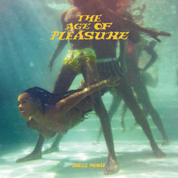
DOWNLOAD HI-RES ARTWORK

“Her most sumptuous album yet…” - ROLLING STONE

“An earthbound affair. True to its title, it’s filled with sensual music that’s about feeling good above all else…Monáe’s free-floating lustiness often brings to mind the music of Prince…” - WALL STREET JOURNAL

“Listening to the album is like being at the world’s most polite orgy; the lyrics are dirty and bold, but the sound is mellow, subversive, enveloping you like a safety blanket…” - ASSOCIATED PRESS

“An ode to freedom, joy, and yes, pleasure…”- CONSEQUENCE

Janelle Monáe, music’s foremost freeassmuthafucka, has shared her hugely anticipated new album, THE AGE OF PLEASURE, available now via Wondaland Arts Society/Atlantic Records HERE.

Executive produced by Janelle Monáe, Nate Wonder, Chuck Lightning, and Sean “Diddy” Combs, THE AGE OF PLEASURE includes such new singles as “Champagne Shit” “Phenomenal (feat. Doechii)” and “Waterslide,” along with the scintillating fan-favorite, “Lipstick Lover,” and lead single “Float (Feat. Seun Kuti + Egypt 80).”

Monáe – who recently graced the June cover of Rolling Stone- will celebrate her new era with THE AGE OF PLEASURE TOUR, getting underway August 30 at Seattle, WA’s WAMU Theater and then traveling North America through mid-October. Produced by Live Nation, the 26-city tour will make stops at such historic venues as Morrison, CO’s Red Rocks Amphitheatre (September 7), Chicago, IL’s Byline Bank Aragon Ballroom (September 14), Toronto, ON’s Massey Hall (September 21), New York City’s Radio City Music Hall (September 26), Brooklyn, NY’s Kings Theatre (September 28), Nashville, TN’s Ryman Auditorium, (October 3), and Atlanta, GA’s Fox Theatre Atlanta (October 6) before culminating at Inglewood, CA’s YouTube Theater (October 18). For complete details and remaining ticket availability, please visit www.jmonae.com.

ABOUT JANELLE MONÁE
Janelle Monáe is without question one of the most celebrated artists of the modern era, an 8x GRAMMY® Award-nominated singer, songwriter, producer, performer, and fashion icon known worldwide for her inimitable style and visionary sound. With multiple celebrated albums, THE ARCHANDROID (2010), THE ELECTRIC LADY (2013), and DIRTY COMPUTER (2018), numerous critically-acclaimed theatrical and television performances, and her unwavering activism for social justice and the LGBTQIA+ community, Monáe continues to be one of the most compelling and important artists of this generation.

# # #

JANELLE MONÁE
THE AGE OF PLEASURE

1. Float (feat. Seun Kuti & Egypt 80)
2. Champagne Shit
3. Black Sugar Beach
4. Phenomenal (feat. Doechii)
5. Haute
6. Ooh La La (feat. Grace Jones)
7. Lipstick Lover
8. The Rush (feat. Nia Long & Amaarae)
9. The French 75 (feat. Sister Nancy)
10. Water Slide
11. Know Better (feat. CKay, Seun Kuti & Egypt 80)
12. Paid In Pleasure
13. Only Have Eyes 42
14. A Dry Red

###

JANELLE MONÁE
THE AGE OF PLEASURE TOUR

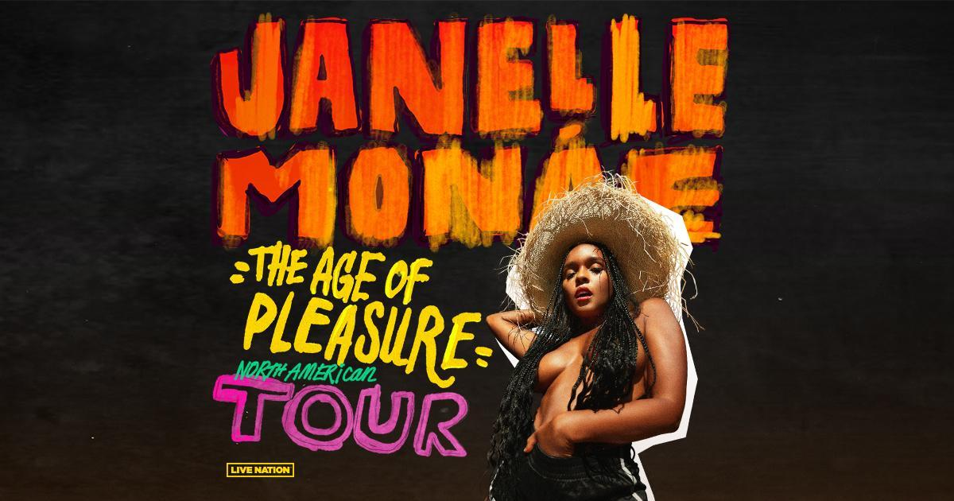

AUGUST
30 – Seattle, WA – WAMU Theater
31 – Vancouver, BC – UBC - Doug Mitchell Thunderbird Sports Centre

SEPTEMBER
2 – Portland, OR – RV Inn Style Resorts Amphitheater
6 –Salt Lake City, UT – The Complex
7 – Morrison, CO – Red Rocks Amphitheatre
9 – Kansas City, MO – The Midland Theatre
11 – Minneapolis, MN – Armory
13 – St. Louis, MO – Stifel Theatre
14 – Chicago, IL – Byline Bank Aragon Ballroom
17 – Boston, MA – MGM Music Hall at Fenway
18 – Philadelphia, PA – The Met
20 – Montreal, QB – Mtelus
21 – Toronto, ON – Massey Hall
24 – Washington, DC – The Anthem
26 – New York City, NY – Radio City Music Hall
28 – Brooklyn, NY – Kings Theatre

OCTOBER
2 – Charlotte, NC – Skyla Credit Union Amphitheatre
3 – Nashville, TN – Ryman Auditorium
4 – Birmingham, AL – Avondale Brewing Company
6 – Atlanta, GA – Fox Theatre Atlanta
9 – Dallas, TX – The Pavilion at Toyota Music Factory
10 – Houston, TX – Bayou Music Center
11 – Austin, TX – Moody Amphitheater
15 – Phoenix, AZ – Arizona Financial Theatre
17 – San Francisco, CA – Bill Graham Civic Auditorium
18 – Inglewood, CA – YouTube Theater

# # #

DOWNLOAD PRESS PHOTO HERE // PHOTO CREDIT: MASON ROSE

CONNECT WITH JANELLE MONÁE
OFFICIAL | FACEBOOK | INSTAGRAM | TWITTER | YOUTUBE | PRESS ASSETS

JANELLE MONÁE PR CONTACTS
Ashley Kalmanowitz // Ashley.kalmanowitz@atlanticrecords.com
Jessica Nall // Jessica.Nall@atlanticrecords.com
Kelly Bush Novak // kbushnovak@id-pr.com
Court Barrett // cbarrett@id-pr.com
Elif Mamak // emamak@id-pr.com

