FOR IMMEDIATE RELEASE
JULY 20, 2023

RAP’S IT-GIRL KALIII RELEASES HER LATEST SINGLE “K TOVEN”

A COMPANION VISUAL ARRIVES ALONGSIDE THE JERSEY CLUB, CLASSICAL MIX

COMES ON THE HEELS OF THE OFFICIAL RIAA CERTIFICATION OF HITS
“AREA CODES” AND “MMM MMM”

FOLLOW-UP TO THE RELEASE OF TOXIC CHOCOLATE: AREA CODES EDITION

WATCH HERE | STREAM HERE

Coming off the success of “Area Codes,” Kaliii releases her second official single of the year, “K Toven.” The single puts a unique, present-day twist on Beethoven’s “Fur Elise.” The song, accompanied by a lively visual, mixes the popular Jersey club sound with classical elements. “K Toven” made its broadcast premiere on BET Jams, MTV Live, MTVU, Yo! MTV and on the Paramount Times Square billboards. “K Toven” also comes on the heels of the official RIAA certification of her hits “Area Codes” and “Mmm Mmm.” The single serves as the follow-up to the previously released project Toxic Chocolate: Area Codes Edition.

Last month proved to be a busy month for rap’s it-girl, Kaliii. The month kicked off with the release of the visual for “Area Codes (718 Remix) feat. Kenzo B.” The visual was accompanied by the release of the Area Codes: The Remixes. The original “Area Codes” peaked at #33 on the Billboard Hot 100, #5 on the Hot Rap Songs, and #10 on the Hot R&B/Hip-Hop Songs charts. Kaliii was also #1 on Billboard’s Emerging Artist chart, was named Billboard’s ‘Rookie of the Month’ for June, and shut down the BET Amplified Stage at the 2023 BET Awards.

ABOUT KALIII
Kaliii’s had a landmark year with 2022. After the release of her highly acclaimed EP Toxic Chocolate, Kaliii was admitted into the XXL 2022 Freshman Class. This momentous, career-defining feat was supported by her thrilling freestyle and cypher performances streaming now. She continued her run with the release of the singles “FNF (Freestyle)” and “Wet” with each visual at over a combined 1M views via YouTube. Toxic Chocolate – available now at all DSPs and streaming services – arrived earlier in 2022 amidst both popular and critical acclaim, with Hot New Hip Hop simply declaring her “Rap's Next ‘It’ Girl.” The EP is highlighted by the incendiary singles, “UonU (Feat. Yung Bleu)“ and “Standards,” the latter of which had its exclusive premiere – alongside Kaliii’s debut interview – on Apple Music’s New Music Daily Radio with Zane Lowe. Kaliii then increased the power of Toxic Chocolate with the surprise addition of the fan favorite “Chainzzz (Feat. Muni Long)” as well as a revised sequence.

The arrival of Toxic Chocolate was further joined by an electrifying performance of the EP standout, “New Day,” filmed exclusively for UPROXX Sessions and streaming now HERE. UPROXX further praised Kaliii for “her gift for wordplay and her spicy relationship sensibilities,” adding, “(Kaliii) turns the tables on the f*ckboys of hip-hop, using their manipulative tactics to even the odds and give them a taste of their own medicine.” After raking in over 100 million streams and receiving praise from Nylon, HIGHSNOBIETY, XXL, Essence, Complex, and Brooklyn Vegan, Kaliii is ready to take her career to new heights with a new love, new music, and a new focus. The rapstress followed up the EP with a flurry of singles and freestyles including “Wet” and “Bout U.” Kaliii kicked off 2023 with her explosive viral hit “Area Codes” which has now spawned several regional remixes. The remixes are a part of Kaliii’s #ToxicThursday release series and have thus far included New York’s Kenzo B on the “718 Remix,” The Bay Area’s Lil Kayla on the “415 Remix,” St. Louis’s Sexyy Red on the “314 Remix,” and Tallahassee’s Luh Tyler on the “850 Remix.” She followed up by releasing the remixes as a combined pack aptly titled, Area Codes: The Remixes and a visual for “Area Codes (718 Remix)” featuring Kenzo B. Kaliii continued her “Area Codes” reign with the release of the project Toxic Chocolate: Area Codes Edition.

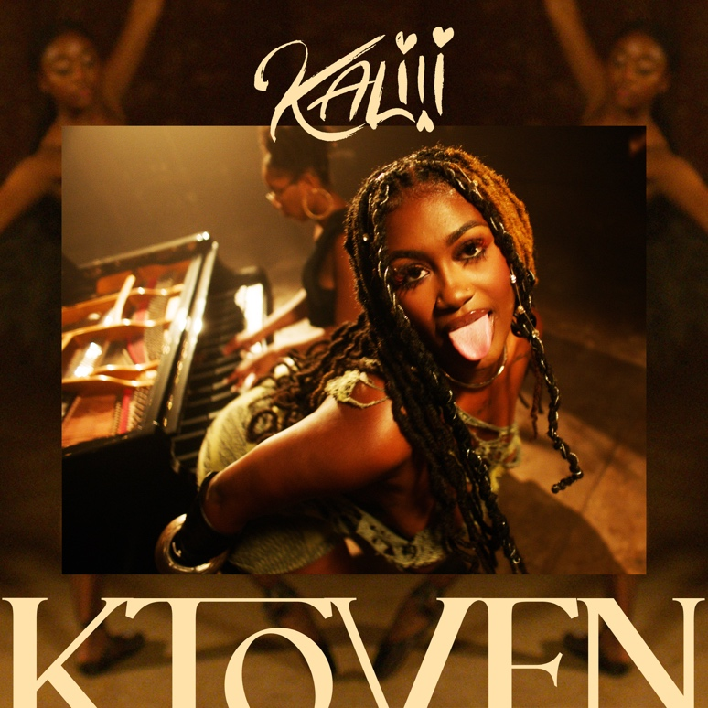
DOWNLOAD HI-RES ARTWORK

CONNECT WITH KALIII
TIKTOK | TWITTER | INSTAGRAM | FACEBOOK | YOUTUBE
PRESS CONTACT
Ariana White | Ariana.White@AtlanticRecords.com

