FOR IMMEDIATE RELEASE
JUNE 30, 2023

THAT KALIII REIGN JUST WON’T LET UP WITH RELEASE OF EP
TOXIC CHOCOLATE: AREA CODES EDITION

COMES ON THE HEELS OF KALIII’S EXPLOSIVE BET AWARDS PERFORMANCE

RECENTLY NAMED BILLBOARD’S ‘ROOKIE OF THE MONTH’ FOR JUNE

FOLLOW-UP TO THE VISUAL FOR THE “AREA CODES (718 REMIX)”
AND AREA CODES: THE REMIXES

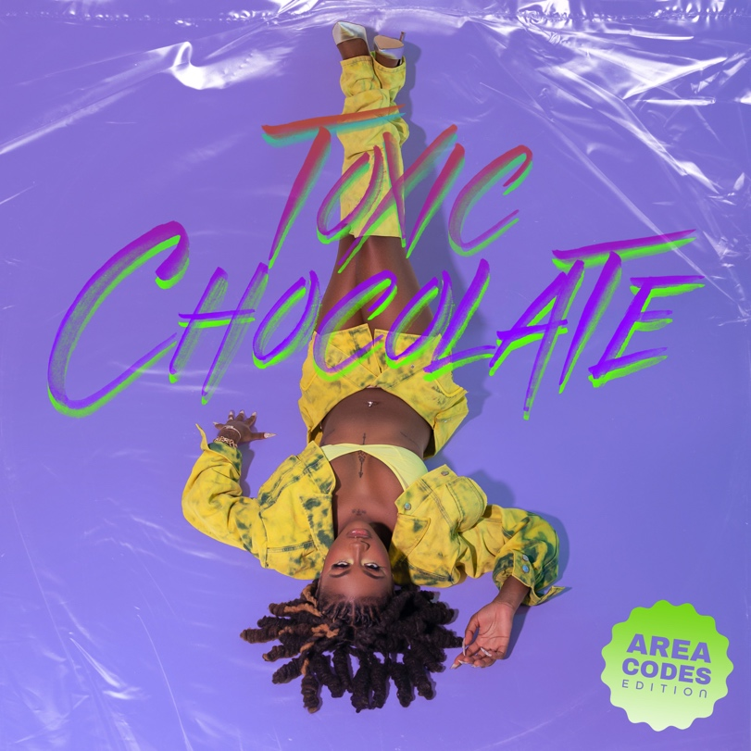
DOWNLOAD HI-RES ARTWORK
STREAM HERE

Coming off the success of “Area Codes,” Kaliii returns with the release of her EP, Toxic Chocolate: Area Codes Edition. The release of the EP comes on the heels of the visual for “Area Codes (718 Remix) feat. Kenzo B.” The visual was accompanied by the release of the Area Codes: The Remixes featuring all five remixes and the Billboard charting original. The original “Area Codes” peaked at #33 on the Billboard Hot 100, #5 on the Hot Rap Songs, and #10 on the Hot R&B/Hip-Hop Songs charts.

Toxic Chocolate was originally released last May and spawned hits like “UonU (Feat. Yung Bleu)“ and “Standards.” After the release of the highly acclaimed EP, Kaliii was included in the 2022 XXL Freshman Class and supported by her cypher and freestyle performances. Most recently, Kaliii has stayed quite active as her viral hit ascends; she was named Billboard’s ‘Rookie of the Month’ for June and she shut down the BET Amplified Stage at the 2023 BET Awards this past Sunday.

TOXIC CHOCOLATE: AREA CODES EDITION TRACKLIST
Area Codes
Standards
Mmm Mmm
Eat It Up
Ms. Lick Back
Toxic Chocolate
Do A Bitch
New Day
UonU
Mmm Mmm (Remix)
Where They At (Snippet)

# # #

ABOUT KALIII
Kaliii’s had a landmark year with 2022. After the release of her highly acclaimed EP Toxic Chocolate, Kaliii was admitted into the XXL 2022 Freshman Class. This momentous, career-defining feat was supported by her thrilling freestyle and cypher performances streaming now. She continued her run with the release of the singles “FNF (Freestyle)” and “Wet” with each visual at over a combined 1M views via YouTube. Toxic Chocolate – available now at all DSPs and streaming services – arrived earlier in 2022 amidst both popular and critical acclaim, with Hot New Hip Hop simply declaring her “Rap's Next ‘It’ Girl.” The EP is highlighted by the incendiary singles, “UonU (Feat. Yung Bleu)“ and “Standards,” the latter of which had its exclusive premiere – alongside Kaliii’s debut interview – on Apple Music’s New Music Daily Radio with Zane Lowe. Kaliii then increased the power of Toxic Chocolate with the surprise addition of the fan favorite “Chainzzz (Feat. Muni Long)” as well as a revised sequence.

The arrival of Toxic Chocolate was further joined by an electrifying performance of the EP standout, “New Day,” filmed exclusively for UPROXX Sessions and streaming now HERE. UPROXX further praised Kaliii for “her gift for wordplay and her spicy relationship sensibilities,” adding, “(Kaliii) turns the tables on the f*ckboys of hip-hop, using their manipulative tactics to even the odds and give them a taste of their own medicine.” After raking in over 100 million streams and receiving praise from Nylon, HIGHSNOBIETY, XXL, Essence, Complex, Brooklyn Vegan, Kaliii is ready to take her career to new heights with a new love, new music, and a new focus. The rapstress followed up the EP with a flurry of singles and freestyles including “Wet” and “Bout U.” Kaliii kicked off 2023 with her explosive viral hit “Area Codes” which has now spawned several regional remixes. The remixes are a part of Kaliii’s #ToxicThursday release series and have thus far included New York’s Kenzo B on the “718 Remix,” The Bay Area’s Lil Kayla on the “415 Remix,” St. Louis’s Sexyy Red on the “314 Remix,” and Tallahassee’s Luh Tyler on the “850 Remix.” She followed up by releasing the remixes as a combined pack aptly titled, Area Codes: The Remixes and a visual for “Area Codes (718 Remix)” featuring Kenzo B.

CONNECT WITH KALIII
TIKTOK | TWITTER | INSTAGRAM | FACEBOOK | YOUTUBE
PRESS CONTACT
Ariana White | Ariana.White@AtlanticRecords.com

