LIL UZI VERT ANNOUNCES HIGHLY ANTICIPATED
PINK TAPE TOUR

Tickets On Sale Today at 2pm Local at Ticketmaster.com

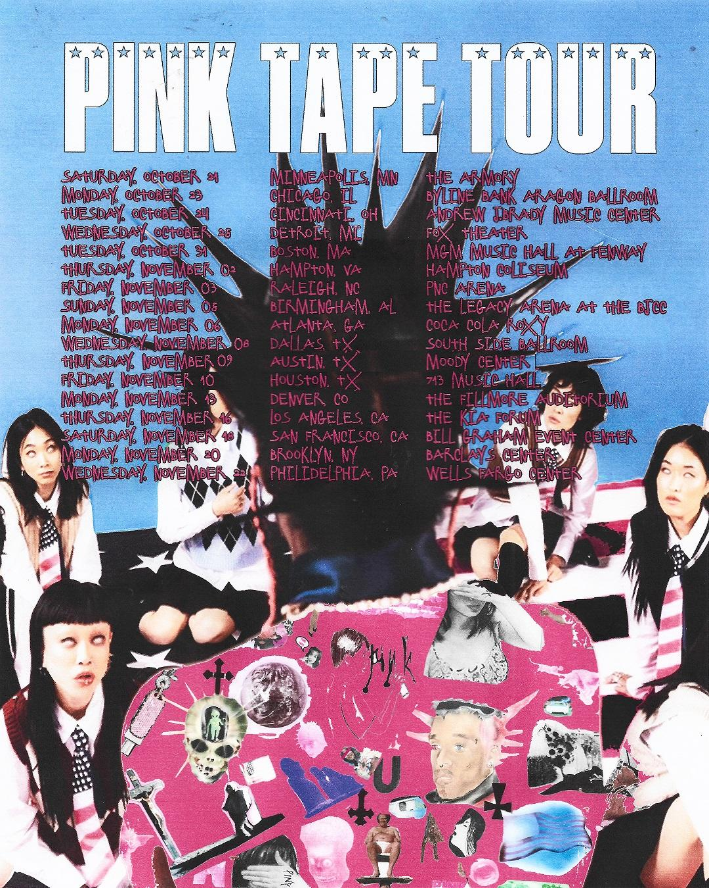

For approved artist images and hi-res tour art, please download HERE.

Today, Grammy-nominated artist Lil Uzi Vert announced their highly anticipated PINK TAPE TOUR headline tour. Produced by Live Nation, the 17-date tour kicks off on Saturday, October 21 in Minneapolis at The Armory, with stops in Chicago, Houston, Los Angeles and more before wrapping up on Wednesday, November 22 in Philadelphia at Wells Fargo Center.

TICKETS: Tickets will be available starting with the general on-sale beginning today at 2 PM local time at ticketmaster.com.

The tour marks the Philadelphia native’s first headlining tour since 2018, when they hit 32 cities as part of the “Endless Summer Tour.”

The tour announcement comes on the heels of Uzi’s most recent album, Pink Tape, released June 30, 2023. Last year, they also unleashed their widely popular track “Just Wanna Rock” as well as their Red & White EP which included standout songs such as “For Fun,” “I Know,” and more.

Most recently, Uzi opened the 2023 BET Awards with an electrifying performance of “Spin Again” and “Just Wanna Rock” from Pink Tape. Earlier this year, they delivered dazzling performances at a wide array of national platforms, from the 2023 Grammys to Wrestlemania 39 to The Tonight Show Starring Jimmy Fallon.

LIL UZI VERT 2023 TOUR DATES:
Sat Oct 21 — Minneapolis, MN — The Armory
Mon Oct 23 — Chicago, IL — Byline Bank Aragon Ballroom
Tue Oct 24 — Cincinnati, OH — The Andrew J Brady Music Center
Wed Oct 25 — Detroit, MI — Fox Theatre
Tue Oct 31 — Boston, MA — MGM Music Hall at Fenway
Thu Nov 02 — Hampton, VA — Hampton Coliseum
Fri Nov 03 — Raleigh, NC — PNC Arena
Sun Nov 05 — Birmingham, AL — Avondale Brewing Company
Mon Nov 06 — Atlanta, GA — Coca Cola Roxy
Wed Nov 08 — Dallas, TX — South Side Ballroom
Thu Nov 9 — Austin, TX — Moody Center
Fri Nov 10 — Houston, TX — 713 Music Hall
Mon Nov 13 — Denver, CO — Fillmore Auditorium
Thu Nov 16 — Los Angeles, CA — The Kia Forum
Sat Nov 18 — San Francisco, CA — Bill Graham Civic Auditorium
Mon Nov 20 — Brooklyn, NY — Barclays Center
Wed Nov 22 — Philadelphia, PA — Wells Fargo Center

About Lil Uzi Vert
In addition to Lil Uzi Vert’s 2018 Grammy nomination as “Best New Artist,” the artist also received the “Breakout Artist of the Year Award” and the “Breakthrough Artist” award during Billboard’s 2017 Touring Awards. The rap superstar has also been featured on several record-breaking tracks including Travis Scotts’ RIAA 3X platinum certified “Wasted” featuring Kanye West, the RIAA gold certified single with Future “Drankin and Smokin” and Lil Baby’s RIAA platinum certified “Commercial” single to name a few. In 2020, Uzi dropped the deluxe edition of the long-awaited release, Eternal Atake, which includes part two of the album, titled LUV vs. The World 2, reaching #1 on the Billboard 200. Eternal Atake would go on to gain RIAA Platinum certification and was nominated for favorite rap/hip hop album at the 2020 American Music Awards. Immediately following these projects, Uzi and Future released both Pluto x Baby Pluto and the deluxe version in the same year. The Eternal Atake would go on to peak at #2 on Billboard 200 and features the notable singles “Patek” and “Over Your Head.” Uzi made his 2022 return a strong one with a flood of national festival performances and the release of the EP Red & White.

Facebook // Twitter // Instagram // YouTube // Website

About Live Nation Entertainment
Live Nation Entertainment (NYSE: LYV) is the world’s leading live entertainment company comprised of global market leaders: Ticketmaster, Live Nation Concerts, and Live Nation Sponsorship. For additional information, visit www.livenationentertainment.com.

MEDIA CONTACTS:

Lil Uzi Vert
Jana Fleishman | janaf@rocnation.com
Didier Morais | didier@vitalversatility.com
Jason Davis | jasondavis@atlanticrecords.com

Live Nation Concerts
Monique Sowinski | moniquesowinski@livenation.com
Maya Sarin | mayasarin@livenation.com

To apply for media credentials for show coverage:
livenation.com/pressrequests

