LIL UZI VERT’S ‘PINK TAPE’ BECOMES THE FIRST RAP ALBUM IN 2023 TO TOP BILLBOARD’S “TOP 200 ALBUMS” CHART

LATEST ALBUM DEBUT FROM GLOBAL PHENOM ALSO BECOMES:
- LARGEST RAP ALBUM DEBUT OF 2023
- THIRD LARGEST OVERALL ALBUM DEBUT OF 2023

18 SONGS FROM ‘PINK TAPE’ DEBUT ON THE BILLBOARD HOT 100 THIS WEEK MAKING UZI THE
14TH ARTIST IN CHART HISTORY TO TALLY 100+ CAREER HOT 100 CHARTED SONGS

‘PINK TAPE’ ALSO TOPS BILLBOARD’S “TOP RAP ALBUMS” & “TOP R&B/HIP-HOP ALBUMS” CHARTS

FIRST WEEK DEBUT MARKS UZI’S THIRD #1 ALBUM DEBUT

SET TO HIT THE ROAD FOR ANTICIPATED “PINK TAPE TOUR”
KICKING OFF OCTOBER 21 IN MINNEAPOLIS, MN

TICKETS AVAILABLE HERE

DOWNLOAD/STREAM ‘PINK TAPE’

WATCH ‘PINK TAPE’ ALBUM TRAILER
Directed by Gibson Hazard

“Long-awaited Pink Tape finds an artist still relentlessly barreling forward, leaving everyone in the dust…” – ROLLING STONE

“…gargantuan new album that refuses to pick one sonic lane. Uzi revels in disparate production techniques and daring stylistic choices…” – BILLBOARD

“The album, which also went live at midnight, is nuts. It’s fucking insane. Pink Tape is a masterpiece.” – STEREOGUM

“…expand their sonic horizons to a space that is comfortable yet still innovating.” – HYPEBEAST

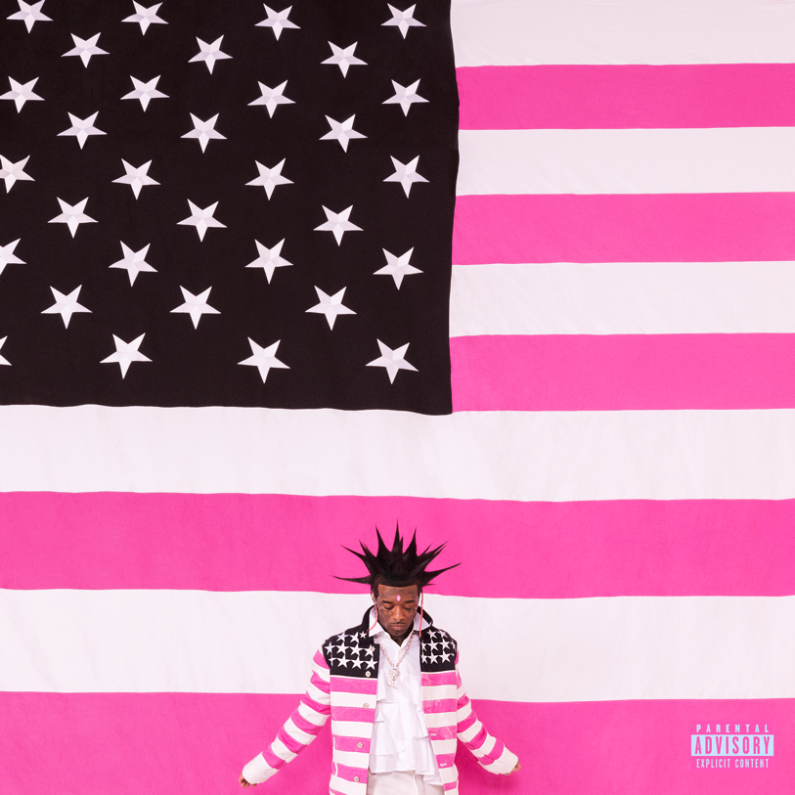

About Lil Uzi Vert
In addition to Lil Uzi Vert’s 2018 Grammy nomination as “Best New Artist,” the artist also received the “Breakout Artist of the Year Award” and the “Breakthrough Artist” award during Billboard’s 2017 Touring Awards. The rap superstar has also been featured on several record-breaking tracks including Travis Scotts’ RIAA 3X platinum certified “Wasted” featuring Kanye West, the RIAA gold certified single with Future “Drankin and Smokin” and Lil Baby’s RIAA platinum certified “Commercial” single to name a few. In 2020, Uzi dropped the deluxe edition of the long-awaited release, Eternal Atake, which includes part two of the album, titled LUV vs. The World 2, reaching #1 on the Billboard 200. Eternal Atake would go on to gain RIAA Platinum certification and was nominated for favorite rap/hip hop album at the 2020 American Music Awards. Immediately following these projects, Uzi and Future released both Pluto x Baby Pluto and the deluxe version in the same year. The Eternal Atake would go on to peak at #2 on Billboard 200 and features the notable singles “Patek” and “Over Your Head.” Uzi made his 2022 return a strong one with a flood of national festival performances and the release of the EP Red & White.

# # #

For Lil Uzi Vert press inquiries, please contact:
Jason Davis (Atlantic Records) – jason.davis@atlanticrecords.com
Jana Fleishman (Roc Nation) – JanaF@rocnation.com

