2x GRAMMY® AWARD-WINNING MULTI-PLATINUM ARTIST
LAUREN DAIGLE
ANNOUNCES SUPPORT FOR FALL 2023
KALEIDOSCOPE TOUR

BRANDON LAKE, CROWDER, JOSH GARRELS & VICTORY BOYD
TO JOIN SELECT DATES

COMPLETE 23-TRACK ALBUM
LAUREN DAIGLE
SET FOR SEPTEMBER 8, 2023 RELEASE
VIA ATLANTIC RECORDS/CENTRICITY MUSIC

DAIGLE TO PERFORM CHART-TOPPING HIT SINGLE
“THANK GOD I DO”
THIS MORNING, JULY 11
ON LIVE WITH KELLY AND MARK

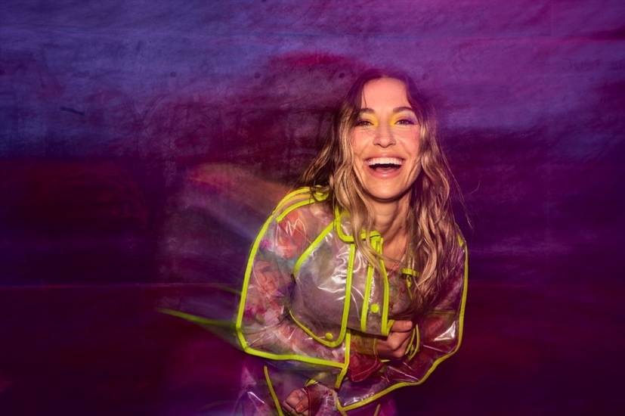
Download Hi-Res HERE | Photo Credit: Jeremy Cowart

“…one of the best singers in contemporary pop.” – VARIETY

“…filled with songs that highlight her brand of personal pop and soulful roots.” – BILLBOARD

“The second half of Lauren Daigle is set to be released this fall. The 10 tracks on the first part of the project provide such a holistic portrait of the singer/songwriter that it is hard to imagine she could have much more to reveal, but the forthcoming release promises even more insight into Daigle’s new sonic territory.” – AMERICAN SONGWRITER

Today, two-time GRAMMY® Award-winning singer-songwriter Lauren Daigle announces support for The Kaleidoscope Tour, the multi-faceted artist’s highly-anticipated fall US arena tour. Brandon Lake, Crowder, Josh Garrels, and Victory Boyd will join Daigle, as she traverses the country from New Jersey’s Prudential Center to LA’s Crypto.com Arena, with stops in Boston, Atlanta, Seattle, Baton Rouge, and many more cities in between.

Later today, at 4pm ET, Daigle will host an Instagram Live with Crowder, Lake, Garrels, and Boyd, discussing the forthcoming tour.

The Kaleidoscope Tour will kick off on September 6 in Memphis, TN. Tickets are on sale at www.laurendaigle.com, and all upcoming dates are enclosed below, with corresponding support acts noted.

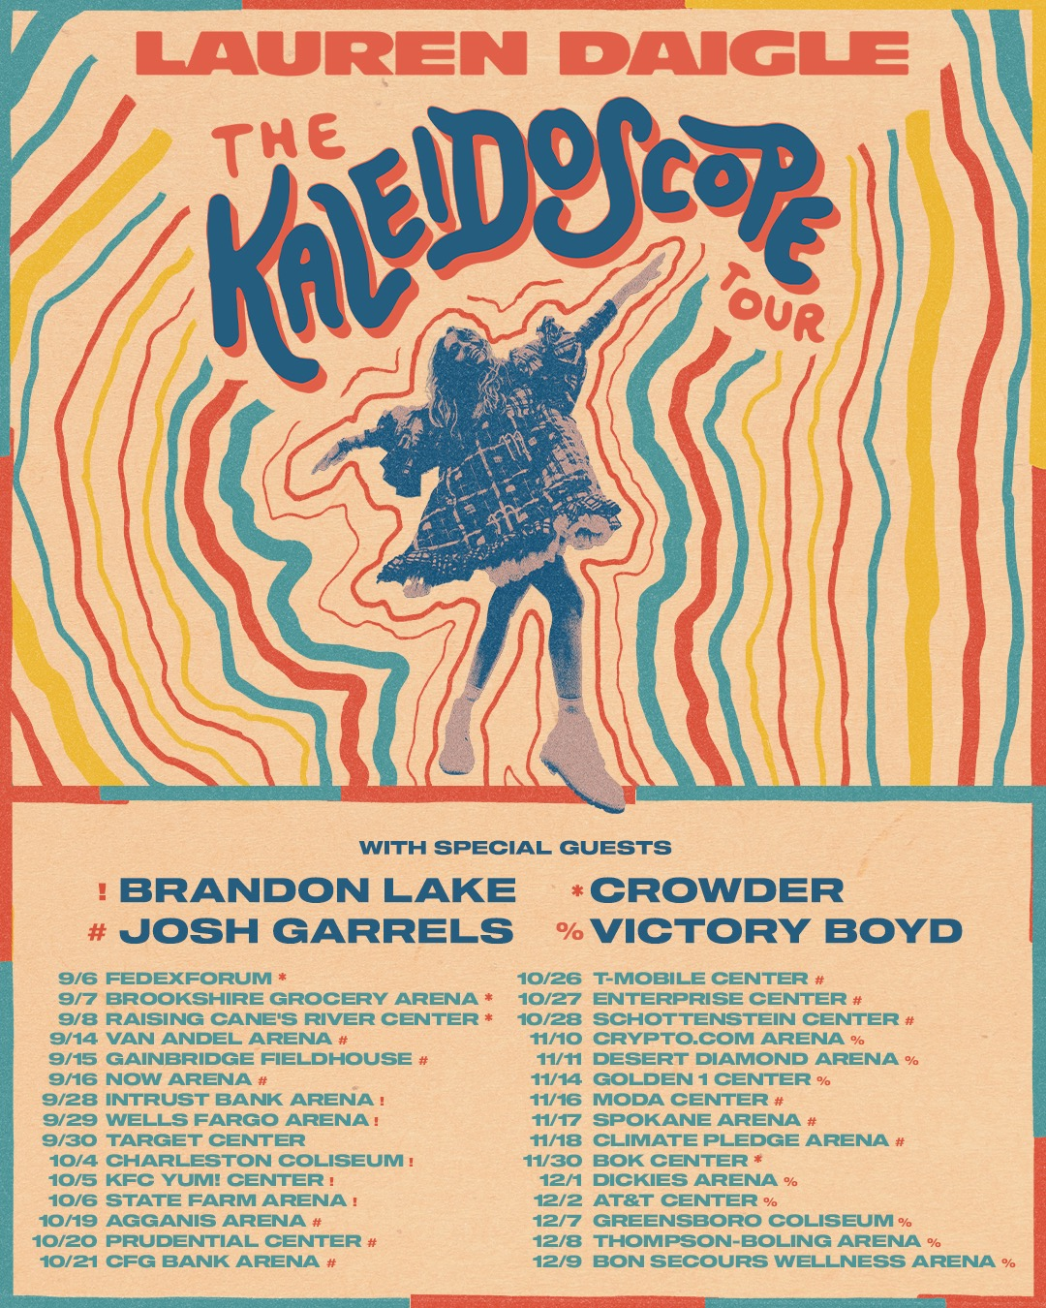
Download Hi-Res Admat HERE

Just yesterday, Daigle was presented with a ‘1 Billion Streams’ plaque by Pandora’s NYC office, as she visits the city to perform her chart-topping single, “Thank God I Do,” on this morning’s episode of Live with Kelly and Mark (check local listings).

“Thank God I Do” is currently a Billboard #1 single, Top 15 at Hot AC Radio, and Top 10 at AC Radio, where it continues to rise.

Daigle’s complete 23-track, self-titled album, Lauren Daigle is due out Friday, September 8, 2023 via Atlantic Records/Centricity Music. The project showcases her stunning and powerful voice, rich storytelling, and incredible musicality, and includes standout songs “Salvation Mountain,” featuring Gary Clark Jr., as well as “Be Okay,” which was written with Ellie Holcomb and will be released ahead of the album on August 4.

Says Daigle:

“In May, I released the first 10 songs from my self-titled album. It had been a while since I had put out new music, so I wanted to share these songs as soon as they were ready to go. This is just the beginning of the journey to the complete story of the 23-song album, which I am excited to announce is coming out September 8. These 23 tracks represent all that I am – they embody my soul and my spirit. I can’t wait for you all to hear them.”

Download Hi-Res Album Artwork HERE

LAUREN DAIGLE: Tracklist

- Thank God I Do
- Saint Ferdinand (feat. Jon Batiste and Natalie Hemby)
- New
- Waiting
- To Know Me
- Kaleidoscope Jesus
- Valuable
- Don’t Believe Them
- Ego
- These Are The Days
- Salvation Mountain (feat. Gary Clark Jr.)
- Back To Me
- 21 Days
- Love Me Still
- Interlude #1
- Turbulent Skies
- Sometimes
- Interlude #2
- Inherited
- He’s Never Gunna
- Be Okay
- Interlude #3
- You’re All I’ll Take With Me

Led by GRAMMY®-winning producer Mike Elizondo (Twenty One Pilots, Mary J. Blige, Fiona Apple, Carrie Underwood) and featuring co-writes with award-winning songwriters, including Natalie Hemby, Amy Wadge, Shane McAnally, Jason Ingram, Lori McKenna, and Jon Greene, Lauren Daigle marks a new creative chapter for the Louisiana-born artist.

Daigle shared the album’s first 10 songs in May to immediate critical acclaim from the likes of Billboard, The Tennessean, and Variety, the latter of whom declared her “one of the best singers in contemporary pop.”

Also in May, Daigle performed soulful cut “These Are The Days” live on the season finale of American Idol, before joining season 21’s runner-up Megan Danielle for a powerful rendition of current single, “Thank God I Do” (watch HERE).

***

With over a billion streams and years of sold-out US and international tours to her name, Lauren Daigle continues to cement her status as a modern vocal powerhouse with a global, ever-growing fanbase.

Since the release of her GRAMMY® Award-winning, platinum-certified 2018 album Look Up Child – which includes the breakthrough, newly-6x platinum-certified hit single “You Say” – Daigle has been a mainstay on the Billboard charts. When Look Up Child debuted at No. 3 on the Top 200 Albums chart, Daigle became the first female artist in history to simultaneously hit the Top 10 on both Billboard’s Pop and Christian Album charts. She went on to break another record when the LP reached 100 weeks at No. 1 on the Top Christian Albums chart, which is the greatest number of weeks that any artist has spent at the top of any individual album chart. Similarly, “You Say” is the longest-running No. 1 to appear on any weekly Billboard chart. Born in Lake Charles, Louisiana, Daigle is a two-time Grammy®, seven-time Billboard Music Award, four-time American Music Award, and ten-time GMA Dove Music Award winner.

Off stage, Daigle remains committed to investing her time to promote music education, work with at-risk youth, and provide care for children, the elderly, and those in need through The Price Fund, an organization she founded in 2018. To date, she has distributed over $2.5 million to 42 nonprofits around the world.

***

LAUREN DAIGLE: UPCOMING TOUR DATES
! Support from Brandon Lake
* Support from Crowder
# Support from Josh Garrels
% Support from Victory Boyd

DATE | MARKET | VENUE
Wed Sep 6, 2023 | Memphis, TN | FedExForum*
Thu Sep 7, 2023 | Bossier City, LA | Brookshire Grocery Arena*
Fri Sep 8, 2023 | Baton Rouge, LA | Raising Cane's River Center*
Thu Sep 14, 2023 | Grand Rapids, MI | Van Andel Arena #
Fri Sep 15, 2023 | Indianapolis, IN | Gainbridge Fieldhouse #
Sat Sep 16, 2023 | Hoffman Estates, IL | NOW Arena #
Thu Sep 28, 2023 | Wichita, KS | INTRUST Bank Arena !
Fri Sep 29, 2023 | Des Moines, IA | Wells Fargo Arena !
Sat Sep 30, 2023 | Minneapolis, MN | Target Center
Wed Oct 4, 2023 | Charleston, WV | Charleston Coliseum !
Thu Oct 5, 2023 | Louisville, KY | KFC Yum! Center !
Fri Oct 6, 2023 | Atlanta, GA | State Farm Arena !
Thu Oct 19, 2023 | Boston, MA | Agganis Arena #
Fri Oct 20, 2023 | Newark, NJ | Prudential Center #
Sat Oct 21, 2023 | Baltimore, MD | CFG Bank Arena #
Thu Oct 26, 2023 | Kansas City, MO | T-Mobile Center #
Fri Oct 27, 2023 | St. Louis, MO | Enterprise Center #
Sat Oct 28, 2023 | Columbus, OH | Schottenstein Center #
Fri Nov 10, 2023 | Los Angeles, CA | Crypto.com Arena %
Sat Nov 11, 2023 | Phoenix, AZ | Desert Diamond Arena %
Tue Nov 14, 2023 | Sacramento, CA | Golden 1 Center %
Thu Nov 16, 2023 | Portland, OR | Moda Center #
Fri Nov 17, 2023 | Spokane, WA | Spokane Arena #
Sat Nov 18, 2023 | Seattle, WA | Climate Pledge Arena #
Thu Nov 30, 2023 | Tulsa, OK | BOK Center*
Fri Dec 1, 2023 | Ft Worth, TX | Dickies Arena %
Sat Dec 2, 2023 | San Antonio, TX | AT&T Center %
Thu Dec 7, 2023 | Greensboro, NC | Greensboro Coliseum %
Fri Dec 8, 2023 | Knoxville, TN | Thompson-Boling Arena %
Sat Dec 9, 2023 | Greenville, SC | Bon Secours Wellness Arena %

CONNECT WITH LAUREN DAIGLE
Website | Facebook | Instagram | Twitter | TikTok | YouTube

For More Information, Please Contact:
Sheila Richman | Atlantic Records | Sheila.Richman@atlanticrecords.com
Katy Carmichael | Atlantic Records | Katy.Carmichael@atlanticrecords.com

Paul Freundlich | PFA Media | paulf@pfamedia.net
Alicia Krass | PFA Media | akrass@pfamedia.net
