2x GRAMMY® AWARD-WINNING MULTI-PLATINUM ARTIST
LAUREN DAIGLE
HONORED BY PANDORA WITH BILLIONAIRES PLAQUE
IN NYC THIS WEEK

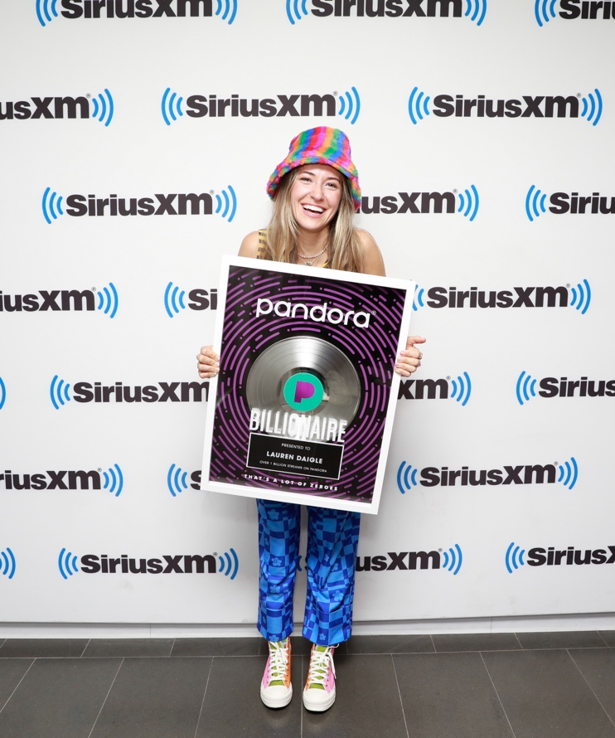
Download All Hi-Res Photos HERE (Photo Credit: Maro Hagopian)

“…one of the best singers in contemporary pop.” – VARIETY

On Monday, July 10, 2023, two-time GRAMMY® Award-winning singer-songwriter Lauren Daigle was surprised with a Billionaires Plaque from Pandora, while visiting the SiriusXM NYC studio for her exclusive performance for SiriusXM’s The Message (ch. 63). The plaque commemorates Daigle’s music having been streamed over 1 billion times on Pandora alone. Hi-res photos of the moment can be downloaded HERE (Photo Credit: Maro Hagopian).

On Tuesday, July 11, Daigle brought her chart-topping single, “Thank God I Do,” to Live with Kelly and Mark. She performed a stirring live rendition of the ballad, which is currently a Billboard #1 single, Top 15 at Hot AC Radio, and Top 10 at AC Radio, where it continues to rise.

Also this week, Daigle announced support acts for her highly-anticipated fall US arena tour, The Kaleidoscope Tour. Brandon Lake, Crowder, Josh Garrels, and Victory Boyd will join the multi-faceted artist, as she traverses the country from New Jersey’s Prudential Center to LA’s Crypto.com Arena, with stops in Boston, Atlanta, Seattle, Baton Rouge, and many more cities in between.

The Kaleidoscope Tour will kick off on September 6 in Memphis, TN. Tickets are on sale at www.laurendaigle.com.

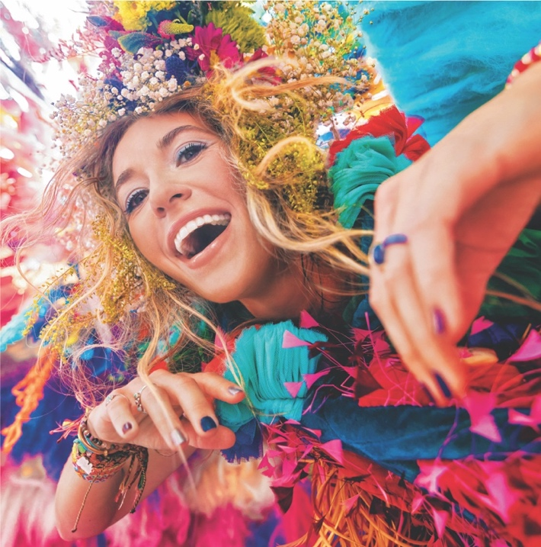
Download Hi-Res Album Artwork HERE

This fall, Daigle will release her complete 23-track, self-titled album, Lauren Daigle on Friday, September 8, 2023 via Atlantic Records/Centricity Music. The project showcases her stunning and powerful voice, rich storytelling, and incredible musicality, and includes standout songs “Salvation Mountain,” featuring Gary Clark Jr., as well as “Be Okay,” which was written with Ellie Holcomb and will be released ahead of the album on August 4.

Led by GRAMMY®-winning producer Mike Elizondo (Twenty One Pilots, Mary J. Blige, Fiona Apple, Carrie Underwood) and featuring co-writes with award-winning songwriters, including Natalie Hemby, Amy Wadge, Shane McAnally, Jason Ingram, Lori McKenna, and Jon Greene, Lauren Daigle marks a new creative chapter for the Louisiana-born artist.

Daigle shared the album’s first 10 songs in May to immediate critical acclaim from the likes of Billboard, The Tennessean, and Variety, the latter of whom declared her “one of the best singers in contemporary pop.”

***

With over a billion streams and years of sold-out US and international tours to her name, Lauren Daigle continues to cement her status as a modern vocal powerhouse with a global, ever-growing fanbase.

Since the release of her GRAMMY® Award-winning, platinum-certified 2018 album Look Up Child – which includes the breakthrough, newly-6x platinum-certified hit single “You Say” – Daigle has been a mainstay on the Billboard charts. When Look Up Child debuted at No. 3 on the Top 200 Albums chart, Daigle became the first female artist in history to simultaneously hit the Top 10 on both Billboard’s Pop and Christian Album charts. She went on to break another record when the LP reached 100 weeks at No. 1 on the Top Christian Albums chart, which is the greatest number of weeks that any artist has spent at the top of any individual album chart. Similarly, “You Say” is the longest-running No. 1 to appear on any weekly Billboard chart. Born in Lake Charles, Louisiana, Daigle is a two-time Grammy®, seven-time Billboard Music Award, four-time American Music Award, and ten-time GMA Dove Music Award winner.

Off stage, Daigle remains committed to investing her time to promote music education, work with at-risk youth, and provide care for children, the elderly, and those in need through The Price Fund, an organization she founded in 2018. To date, she has distributed over $2.5 million to 42 nonprofits around the world.

***

CONNECT WITH LAUREN DAIGLE
Website | Facebook | Instagram | Twitter | TikTok | YouTube

For More Information, Please Contact:
Sheila Richman | Atlantic Records | Sheila.Richman@atlanticrecords.com
Katy Carmichael | Atlantic Records | Katy.Carmichael@atlanticrecords.com

Paul Freundlich | PFA Media | paulf@pfamedia.net
Alicia Krass | PFA Media | akrass@pfamedia.net
