FOR IMMEDIATE RELEASE
JULY 14, 2023

R&B STAR MAHALIA RELEASES HER SECOND STUDIO ALBUM IRL

FOLLOW-UP TO PREVIOUSLY SINGLES AND VISUALS “READY,” “CHEAT,” AND
“TERMS & CONDITIONS”

IN REAL LIFE TOUR KICKS OFF OCTOBER 8 IN LEEDS, UK

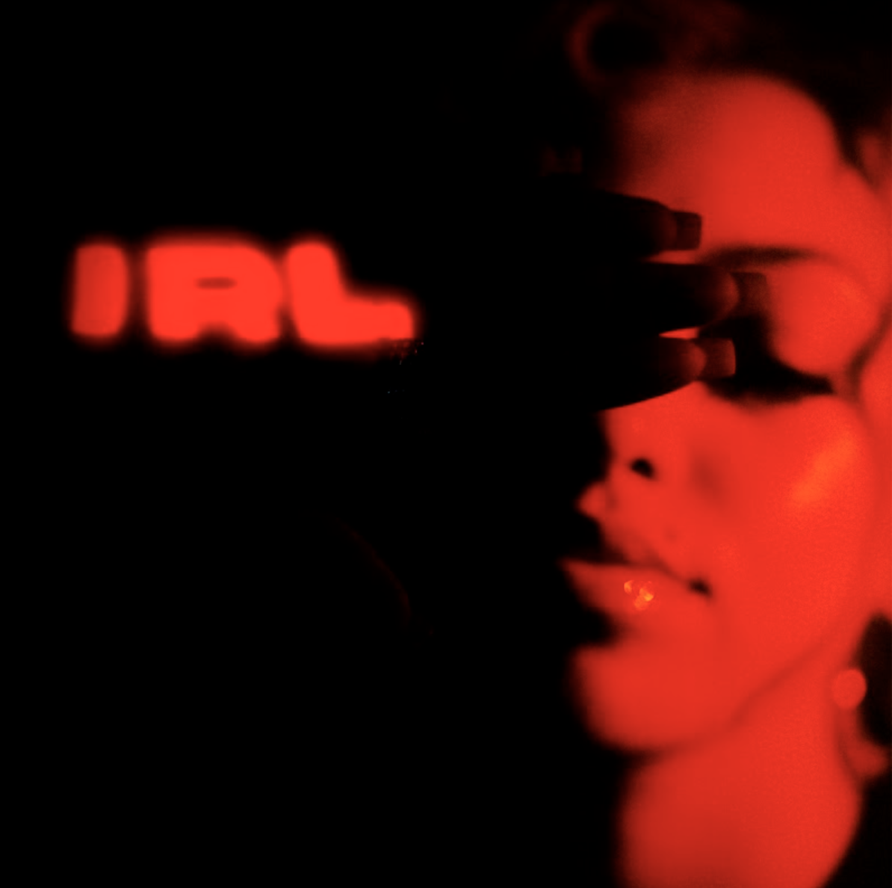
STREAM HERE

British musician Mahalia has released her highly anticipated second album, IRL. Through her new record, the BRIT and GRAMMY nominated artist has delivered a beautiful classic; effortlessly condensing any number of disparate styles and genres into music that thrillingly broaches any gap between Pop, Soul, and R&B. A bold, brave, and courageous leap forward from her debut album Love and Compromise - IRL is an album that speaks to the musical and emotional era of where Mahalia is now, and how she got here.

Including 9 brand-new, unheard tracks, the album also includes previously released singles “Terms & Conditions,” “Ready,” and “Cheat featuring pop powerhouse JoJo. An array of incredible musicians are also scattered throughout the record, including vocal appearances from the likes of Stormzy, Joyce Wrice, Destin Conrad, Kojey Radical, and more - all of which are listed here.

In addition to releasing her new album, Mahalia also announced a huge UK and European Tour for the end of 2023. The In Real Life Tour begins in Leeds on October 8th and concludes in Berlin on November 7th. The UK leg also includes a stop at London’s prestigious Eventim Apollo (FKA Hammersmith Apollo) on October 19th. Tickets are available to purchase via www.mahaliamusic.com.

In the world of music, there are shining beacons of light – artists, producers, musicians – that make us happy listeners and effortlessly provide us with inspiration. One of those UK artists is undoubtedly Mahalia. Her debut album Love and Compromise landed in the summer of 2019 and soon became a critically acclaimed introduction. Through her music, she effortlessly weaves soul, contemporary R&B, and 70s in one intoxicating concoction. Passionate in her commitment to a heartfelt display of emotion, she combats the current trend in music of toxicity in this terrain and calls for a balance in perspectives. As a result, Mahalia says that “[This culture] has not allowed people to feel all-encompassing, suffocating emotions.” Throughout her 2022 release, “Bag Of You,” she even apologizes for her neediness, but still battles through her conflictions to be transparent, admitting she wants her lover all to herself. In her head, Mahalia wants to make her fans feel the way that older generation of lovers made her feel. Citing Bonnie Raitt’s “I Can’t Make You Love Me,” as well as Anthony Hamilton’s “Charlene” as exemplary love staples.

Emboldened by her inflections, insights, and young adulthood, Mahalia is not only breaking the mold on her second album but determined to live life cognizantly. “This is a real reflection of the journeys I've had, what actually happened, and a celebration of everyone who got me there. There are names and family members I mention because it all helped in shaping who I am,” Mahalia rationalizes. With an innocent, yet assured gleam appearing on her face, “I’m so proud of this album, and so proud of how much I challenged myself to just let those stories out.”

The last few years have marked many achievements for the Leicester-born star. Beginning 2020 with her second BRIT nomination, Mahalia featured on up-and-coming fellow Midlands rapper Pa Salieu’s debut mixtape, ‘Send Them To Coventry’, whilst also gracing the track list of Headie One’s #1 album ‘Edna’. Subsequently, Mahalia also received a GRAMMY nomination for ‘All I Need’ - Jacob Collier’s single of which she features alongside US rapper, Ty Dolla $ign. Shortly after, Mahalia concluded the year with three MOBO nominations for ‘Best Female Act’, ‘Best R&B/Soul Act’ and ‘Album Of The Year’ for her debut album, ‘Love and Compromise’, winning in the first two categories. In 2021, Mahalia was also nominated for her first ever Ivor Novello award for her 2020 collaboration with UK lyricist Pa Salieu for his single ‘Energy’ and subsequently concluded the year with an incredible headline show at London’s prestigious venue, O2 Brixton Academy. Adding to her long list of achievements Mahalia opened for Adele at her 2022 BST shows in Hyde Park last Summer whilst also joining Alicia Keys during her o2 Arena shows in London - she then concluded the year on a high, winning her third MOBO Award for Best R&B/Soul Act.

Besides the awards and nominations, it’s also been a time of deep personal growth, one that Mahalia describes as a real rollercoaster in her personal and professional life. Reflection has been the thread running through Mahalia’s writing and the singer hopes that her music will encourage her listeners to carve out time to also look back and re-evaluate: “We’re all fixated on how we can make ourselves better but I want people to also reminisce on lovely or painful situations they’ve lived through and how they’ve helped shape the people they are now.”

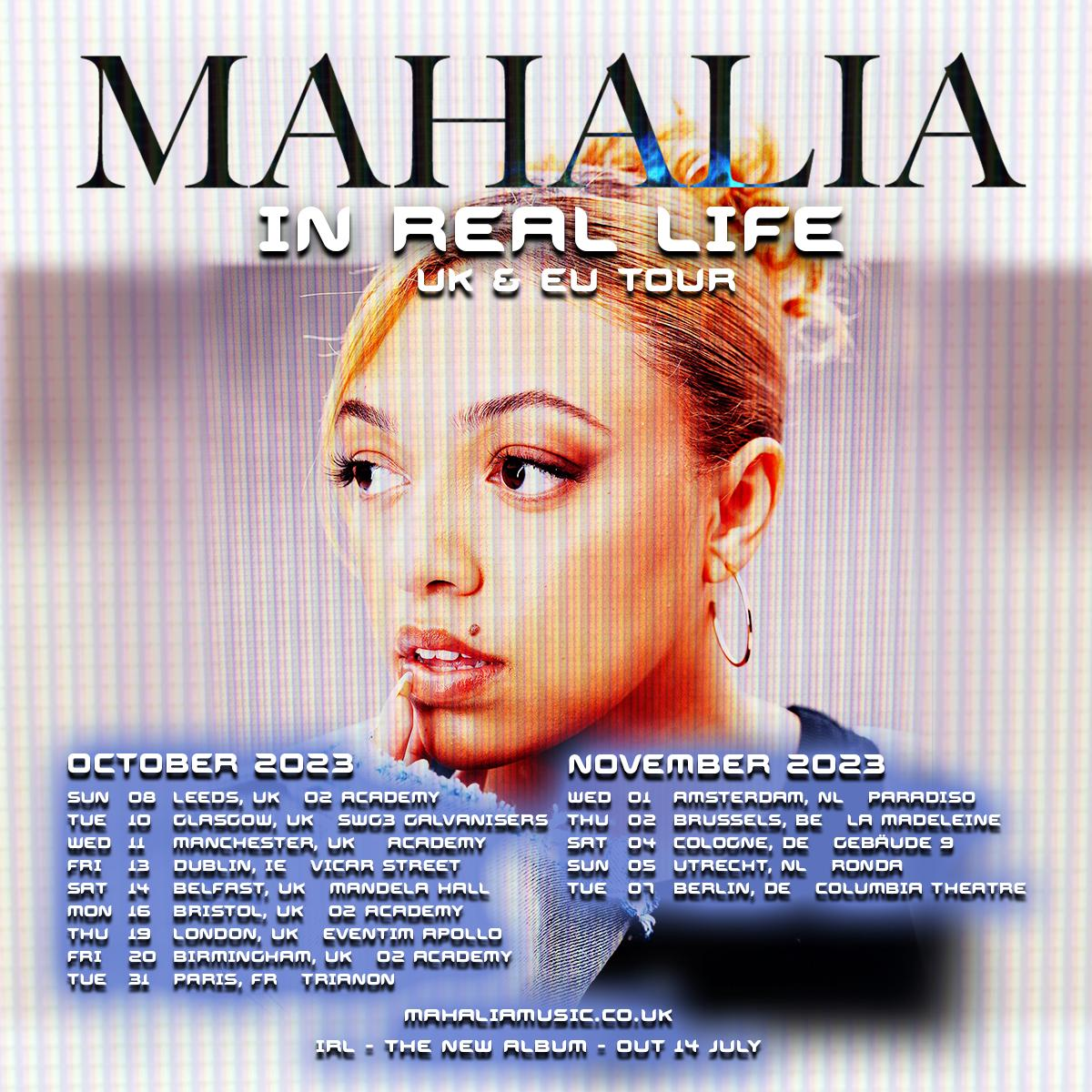

IN REAL LIFE – UK & EUROPE TOUR

October 2023
Sun 08 – Leeds – O2 Academy
Tue 10 – Glasgow – SWG3 Galvanisers
Wed 11 – Manchester – Academy
Fri 13 – Dublin – Vicar Street
Sat 14 – Belfast – Mandela Hall
Mon 16 – Bristol – O2 Academy
Thu 19 – London - Eventim Apollo
Fri 20 – Birmingham – O2 Academy
Tue 31 – Paris, FR – Trianon

November 2023
Wed 1 – Amsterdam, NL – Paradiso
Thu 2 – Brussels, BE – La Madeleine
Sat 4 – Cologne, GE – Gebäude 9
Sun 5 – Utrecht, NL – Ronda
Tue 7 – Berlin, GE – Columbia Theatre

# # #

CONNECT WITH MAHALIA
OFFICIAL WEBSITE | TWITTER | FACEBOOK | INSTAGRAM

PRESS CONTACT
ARIANA WHITE | ARIANA.WHITE@ATLANTICRECORDS.COM

