MASON RAMSEY RELEASES NEW SINGLE “REASONS TO COME HOME”

DOWNLOAD/STREAM

FIRST SINGLE FROM FORTHCOMING EP ARRIVES TODAY ALONGSIDE OFFICIAL MUSIC VIDEO

WATCH HERE

“‘Reasons To Come Home’ is a very special song to me. It’s all about my amazing grandparents, who raised me and are my only ties to my hometown of Golconda, IL. While the song is a love letter to Golconda and all the things I love there, it’s also a realization that when my grandparents are gone, I sadly won’t have any reason to go back to Golconda.”

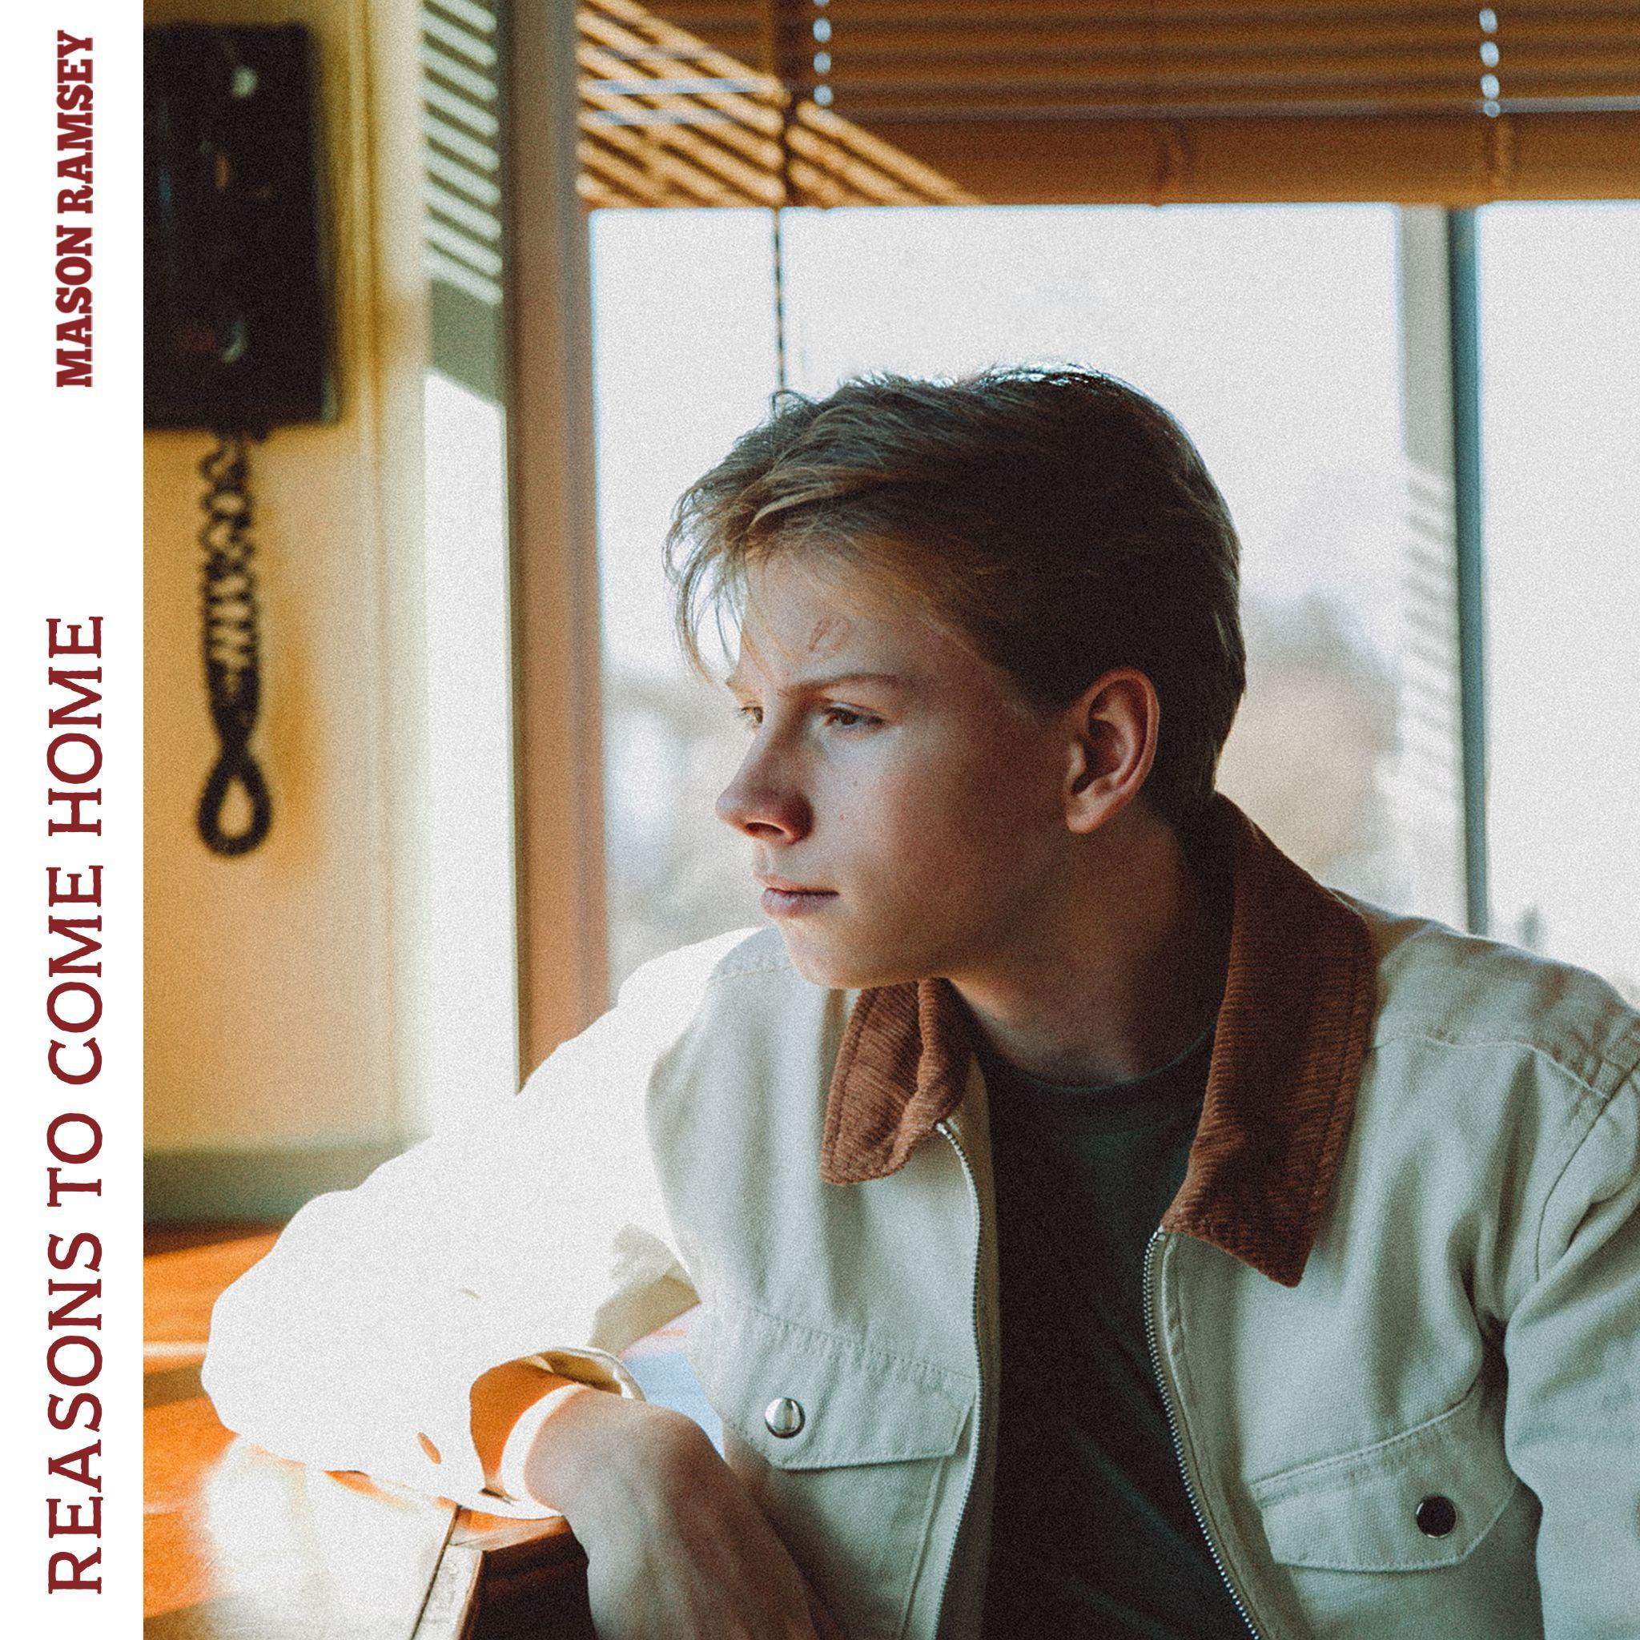
(DOWNLOAD HI-RES ARTWORK + PHOTOS)

(NEW YORK, NY – June 30, 2023) – 16-year-old country phenom, Mason Ramsey returns with “Reasons To Come Home,” out today via Atlantic Records: DOWNLOAD/STREAM HERE. The song – which is the singer’s first new release since 2019 – arrives alongside an official music video directed by Kaiser Cunningham and Taylor Kelly: WATCH HERE.

“Over the past couple of years, everything changed, and I’ve grown up. I’m allowing the fans to get to know me a little bit more and see what life has been like.”

Last year, Ramsey released an official music video for “Before I Knew It,” directed by Luke Harvey. “Before I Knew It,” went viral on TikTok amassing 550K creates and 3 billion views on the platform, over 2.7 million on the song’s visualizer, and over 30 million streams, to date. The song comes off Ramsey’s 2019 project, TWANG EP. Ramsey then hit the road on his sold out “HOW’S UR GIRL & HOW’S UR FAMILY TOUR” tour and took the stage with Lil Nas X, Billy Ray Cyrus and BTS at the 62nd Annual Grammy Awards to perform their record breaking collab “Old Town Road.”

* * *

ABOUT MASON RAMSEY
As the youngest major label Country artist signed in the genre in nearly two decades, MASON RAMSEY continues his fast-track to stardom after being discovered singing in an aisle at his local Walmart. Ramsey’s music illustrates how far he’s come – the differences prove instantly apparent as his voice booms with the kind of confidence only gained through experience and his songwriting brims with unfiltered truth buoyed by intimate creativity.

Praised by THE NEW YORK TIMES as delivering "a stylistically diverse country and roots music EP,” the ATLANTIC RECORDS artist’s debut FAMOUS EP (Atlantic Records/Big Loud Records) spawned a hit single of the same name which scored a #4 spot on Billboard’s Hot Country Songs Chart. In addition to making his debut at the famed Grand Ole Opry, the Golconda, IL-bred phenom has also performed at several high-profile festivals including CMA FEST, iHEARTCOUNTRY FESTIVAL, STAGECOACH, and COACHELLA, with high profiled TV performances on THE ELLEN DEGENERES SHOW and THE TODAY SHOW.

(Credit - Krista Johnson; DOWNLOAD HI-RES ARTWORK + PHOTOS)

Connect with Mason Ramsey:
INSTAGRAM | TWITTER | FACEBOOK | TIKTOK
For all Mason Ramsey press inquiries, please contact:
Jason Davis (Atlantic Records) – Jason.Davis@atlanticrecords.com
Jensen Sussman (Sweet Talk Publicity) – Jensen@sweettalkpr.com
Julianne Cassidy (Sweet Talk Publicity) – jcassidy@sweettalkpr.com

# # #

