FOR IMMEDIATE RELEASE
JUNE 29, 2023

RIAA PLATINUM CERTIFIED SINGER-SONGWRITER MATT MAESON
SHARES “GET HAPPY”

DOWNLOAD/STREAM HERE

CONTINUES INTIMATE THATS MY CUE HEADLINE SOLO TOUR TREK

INCLUDING NEWLY ANNOUNCED STOP AT NASHVILLE’S RYMAN AUDITORIUM ON 8/26

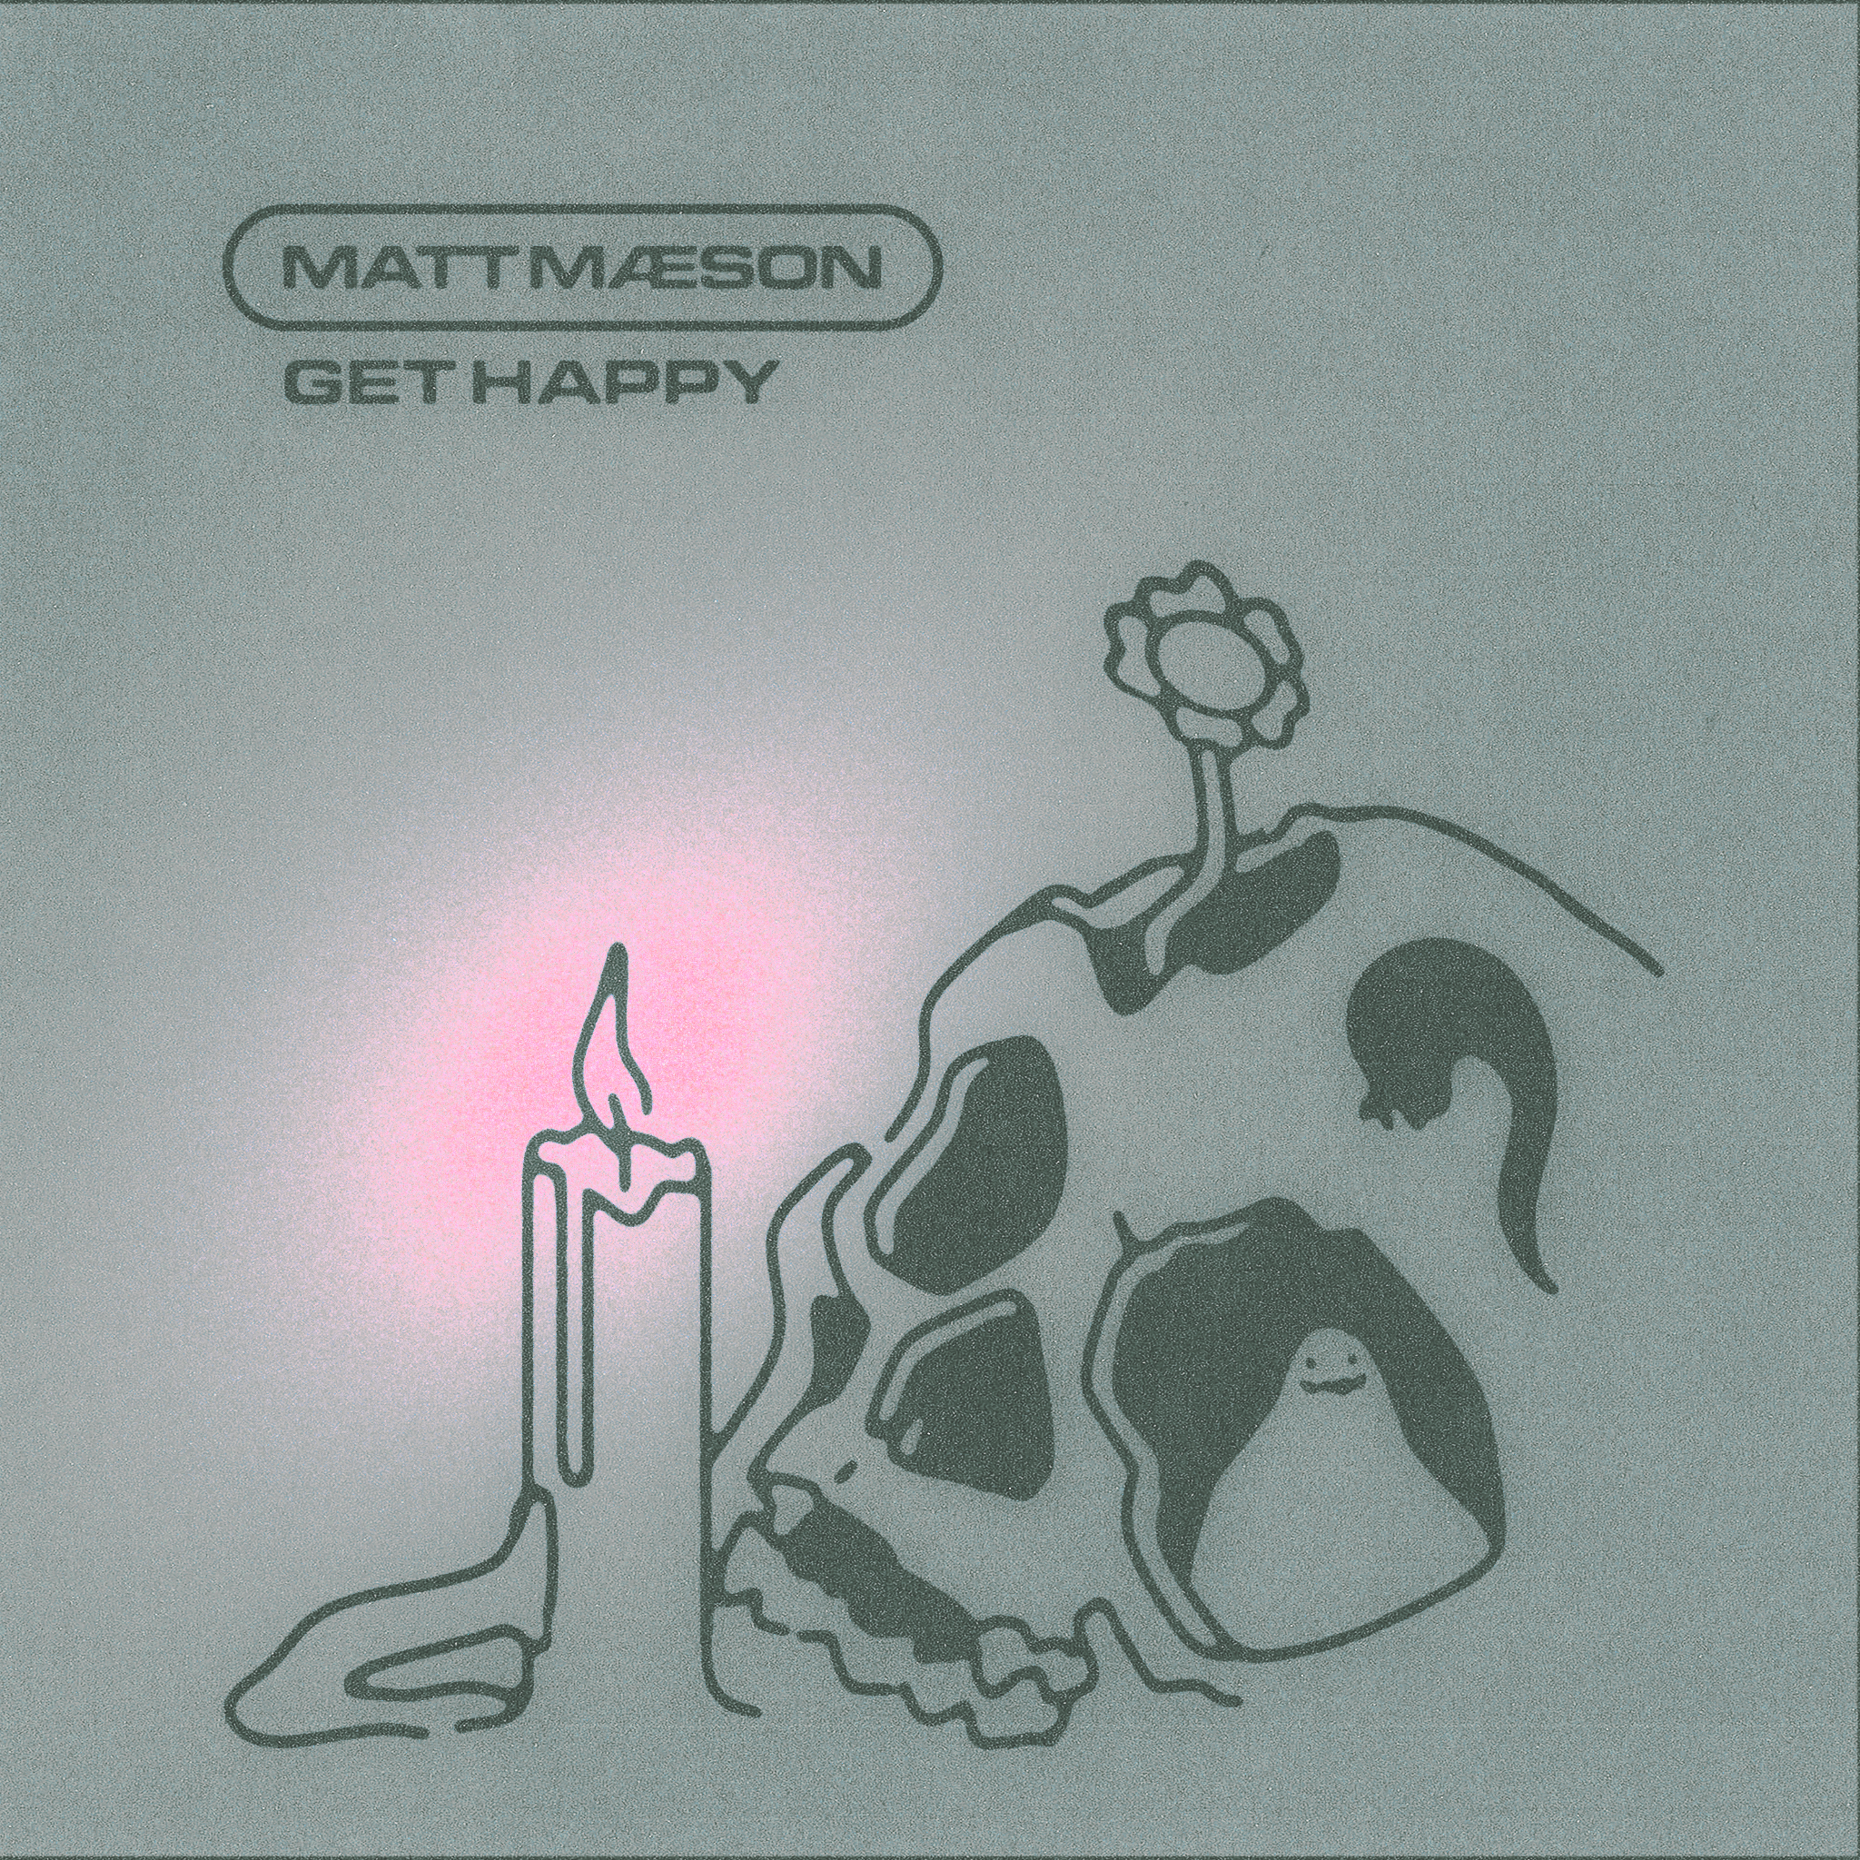

Chart-topping, RIAA platinum certified singer-songwriter Matt Maeson has released new single, “Get Happy,” available everywhere now via Neon Gold/Atlantic Records HERE.

Matt Maeson continues his largely sold-out solo headline That’s My Cue tour throughout the US, which includes a newly announced stop at Nashville’s Ryman Auditorium on August 26th, 2023 and a full-band festival performance at Rifflandia Music Festival in Victoria, BC in September. More tour information can be found HERE.

“Get Happy” follows Matt’s introspective single “Rational” which was released last month. Prior to that, Maeson dropped his highly anticipated sophomore studio album, Never Had To Leave in 2022, a revelatory body of work that embodies a newfound hopefulness while reinforcing the raw intensity and unapologetic truth-telling that have defined Maeson’s music from the very start.

Never Had To Leave includes the anthemic single “Cut Deep,” produced by Kenny Beats and ClickNPress and the mesmerizing Top 20 Alternative radio hit, “Blood Runs Red.” Hailed by Ones To Watch for “(retaining) all the hallmarks that make the affecting crooner such a force to behold,” “Blood Runs Red” has proven another landmark track for Maeson, boasting over 2M worldwide streams while ascending at Alternative Radio airplay charts nationwide. An official music video is streaming now via YouTube HERE.

Hailed by American Songwriter for “(creating) a sound unlike much else out there,” 2019 saw Matt Maeson arrive at the forefront of American Alternative music with his critically acclaimed breakthrough debut album, Bank On The Funeral, highlighted by the RIAA platinum certified single, “Cringe,” which spent four consecutive weeks atop Billboard’s “Alternative Songs” chart after a steady 25-week climb. Maeson then made history with the platinum certified “Hallucinogenics (Feat. Lana Del Rey),” which spent three weeks at #1 on the Alternative chart while also proving his first multi-format hit by topping Triple A airplay charts nationwide. The triumphant success of “Hallucinogenics” affirmed Maeson as the first ever male solo artist to earn two #1 Alternative hits from a full-length debut album and only the fifth male artist to accomplish that achievement following iconic superstars Beck, Elvis Costello, Peter Gabriel, and Morrissey. Moreover, Maeson joined Cage the Elephant and Bush as one of only three artists in history have had two number #1 Alternative hits on their debut album.

# # #

MATT MAESON THATS MY CUE TOUR 2023
SUPPORT FROM BRENNAN SMILEY, HUSSEY, MIKEY FERRARI

JULY
7/7 Paradise Rock Club – Boston, MA
7/8 Paradise Rock Club – Boston, MA
7/12 Iron City – Birmingham, LA
7/13 House of Blues – New Orleans, LA

AUGUST
8/26 Ryman Auditorium – Nashville, TN

SEPTEMBER
9/12 McDonald Theater – Eugene, OR
9/13 The Showbox Market – Seattle, WA
9/16 Rifflandia Music Festival – Victoria, BC †
9/17 Knitting Factory – Spokane, WA
9/19 The Elm – Bozeman, MT
9/21 Knitting Factory – Boise, ID
9/24 Boulder Theater – Boulder, CO
9/26 Brooklyn Bowl – Las Vegas, NV
9/27 The Regent Theater – Los Angeles, CA
9/29 Fremont Theater – San Luis Obispo, CA
9/30 Ventura Music Hall – Ventura, CA

OCTOBER
10/2 Observatory – Santa Ana, CA

NOVEMBER
11/5 The Academy - Dublin, IE
11/6 Manchester Gorilla - Manchester, GB
11/8 Electric Brixton -London, GB
11/9 La Maroquinerie - Paris, FR

† FESTIVAL PERFORMANCE

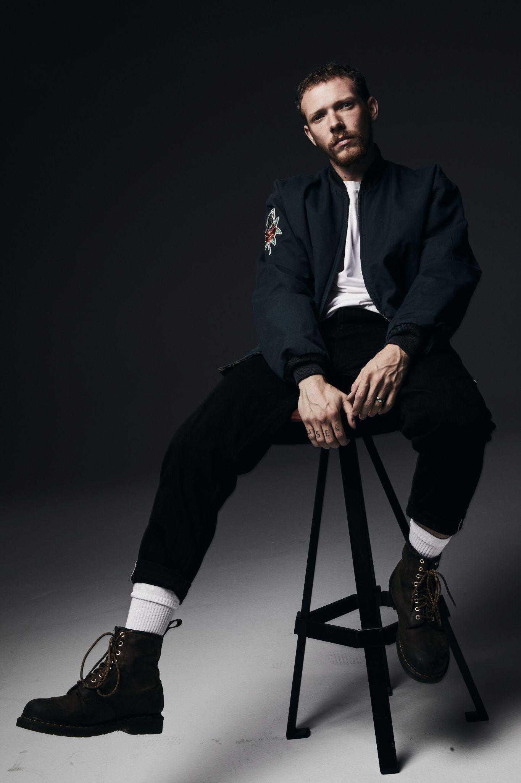

# # #

PRESS CONTACTS
COREY BREWER |COREY.BREWER@ATLANTICRECORDS.COM
GABRIELLE REESE (TOUR) | GABRIELLE.REESE@ATLANTICRECORDS.COM

CONNECT WITH MATT MAESON
MATTMAESON.COM | FACEBOOK | TWITTER | INSTAGRAM | YOUTUBE

