FOR IMMEDIATE RELEASE
MAY 19, 2023

ACCLAIMED SINGER-SONGWRITER MATT MAESON RETURNS WITH “RATIONAL”

DOWNLOAD/STREAM HERE

ANNOUNCES INTIMATE THATS MY CUE HEADLINE SOLO TOUR KICKING OFF MAY 24 IN RICHMOND- ON SALE NOW HERE

INCLUDES ALREADY SOLD-OUT SHOWS IN WASHINGTON DC, PHILADELPHIA, ASHEVILLE, TAMPA & JACKSONVILLE & FESTIVAL PERFORMANCES AT BONNAROO & WONDERWORKS MUSIC FESTIVAL

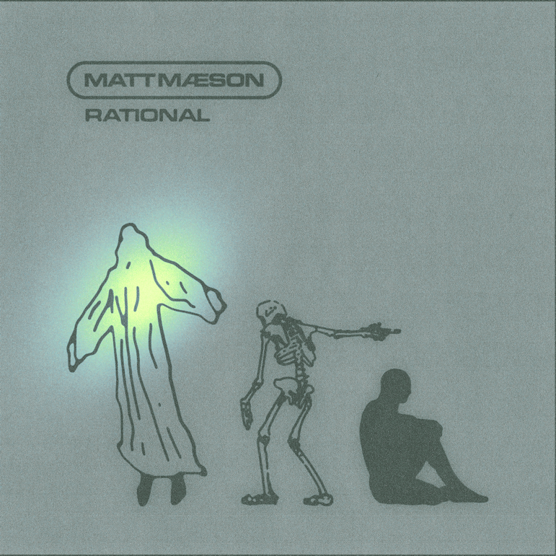
DOWNLOAD HIGH-RES ARTWORK

Chart-topping, RIAA platinum certified singer-songwriter Matt Maeson has returned with new single, “Rational,” available everywhere now via Neon Gold/Atlantic Records HERE.

"I think rational explains itself pretty well. I wrote it in a time when I was very on edge. I had just overworked myself to the point that I would fall into these kind of mental episodes. I would just go from feeling positive, like I was doing great and all of the sudden I would shift into these moments of extreme insecurity and that insecurity would beget anger and that anger would show its face in irrational behavior. Whether it’s within my career or to my team or to my family, it’s something that I have to monitor and try and remind myself that it’s temporary. “And all this confusion is just and illusion, it’s borrowing time becoming a nuisance” It’s a lot harder to climb out of those pits than it is to fall in."
-MATT MAESON

Matt Maeson also announces the solo headline That’s My Cue tour today, which will travel through the US from May 24th to October 2nd and includes full-band festival performances at Wonderworks Music Festival, Bonnaroo, and Rifflandia Music Festival. General on sale begins today, Friday, May 19 at 10am local. More tour information can be found HERE.

“Rational” marks Maeson’s return since the release of his highly anticipated sophomore studio album, Never Had To Leave, a revelatory body of work that embodies a newfound hopefulness while reinforcing the raw intensity and unapologetic truth-telling that have defined Maeson’s music from the very start.

Never Had To Leave includes the anthemic new single “Cut Deep,” produced by Kenny Beats and ClickNPress and the mesmerizing Top 20 Alternative radio hit, “Blood Runs Red.” Hailed by Ones To Watch for “(retaining) all the hallmarks that make the affecting crooner such a force to behold,” “Blood Runs Red” has proven another landmark track for Maeson, boasting over 2M worldwide streams while ascending at Alternative Radio airplay charts nationwide. An official music video is streaming now via YouTube HERE.

Hailed by American Songwriter for “(creating) a sound unlike much else out there,” 2019 saw Matt Maeson arrive at the forefront of American Alternative music with his critically acclaimed breakthrough debut album, Bank On The Funeral, highlighted by the RIAA platinum certified single, “Cringe,” which spent four consecutive weeks atop Billboard’s “Alternative Songs” chart after a steady 25-week climb. Maeson then made history with the platinum certified “Hallucinogenics (Feat. Lana Del Rey),” which spent three weeks at #1 on the Alternative chart while also proving his first multi-format hit by topping Triple A airplay charts nationwide. The triumphant success of “Hallucinogenics” affirmed Maeson as the first ever male solo artist to earn two #1 Alternative hits from a full-length debut album and only the fifth male artist to accomplish that achievement following iconic superstars Beck, Elvis Costello, Peter Gabriel, and Morrissey. Moreover, Maeson joined Cage the Elephant and Bush as one of only three artists in history have had two number #1 Alternative hits on their debut album.

# # #

MATT MAESON THATS MY CUE TOUR 2023
SUPPORT FROM BRENNAN SMILEY, HUSSEY, MIKEY FERRARI

MAY
5/24 – The National - Richmond, VA
5/25 – The Norva – Norfolk, CA
5/28 – Wonderworks Music Festival – Pittsburgh, PA †
5/30 – TLA – Philadelphia, PA – SOLD OUT
5/31 – 9:30 Club – Washington, DC – SOLD OUT

JUNE
6/2 – Orange Peel - Asheville, NC – SOLD OUT
6/3 – The Ritz – Raleigh, NC
6/5 – Charleston Music Hall – Charleston, SC
6/7 – Jannus Live – Tampa, FL – SOLD OUT
6/8 – The Beacham Theater – Orlando, FL
6/10 – Ponte Vedra Concert Hall – Jacksonville, FL – SOLD OUT
6/13 – Tabernacle – Atlanta, GA
6/16 – Bonnaroo – Manchester, TN
6/17 – Hattiesburg Saenger Theater – Hattiesburg, MS

JULY
7/8 Paradise Rock Club – Boston, MA
7/12 Iron City – Birmingham, LA
7/13 House of Blues – New Orleans, LA

SEPTEMBER
9/12 McDonald Theater – Eugene, OR
9/13 The Showbox Market – Seattle, WA
9/16 Rifflandia Music Festival – Victoria, BC †
9/17 Knitting Factory – Spokane, WA
9/19 The Elm – Bozeman, MT
9/21 Knitting Factory – Boise, ID
9/24 Boulder Theater – Boulder, CO
9/26 Brooklyn Bowl – Las Vegas, NV
9/27 The Regent Theater – Los Angeles, CA
9/29 Fremont Theater – San Luis Obispo, CA
9/30 Ventura Music Hall – Ventura, CA

OCTOBER
10/2 Observatory – Santa Ana, CA

† FESTIVAL PERFORMANCE

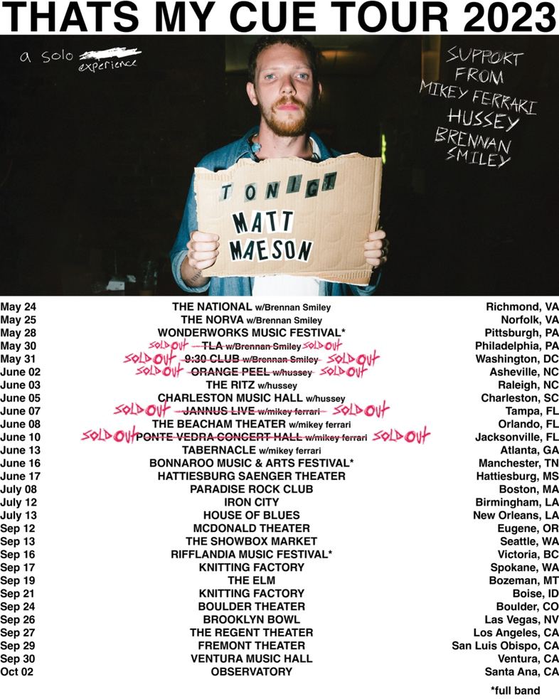
TOUR AD MAT HERE

# # #

PRESS CONTACTS
COREY BREWER |COREY.BREWER@ATLANTICRECORDS.COM
GABRIELLE REESE (TOUR) | GABRIELLE.REESE@ATLANTICRECORDS.COM

CONNECT WITH MATT MAESON
MATTMAESON.COM | FACEBOOK | TWITTER | INSTAGRAM | YOUTUBE

