OLIVER TREE ANNOUNCES MASSIVE INTERNATIONAL RUN

OLIVER TREE PRESENTS ALONE IN A CROWD
GETS UNDERWAY OCTOBER 10 AT AUCKLAND, NZ’S SHED 10

LIVE NATION-PRODUCED TOUR TRAVELS THROUGH NOVEMBER
WITH STOPS IN AUSTRALIA, FRANCE, LUXEMBOURG, THE UK,
BELGIUM, THE NETHERLANDS, GERMANY, SWITZERLAND AND ITALY

ALONE IN A CROWD ARRIVES VIA ATLANTIC RECORDS ON FRIDAY, SEPTEMBER 29

PRE-ORDER/PRE-SAVE/PRE-ADD THE NEW ALBUM ALONE IN A CROWD HERE
FOR EARLY ACCESS TO TICKETS

PRESALES BEGIN TUESDAY, JULY 18 AT 10:00 AM (LOCAL)

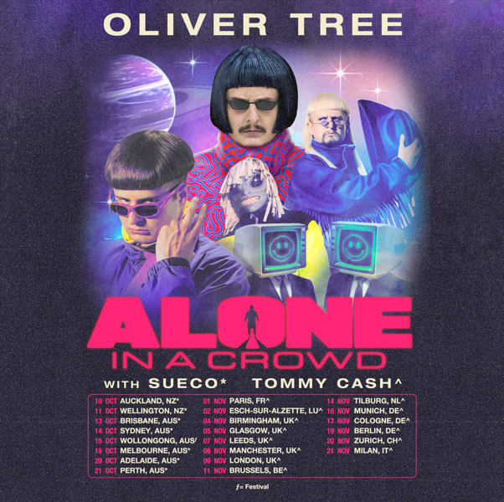

Internationally acclaimed, multi-Platinum, chart-topping artist Oliver Tree has announced a major world tour – his biggest headline run thus far. Produced by Live Nation, OLIVER TREE PRESENTS ALONE IN A CROWD gets underway October 10 at Auckland, NZ’s Shed 10 and then travels through November with stops in Australia, France, Luxembourg, the UK, Belgium, the Netherlands, Germany, Switzerland, and Italy. Support includes Sueco (AUS/NZ) and Tommy Cash (EU/UK).

International presales begin Tuesday, July 18 at 10:00 am (local). Album pre-order presales begin Wednesday, July 19 at 10:00 am (local). Live Nation and local pre-order presales begin Thursday, July 20 at 10:00 am (local). All presales conclude Friday, July 21 at 9:00 am (local). General on-sales begin Friday, July 21 at 10:00 am (local). For complete details, please see https://www.olivertreemusic.com/tour/.

OLIVER TREE PRESENTS ALONE IN A CROWD heralds the eagerly awaited arrival of Oliver Tree’s upcoming third solo album, ALONE IN A CROWD, arriving via Atlantic Records on Friday, September 29. Pre-orders are available now HERE.

ALONE IN A CROWD includes such recent hits as “Bounce,” joined by an official music video – written, produced, and directed by Oliver – streaming now at YouTube HERE. The album will also include last year’s high-energy RIAA Certified collaboration with GRAMMY® Award-nominated producer Robin Schulz, “Miss You,” which swiftly amassed over 600M global streams following top 10 debuts on both Billboard’s “Hot Dance/Electronic Songs” chart and the UK’s Official Singles Chart. Recently certified 2x Platinum in Australia as well as Platinum in both the UK and Canada, the track is accompanied by a typically quirky, Oliver Tree-directed official music video, currently boasting more than 200M views via YouTube HERE.

A one-of-a-kind artist who continues to top the charts and sell out amphitheaters worldwide, Oliver Tree explore and dissects the absurdity of modern culture, fame, and social media with Dadaist meta-humor unlike any other. ALONE IN A CROWD – which introduces a new character to Tree’s surrealistic universe, fashion designer Cornelius Cummings – serves to reflect both the light and the darkness of human nature within popular culture, holding up a mirror while simultaneously embracing the absurdity of it all through rich themes of loneliness, disconnection, and the ridiculousness of our shared human experience.

Now boasting more than 5B global streams, over 2B YouTube views, over 15M TikTok followers, and an cumulative social reach of over 30M, Oliver Tree has already had a very productive 2023 with such electric releases as his first-ever collaboration with fellow superstar David Guetta, “Here We Go Again,” streaming now HERE. An official lyric video, written and directed by Oliver, has earned over 14M views via YouTube HERE. “Here We Go Again” in turn followed KSI’s “Voices (Feat. Oliver Tree),” joined by an official music video now boasting close to 7M views HERE.

With over 20M monthly listeners on Spotify, Oliver wrapped up his very busy 2022 with the long awaited release of COWBOY TEARS DROWN THE WORLD IN A SWIMMING POOL OF SORROW, an expanded deluxe edition of his acclaimed sophomore LP, COWBOY TEARS, available now HERE. Highlights include such favorites as “I Hate You,” “Placeholder,” and “Suitcase Full Of Cash,” the latter accompanied by an official visual featuring guest appearances from viral stars Alissa Violet, Tana Mongeau, Viking Barbie, and Melissa Ong, streaming now at Oliver’s YouTube channel HERE.

Oliver – who lit up last month’s Governors Ball in New York City with a top-billed, typically show-stealing performance – celebrated the impending arrival of ALONE IN A CROWD with his biggest headline show to date, “OLIVER TREE – THE WORLD’S TINIEST TAP DANCER – LIVE AT RED ROCKS,” a once-in-a-lifetime concert event at Morrison, CO’s world-famous Red Rocks Amphitheatre.

# # #

OLIVER TREE PRESENTS ALONE IN A CROWD
WORLD TOUR 2023
PRODUCED BY LIVE NATION

ADMAT

OCTOBER
10 – Auckland, NZ – Shed 10
11 – Wellington, NZ – Michael Fowler Centre
13 – Brisbane, AUS – Fortitude Music Hall
14 – Sydney, AUS – Hordern Pavilion
15 – Wollongong, AUS – Yours and Owls Festival *
18 – Melbourne, AUS – Festival Hall
20 – Adelaide, AUS – Hindley Street Music Hall
21 – Perth, AUS – Metro City

NOVEMBER
1 – Paris, France – L’Olympia
2 – Esch-sur-Alzette, Luxembourg – Rockhal
4 – Birmingham, UK – O2 Academy Birmingham
5 – Glasgow, UK – O2 Academy Glasgow
7 – Leeds, UK – O2 Academy Leeds
8 – Manchester, UK – O2 Apollo
9 – London, UK – Troxy
11 – Brussels, Belgium – Ancienne Belgique
14 – Tilburg, Netherlands – 013 Poppodium
16 – Munich, Germany – TonHalle München
17 – Cologne, Germany – E–Werk
19 – Berlin, Germany – Columbiahalle
20 – Zurich, Switzerland – Halle 622
21 – Milan, Italy – Fabrique

* FESTIVAL PERFORMANCE

10/10-10/21 w/ Sueco
11/1-11/21 w/ Tommy Cash

# # #

DOWNLOAD PRESS PHOTO HERE
PHOTO CREDIT: BRANKO STARČEVIĆ

# # #

ABOUT LIVE NATION ENTERTAINMENT
Live Nation Entertainment (NYSE: LYV) is the world’s leading live entertainment company comprised of global market leaders: Ticketmaster, Live Nation Concerts, and Live Nation Sponsorship. For additional information, visit www.livenationentertainment.com.

# # #

CONNECT WITH OLIVER TREE
WEBSITE | FACEBOOK | INSTAGRAM | SPOTIFY | TIK TOK | TWITTER | YOUTUBE
# # #

For All Media Inquiries, Please Contact:
HIGH RISE PR
Alexandra Baker | alexandra@highrisepr.com
Jamie Sward | jamie@highrisepr.com
ATLANTIC RECORDS
Jessica Nall | jessica.nall@atlanticrecords.com

LIVE NATION
Monique Sowinski | moniquesowinski@livenation.com
Navier Grimes | naviergrimes@livenation.com

