FOR IMMEDIATE RELEASE
JULY 24, 2023

ALEX WARREN ANNOUNCES “ALEX WARREN LIVE”

ACCLAIMED SINGER-SONGWRITER TO PERFORM FIRST-EVER HEADLINE SHOWS THIS SEPTEMBER
WITH A NIGHT AT THE TROUBADOUR IN LA ON SEPTEMBER 6

PRE-SALE BEGINS WEDNESDAY, JULY 26 AT 10 AM PT
GENERAL ON-SALE BEGINGS FRIDAY, JULY 28 AT 10 AM PT
TICKET INFO AVAIL HERE
DEEPLY PERSONAL NEW SINGLE “CHANGE YOUR MIND” OUT NOW HERE
WATCH OFFICIAL MUSIC VIDEO

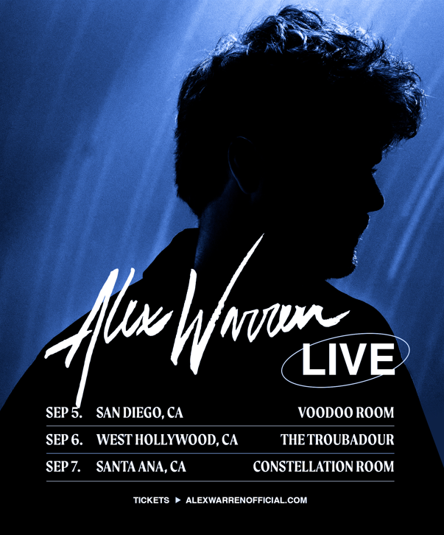

“Alex Warren’s story is one you’ll want to sit down for – and his music is everything and more.” – PEOPLE

Acclaimed singer-songwriter Alex Warren has announced his first ever headline shows, Alex Warren Live. The shows get underway on September 5 at San Diego, CA’s Voodoo Room and continue with stops at Los Angeles’ The Troubadour on September 6 and Santa Ana’s Constellation Room on September 7. Artist pre-sale begins Wednesday, July 26 at 10 AM PT via Seated and general on-sale begins Friday, July 28 at 10 AM PT. For complete details, please visit https://tix.to/AlexWarrenLivePR.

The announce follows Warren’s latest single “Change Your Mind” – A powerful examination of mental health issues and his own brother’s attempts at suicide. The track arrived following a series of viral social media posts that have drawn more than 18M+ views across pre-release TikTok posts and was joined with a heartfelt and emotional music video, directed by Dice Nguyen, which premiered exclusively on PEOPLE – Watch HERE.

“Change Your Mind” followed emotionally rich singles from Warren, including the heartbreaking “Give You Love,” which was joined by a companion video which co-stars his beloved fiancée, Kouvr Annon, and tells the incredible story of their love and relationship – Watch HERE. Other singles include Warren’s deeply moving anthem, “Chasing Shadows” and his critically acclaimed label debut single, “Headlights,” which garnered 74M views on TikTok prior to release. An official music video, based on Alex’s ongoing struggles with anxiety and depression, is streaming now HERE following its exclusive premiere via Rolling Stone.

Named among PEOPLE‘s list of “Talented Emerging Artists Making Their Mark,” Alex Warren is one of the most followed Gen Z celebrities on YouTube, Instagram and TikTok. From being homeless and sleeping in friends’ cars to now, Alex has shared his life with the internet for more than 11 years, building an online community of 25M+ cumulative followers. Known for his vulnerable pop melodies, passionate vocals, and lyrical candor, Alex released his first single, “One More I Love You,” in 2021, channeling his traumatic childhood experiences into a heart-wrenching musical debut. Since then, Alex independently released two more singles, “Screaming Underwater“ and “Remember Me Happy“.

DOWNLOAD PRESS PHOTO
CREDIT: RYAN SIMMONS

ALEX WARREN LIVE

SEPTEMBER
5 – San Diego, CA – Voodoo Room
6 – West Hollywood, CA – The Troubadour
7 – Santa Ana, CA – Constellation Room

CONNECT WITH ALEX WARREN:
FACEBOOK | INSTAGRAM | SNAPCHAT | TIKTOK | TWITTER | YOUTUBE | PRESS ASSETS

CONTACT:
ANDREW GEORGE | ANDREW.GEORGE@ATLANTICRECORDS.COM

