FOR IMMEDIATE RELEASE
JULY 6, 2023

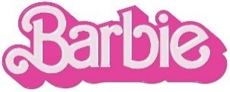
FIFTY FIFTY AND KALIII HAVE BIG “BARBIE DREAMS” ON NEW SINGLE FROM
BARBIE THE ALBUM

HOTTEST NEW K-POP GROUP AND VIRAL “AREA CODES” HITMAKER JOIN FORCES
FOR ELECTRIFYING COLLABORATION FROM STAR-STUDDED SOUNDTRACK

“BARBIE DREAMS” WAS PRECEDED BY “BARBIE WORLD” FROM NICKI MINAJ AND ICE SPICE,
“DANCE THE NIGHT” FROM DUA LIPA, “WATATI (FT. ALDO RANKS)” FROM KAROL G,
“ANGEL” FROM PINKPANTHERESS AND “SPEED DRIVE” FROM CHARLI XCX
WHICH HAVE COLLECTIVELY AMASSED OVER 350 MILLION GLOBAL STREAMS

“BARBIE WORLD” ENTERS BILLBOARD HOT 100 TOP 10 OFFICIALLY BECOMING
THE HIGHEST CHARTING AND STREAMING FEMALE RAP DEBUT OF 2023

ALL-NEW COMPANION ALBUM TO WARNER BROS. PICTURES’ HIGHLY ANTICIPATED FILM
INSPIRED BY MATTEL’S BARBIE FEATURES MASSIVE NEW TRACKS FROM AN UNPRECEDENTED LINEUP OF GLOBAL SUPERSTARS INCLUDING LIZZO, TAME IMPALA, THE KID LAROI AND MORE

SOUNDTRACK EXECUTIVE PRODUCED BY OSCAR, GOLDEN GLOBE AND
7X GRAMMY® AWARD WINNING ARTIST AND PRODUCER MARK RONSON

BARBIE + BARBIE THE ALBUM ARRIVE EVERYWHERE ON JULY 21ST

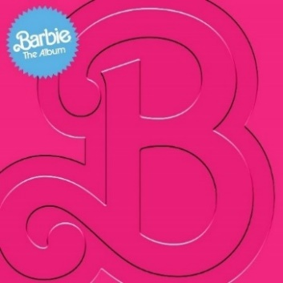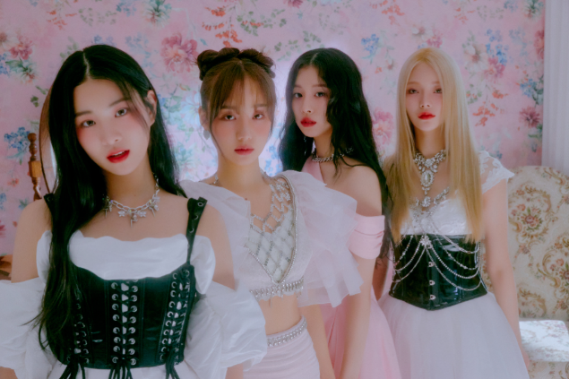
DOWNLOAD HI-RES IMAGES HERE

Following “Speed Drive” from Charli XCX, BARBIE THE ALBUM continues its star-studded rollout with the high-energy new track from K-Pop group FIFTY FIFTY “Barbie Dreams” featuring Atlanta bred rapper Kaliii and an interpolation of Janet Jackson’s “Together Again” – listen HERE. Produced by London-bred multi-platinum DJ/songwriting/production duo Space Primates, the track follows both FIFTY FIFTY’s viral hit single “Cupid” which has become the longest-charting song by a K-pop girl group on the Billboard Hot 100 in addition to racking in over 3.6B+ streams, 30B+ TikTok views and Kaliii’s breakthrough moment with “Area Codes,” which has amassed over 130M streams and 5B TikTok views.

BARBIE THE ALBUM is the official musical companion to the highly anticipated summer event film Barbie, starring Margot Robbie and Ryan Gosling as Barbie and Ken and distributed by Warner Bros. Pictures. Available for pre-order HERE, the soundtrack arrives in stores and at all online retailers on Friday, July 21st in conjunction with the theatrical release of the feature film.

“Barbie Dreams” was preceded by Charli XCX’s “Speed Drive,” global megastars Nicki Minaj and Ice Spice’s iconic “Barbie World,” – which has entered the Billboard Hot 100 Top 10, officially becoming the highest charting and streaming female rap debut of 2023 so far – UK-based artist and producer PinkPantheress’ captivating track, “Angel,” global recording artist KAROL G’s high-energy anthem, “WATATI (ft. Aldo Ranks)” and the electrifying lead single “Dance The Night” from 3x GRAMMY® Award-winning global superstar Dua Lipa, who also makes a special appearance in the film. Upon release, “Angel” was praised by THE NEW YORK TIMES for its “dreamy melody” as ELLE dubbed it “an unexpected party anthem.” “WATATI” was also immediately met with critical acclaim with ROLLING STONE calling it a “reggaetón party” and HOLA! stating it’s an “exciting addition, poised to be a hit.” The high-energy anthem is complemented by its official visual directed by Mike Ho and starring KAROL herself as she enters the actual World of Barbie, shot on-site in LA – watch HERE. Produced by Mark Ronson, Andrew Wyatt and the Picard Brothers, “Dance The Night” arrived alongside a dazzling official video featuring a special appearance from Barbie writer/director/executive producer Greta Gerwig (“Little Women,” “Lady Bird”) – watch HERE. Upon release, V MAGAZINE called the track “disco-pop perfection,” NPR described it as “undeniably glamorous,” BILLBOARD asserted it has “one of the sleekest bridges in mainstream pop this year,” and INSTYLE declared it “our new summer anthem.” All singles released so far have already amassed an impressive 350M combined global audio streams and official video views.

BARBIE THE ALBUM will continue to feature massive new tracks from an unprecedented lineup of artists including Lizzo, Ava Max, Dominic Fike, Khalid, The Kid LAROI, Tame Impala, HAIM and GAYLE. Barbie star Ryan Gosling also joins the robust roster of soundtrack artists with his iconic original song performed as his character, Ken. See below for full tracklisting.

BARBIE THE ALBUM continues the hugely successful partnership between Atlantic Records and Warner Bros. Pictures. The two companies previously teamed up for 2020’s BIRDS OF PREY: THE ALBUM which spawned the RIAA Certified 2x Platinum smash “Boss B*tch” by Doja Cat, along with the 2016’s GRAMMY® Award-nominated SUICIDE SQUAD: THE ALBUM, which topped album charts in over 70 countries around the world, including two consecutive weeks on the Billboard 200, and featured the RIAA Certified Diamond hit “Heathens” by Twenty One Pilots.

BARBIE THE ALBUM was executive produced by internationally renowned DJ and Oscar, Golden Globe and 7x GRAMMY® award winning artist and producer, Mark Ronson and Barbie writer/director/executive producer Greta Gerwig. The soundtrack album was Produced and overseen by Atlantic Records’ West Coast President, Kevin Weaver (Soundtrack Album Producer of The Greatest Showman, Suicide Squad, Daisy Jones & The Six, Birds Of Prey, Furious 7, The Fault in Our Stars, The Fate of the Furious) and Atlantic Records’ EVP and Co-Head of Pop/Rock A&R, Brandon Davis. Named by Rolling Stone as a “soundtrack guru,” Weaver is a GRAMMY® Award winner and five-time nominee, who has produced numerous multi-platinum soundtrack projects that have amassed tens of millions of albums sold worldwide. Additional key players involved on the project include Soundtrack Album Co-Producers, Brandon Creed and Joseph Khoury, as well as the Barbie Music Supervisor and Album Executive Producer, George Drakoulias.

About the film BARBIE
To live in Barbie Land is to be a perfect being in a perfect place. Unless you have a full-on existential crisis. Or you’re a Ken. Warner Bros. Pictures Presents a Heyday Films Production, a LuckyChap Entertainment Production, an NB/GG Pictures Production, a Mattel Production, Barbie. The film will be distributed worldwide by Warner Bros. Pictures and released in theaters only nationwide on July 21, 2023 and internationally beginning July 19, 2023. Directed by Greta Gerwig, Barbie stars Margot Robbie, Ryan Gosling, America Ferrera, Kate McKinnon, Issa Rae, Rhea Perlman, and Will Ferrell. The film is written by Greta Gerwig & Noah Baumbach, based on “Barbie” by Mattel, and produced by David Heyman, Margot Robbie, Tom Ackerley and Robbie Brenner. The executive producers are Gerwig, Baumbach, Ynon Kreiz, Richard Dickson, Michael Sharp, Josey McNamara, Courtenay Valenti, Toby Emmerich and Cate Adams. The film’s music supervisor is George Drakoulias, with music by Mark Ronson and Andrew Wyatt.

ABOUT FIFTY FIFTY:
FIFTY FIFTY is a 4-member girl group under the ATTRAKT Creative Content Group. The members include SAENA, ARAN, KEENA, and SIO, and their name has two meanings, the first combine themselves and their fans, the first “50” or “half” represents their fans, and the other “half” represents themselves, combining those two makes 100 or a “whole.” The second meaning is “dream world” vs. reality, with “50” representing each respective “half,” and this is meant to express the concept of their travels in between the real world full of challenges and an ideal world that’s filled with nothing but love, friendship, and happiness. With their music and concept, FIFTY FIFTY seeks to share their journey with their fans and share their personal stories through a wide spectrum of music.

ABOUT KALIII:
Kaliii’s had a landmark year with 2022. After the release of her highly acclaimed EP Toxic Chocolate, Kaliii was admitted into the XXL 2022 Freshman Class. This momentous, career-defining feat was supported by her thrilling freestyle and cypher performances streaming now. She continued her run with the release of the singles “FNF (Freestyle)” and “Wet” with each visual at over a combined 1M views via YouTube. Toxic Chocolate – available now at all DSPs and streaming services – arrived earlier in 2022 amidst both popular and critical acclaim, with Hot New Hip Hop simply declaring her “Rap's Next ‘It’ Girl.” The EP is highlighted by the incendiary singles, “UonU (Feat. Yung Bleu)“ and “Standards,” the latter of which had its exclusive premiere – alongside Kaliii’s debut interview – on Apple Music’s New Music Daily Radio with Zane Lowe. Kaliii then increased the power of Toxic Chocolate with the surprise addition of the fan favorite “Chainzzz (Feat. Muni Long)” as well as a revised sequence.

The arrival of Toxic Chocolate was further joined by an electrifying performance of the EP standout, “New Day,” filmed exclusively for UPROXX Sessions and streaming now HERE. UPROXX further praised Kaliii for “her gift for wordplay and her spicy relationship sensibilities,” adding, “(Kaliii) turns the tables on the f*ckboys of hip-hop, using their manipulative tactics to even the odds and give them a taste of their own medicine.” After raking in over 100 million streams and receiving praise from Nylon, HIGHSNOBIETY, XXL, Essence, Complex, Brooklyn Vegan, Kaliii is ready to take her career to new heights with a new love, new music, and a new focus. The rapstress followed up the EP with a flurry of singles and freestyles including “Wet” and “Bout U.” Kaliii kicked off 2023 with her explosive viral hit “Area Codes” which has now spawned several regional remixes. The remixes are a part of Kaliii’s #ToxicThursday release series and have thus far included New York’s Kenzo B on the “718 Remix,” The Bay Area’s Lil Kayla on the “415 Remix,” St. Louis’s Sexyy Red on the “314 Remix,” and Tallahassee’s Luh Tyler on the “850 Remix.” She followed up by releasing the remixes as a combined pack aptly titled, Area Codes: The Remixes and a visual for “Area Codes (718 Remix)” featuring Kenzo B.

BARBIE THE ALBUM TRACKLIST

- Lizzo – Pink
- Dua Lipa – Dance The Night
- Nicki Minaj & Ice Spice – Barbie World (with Aqua)
- Charli XCX – Speed Drive
- KAROL G – WATATI (feat. Aldo Ranks)
- TBA
- Tame Impala – Journey To The Real World
- Ryan Gosling – I’m Just Ken
- Dominic Fike – Hey Blondie
- HAIM – Home
- TBA
- The Kid LAROI – Forever & Again
- Khalid – Silver Platter
- PinkPantheress – Angel
- GAYLE – butterflies
- Ava Max – Choose Your Fighter
- FIFTY FIFTY – Barbie Dreams (feat. Kaliii)

CONNECT:
BARBIETHEALBUM.COM | INSTAGRAM | TIKTOK | TWITTER | FACEBOOK | PRESS SITE

BARBIE THE ALBUM PRESS CONTACT:
ANDREW GEORGE
ANDREW.GEORGE@ATLANTICRECORDS.COM

