FOR IMMEDIATE RELEASE
JULY 29, 2023

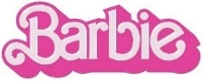

4X GRAMMY® AWARD WINNING LIZZO’S “PINK (BAD DAY)” FROM BARBIE
OUT NOW

STAR-STUDDED BARBIE THE ALBUM SURPASSES 650M+ GLOBAL STREAMS

GRETA GERWIG’S BARBIE OFFICIALLY #1 AT GLOBAL BOX OFFICE SKATING PAST $500M WORLDWIDE

LISTEN TO “PINK (BAD DAY)”
STREAM BARRBIE THE ALBUM

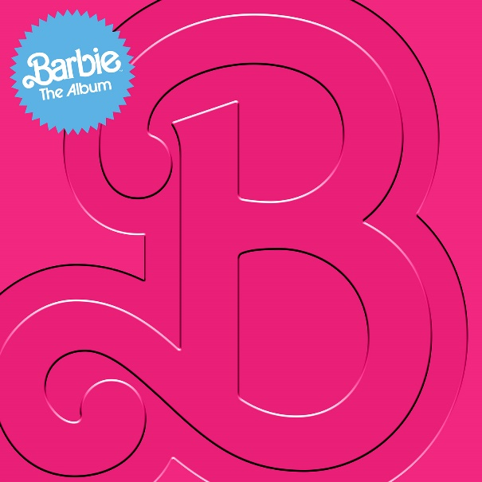
DOWNLOAD HI-RES IMAGES HERE

Following an overwhelming demand from fans, 4x GRAMMY® Award and Emmy award winning, RIAA multi-platinum certified superstar LIZZO’s “Pink (Bad Day)” has been officially released. The track was written and performed for Greta Gerwig’s critically acclaimed #1 film, Barbie, starring Margot Robbie and Ryan Gosling as Barbie and Ken and distributed by Warner Bros. Pictures. On the heels of its record-shattering opening weekend, Barbie has surpassed the half-billion-dollar mark at the global box office. Since last week’s release of the film, “Pink (Bad Day)” has already garnered over 14.2M TikTok views and 1.4M engagements, plus 17.5K+ posts across TikTok and Instagram. As of today, fans can now listen to the full version of “Pink (Bad Day)” along with the previously released “Pink” from Atlantic Records’ BARBIE THE ALBUM, the groundbreaking and star-studded musical companion to Barbie, now surpassing over 650M global streams.

FOR MORE INFO, DOWNLOAD OFFICIAL PRESS MATERIALS:
LIZZO | BARBIE THE ALBUM

WHAT CRITICS ARE SAYING ABOUT BARBIE THE ALBUM
“The Album of Summer 2023” – COSMOPOLITAN’S “BEST MOVIE SOUNDTRACKS OF ALL TIME”
“‘Barbie the Album’ Is Like a Perfect Night on the Dreamhouse Dancefloor. You Won’t Want It to End” – ROLLING STONE
“the soundtrack of the summer, a cultural moment of pop music's biggest icons” – THE TODAY SHOW
“an upbeat, immersive soundtrack full of pop gems from a global who’s who of top pop hitmakers” – BILLBOARD
“the kind of stellar original soundtrack we haven’t heard in years” – USA TODAY
“an electric sprawl of a soundtrack that can be enjoyed from start to finish” – ASSOCIATED PRESS
“The soundtrack is more than just an accessory...it is a crucial element in bringing Gerwig’s creative vision to life” – PEOPLE
“more memorable pop moments than most major motion picture soundtracks” – FADER
“a veritable toybox of the biggest pop stars today” – GRAMMY.COM
“a shimmering pop mixtape as joyful as the movie” – CONSEQUENCE
“The Barbie soundtrack is a pop lover's dream” – ESQUIRE
“a stellar musical experience” – FORBES

CONNECT WITH LIZZO
OFFICIAL | FACEBOOK | INSTAGRAM | TIKTOK TWITTER | YOUTUBE

CONNECT WITH BARBIE THE ALBUM:
BARBIETHEALBUM.COM | INSTAGRAM | TIKTOK | TWITTER | FACEBOOK | PRESS SITE

BARBIE THE ALBUM PRESS CONTACT:
ANDREW GEORGE | ANDREW.GEORGE@ATLANTICRECORDS.COM

