FOR IMMEDIATE RELEASE
JULY 28, 2023

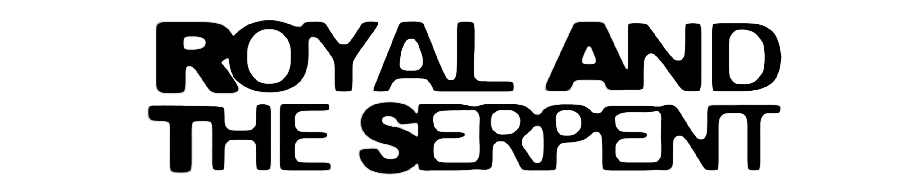

ROYAL & THE SERPENT SETS RAT TRAP 3: the band-aid

RAT TRAP SAGA CONTINUES WITH THIRD CHAPTER
IN NEW SERIES OF TWO-TRACK RELEASES

SPECIAL GUEST RUN ON FALL OUT BOY’S SO MUCH FOR (TOUR) DUST
CONTINUES THROUGH EARLY AUGUST

SPECIAL IN-STORE PERFORMANCES AND AUTOGRAPH SESSIONS
SET FOR SELECT INDEPENDENT RECORD STORES ACROSS THE COUNTRY

LISTEN HERE

WATCH “UTOPIA” OFFICIAL MUSIC VIDEO | WATCH “SWEET TOOTH” OFFICIAL MUSIC VIDEO

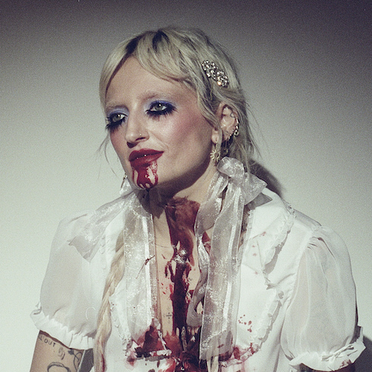
DOWNLOAD HI-RES ARTWORK + VIDEO THUMBNAILS

RIAA Gold-certified singer-songwriter Royal & the Serpent continues her RAT TRAP saga with her latest two-track project, RAT TRAP 3: the band-aid – Listen HERE. The third installment in an all-new series of double-sided singles arriving each month through the summer, today’s release includes “Utopia” and the addictive “Sweet Tooth.” Watch the official music videos for each track HERE.

Royal kicked off her RAT TRAP saga this spring with the premiere of its first chapter, RAT TRAP I: the blueprint, featuring “Astroturf” and the powerfully inspiring LGBTQ+ anthem, “One Nation Underdogs,” both joined by official music videos streaming now HERE. RAT TRAP 2: the burn followed in June, continuing the tale with “JUNKIE” and the enthusiastic “SLUG,” each of which arrived alongside official music videos streaming now HERE.

Royal & the Serpent is currently celebrating the “royalverse” with a special guest run on Fall Out Boy’s So Much For (Tour) Dust, with dates set through early August. In addition, Royal will visit select independent record stores throughout the tour, including in-store performances and autograph sessions at Brooklyn, NY’s Rough Trade NYC (August 1) and Philadelphia, PA’s Repo Records (August 6). For complete details and ticket information, please visit www.royalandtheserpent.com.

The RAT TRAP series follows last year’s explosive HAPPINESS IS AN INSIDE JOB, an intimately detailed, five-song document of Royal’s journey to self-love. The project includes such searing tracks as “IM FINE,” “No Regrets,” “Happiness 4 Dummies,” “Love Abuser (Save Me),” and “Death of Me,” all accompanied by official visuals streaming now at YouTube.

ABOUT ROYAL & THE SERPENT
Royal & the Serpent is an artist entirely unafraid to bare the deepest and darkest parts of her psyche. After making her Atlantic Records debut with the 2020 EP, get a grip – highlighted by the RIAA Gold-certified single “Overwhelmed,” which captured the chaos of sensory overload and spent 22 weeks on Billboard’s “Alternative Airplay” chart – the L.A.-based singer-songwriter revealed even more of her frenetic inner world in 2022 with IF I DIED WOULD ANYONE CARE and Happiness Is An Inside Job. Her unfiltered songwriting has proved wildly resonant to her ever-growing fanbase – and led to such triumphs as touring with Demi Lovato, grandson, PVRIS, and Fall Out Boy.

Originally from New Jersey, Royal first took up guitar at age 14 with help from the then-six-year-old sister of her friend Donna Missal (a fellow singer-songwriter now signed to Harvest Records), then relocated to L.A. at age 18. While working as a bartender, Royal soon started self-releasing her music, beginning with her spellbinding 2017 single “Temperance.” Thanks to the buzz behind songs like 2019’s “Weddings & Funerals” and “Salvador Dali” – as well as her electrifying live show – she eventually inked a deal with Atlantic and released “Overwhelmed” in the early days of Covid lockdown.

Over the past few years, Royal has built a close-knit community of fans undeniably drawn to her one-of-a-kind balance of intense sensitivity and unruly self-possession. “The main reason I make music is that it’s the best therapy I could ever ask for: the process of taking everything in my brain and putting it on paper and then singing it out loud for people is so helpful and healing for me. The idea that my own expression can affect people in positive ways is such a blessing and a gift; I don’t ever take it lightly. I just want to keep telling my truth and reach as many people as I possibly can, and see where this little journey takes us.”

ROYAL & THE SERPENT
ON TOUR 2023

JULY
29 – Clarkston, MI – Pine Knob Music Theatre
30 – Toronto, ON – Budweiser Stage

AUGUST
1 – Forest Hills, NY – Forest Hills Stadium
2 – Boston, MA – Fenway Park
4 – Darien Center, NY – Darien Lake Amphitheater
5 – Holmdel, NJ – PNC Bank Arts Center
6 – Camden, NJ – Freedom Mortgage Pavilion

All Dates W/ Fall Out Boy So Much For (Tour) Dust

# # #

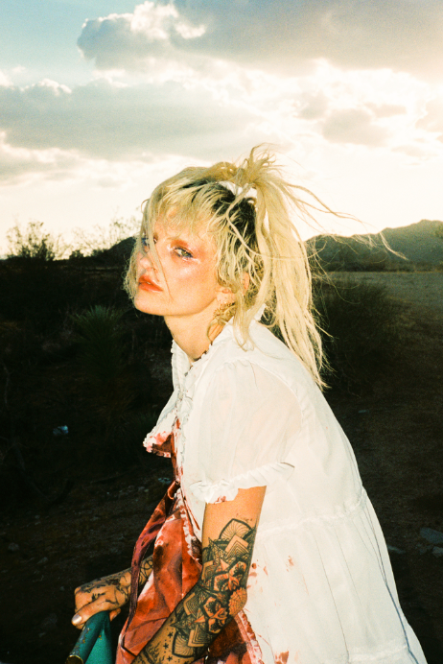
DOWNLOAD HI-RES IMAGES
PHOTO CREDIT: JUAN FLORES

# # #

CONNECT WITH ROYAL & THE SERPENT:
OFFICIAL | FACEBOOK | INSTAGRAM | TWITTER | YOUTUBE

PRESS CONTACTS:
Corey Brewer / Corey.Brewer@atlanticrecords.com
Jessica Nall / Jessica.Nall@atlanticrecords.com
Gabby Reese / Gabrielle.Reese@atlanticrecords.com

