FOR IMMEDIATE RELEASE

JUNE 9, 2023

**SOPHIE POWERS SHARES DARKLY POWERFUL NEW SINGLE “BATHROOM FLOOR”**

**TEAMS UP WITH THE NATIONAL ALLIANCE FOR EATING DISORDERS**

**ORGANIZATION IN AN EFFORT TO RAISE $3K**

**BUSY LIVE SCHEDULE INCLUDES TOURS ALONGSIDE**

**WATERPARKS AND POPTROPICASLUTZ!**

**“BATHROOM FLOOR” AVAILABLE NOW AT ALL DSPS AND STREAMING SERVICES**

[**LISTEN**](https://nam04.safelinks.protection.outlook.com/?url=https%3A%2F%2Fsophiepowers.lnk.to%2FBathroomFloor&data=05%7C01%7CKeliza.Lewinson%40atlanticrecords.com%7C71e7c3e4f71248720ee508db65f2623e%7C8367939002ec4ba1ad3d69da3fdd637e%7C0%7C0%7C638215863938679146%7CUnknown%7CTWFpbGZsb3d8eyJWIjoiMC4wLjAwMDAiLCJQIjoiV2luMzIiLCJBTiI6Ik1haWwiLCJXVCI6Mn0%3D%7C3000%7C%7C%7C&sdata=w054tW6EuVOn8Iz9MVg0Lb6rENkeUGPOfJLfQipSP%2FM%3D&reserved=0) **TO “BATHROOM FLOOR” |** [**WATCH**](https://www.youtube.com/watch?v=2J4V_3slc6w&pp=ygUcYmF0aHJvb20gZmxvb3Igc29waGllIHBvd2Vycw%3D%3D) **OFFICIAL MUSIC VIDEO**

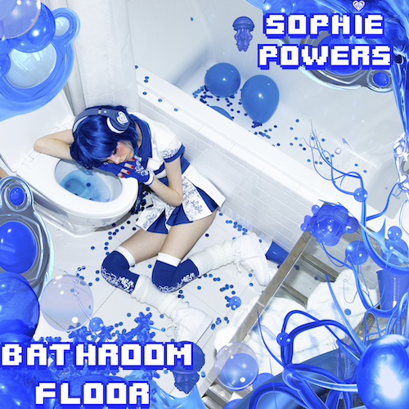

[DOWNLOAD HI-RES IMAGE](https://press.atlanticrecords.com/sites/g/files/g2000014001/files/2023-06/bathroom%20floor%20artwork.png)

Alt-pop singer-songwriter **Sophie Powers** has shared her darkly powerful new single, “[**Bathroom Floor**](https://nam04.safelinks.protection.outlook.com/?url=https%3A%2F%2Fsophiepowers.lnk.to%2FBathroomFloor&data=05%7C01%7CKeliza.Lewinson%40atlanticrecords.com%7C71e7c3e4f71248720ee508db65f2623e%7C8367939002ec4ba1ad3d69da3fdd637e%7C0%7C0%7C638215863938679146%7CUnknown%7CTWFpbGZsb3d8eyJWIjoiMC4wLjAwMDAiLCJQIjoiV2luMzIiLCJBTiI6Ik1haWwiLCJXVCI6Mn0%3D%7C3000%7C%7C%7C&sdata=w054tW6EuVOn8Iz9MVg0Lb6rENkeUGPOfJLfQipSP%2FM%3D&reserved=0),” available now via Atlantic Records in partnership with TAG Music, the innovative new record label founded by trailblazing musician/entrepreneur Gabe Saporta (Cobra Starship, Midtown). An official music video premieres today at YouTube [HERE](https://www.youtube.com/watch?v=2J4V_3slc6w&pp=ygUcYmF0aHJvb20gZmxvb3Igc29waGllIHBvd2Vycw%3D%3D).

“*You know you’ve hit rock bottom when you’re ‘on the bathroom floor’ and you ‘can’t feel shit,’*” says Sophie Powers. “*As the chorus of my song states, that’s exactly where I was mentally, and physically while writing it. The track goes into depth about my struggles with self-hatred, depression, body dysmorphia, and escaping a dark hole through seeking validation and distractions from others. The funny thing is, as soon as those distractions and people go away, what’s left? The same spiral of self-hatred-depression-insomnia-body dysmorphia-dark thoughts-anxiety-etc. continues…I never want to encourage or glamourize mental illness, but by simply speaking about it, maybe I can destigmatize the subject, and hopefully help someone else out who’s struggling.*” However, this angsty track is not the only way that Sophie Powers intends to bring awareness to mental illness related causes. Powers, in support of [The National Alliance for Eating Disorders Organization](https://www.allianceforeatingdisorders.com/), has pledged to help raise $3,000 in donations in correspondence with her new release.

“Bathroom Floor” follows Powers’ recently released label debut single, “[**Nosebleed**](https://nam04.safelinks.protection.outlook.com/?url=https%3A%2F%2Fsophiepowers.lnk.to%2FNosebleed&data=05%7C01%7CKeliza.Lewinson%40atlanticrecords.com%7C71e7c3e4f71248720ee508db65f2623e%7C8367939002ec4ba1ad3d69da3fdd637e%7C0%7C0%7C638215863938679146%7CUnknown%7CTWFpbGZsb3d8eyJWIjoiMC4wLjAwMDAiLCJQIjoiV2luMzIiLCJBTiI6Ik1haWwiLCJXVCI6Mn0%3D%7C3000%7C%7C%7C&sdata=1Jq70RIFU5f5ivQvwUh8NADK8wPL01laQiLTVMYsHXg%3D&reserved=0),” available everywhere now for streaming and download. Marked by its provocative lyricism and grungy twist on an inherently cookie-cutter genre, the track explores this generation's tendency to experience emotional extremes, as noted by the powerful chorus, “*and we feel nothing even though we feel it all.*” “Nosebleed” is joined by an official music video streaming now at YouTube [HERE](https://www.youtube.com/watch?v=uXN0uOVIwZ8).

Powers is currently introducing fans to her new music on a major North American tour supporting Waterparks, with dates continuing through a two-night stand at Los Angeles, CA’s historic Fonda Theatre on June 13 and 14. The Toronto, ON-born, Los Angeles, CA-based singer/designer will then join forces with poptropicaslutz! for the “Truth Is In The Glitter Tour,” beginning August 4 at West Hollywood, CA’s historic Roxy Theatre and then traveling through mid-August. Additional dates will be announced. For updates, please visit [www.sophiepowers.com/tour](https://nam04.safelinks.protection.outlook.com/?url=http%3A%2F%2Fwww.sophiepowers.com%2Ftour&data=05%7C01%7CKeliza.Lewinson%40atlanticrecords.com%7C71e7c3e4f71248720ee508db65f2623e%7C8367939002ec4ba1ad3d69da3fdd637e%7C0%7C0%7C638215863938679146%7CUnknown%7CTWFpbGZsb3d8eyJWIjoiMC4wLjAwMDAiLCJQIjoiV2luMzIiLCJBTiI6Ik1haWwiLCJXVCI6Mn0%3D%7C3000%7C%7C%7C&sdata=238gGJWkrr5o%2BQV8YBGcHJRiSWjAur3RuECLHvDHLYM%3D&reserved=0).

Sophie Powers has been a force to be reckoned with since convincing her parents to let her drop out of high school and pursue a career in music at 16 years old. Within two years of taking that risk, she quickly earned attention for her direct and emotionally charged songs about teen relationships, depression, anxiety, all told through a unique musical blend of hyper pop, dark pop and punk pop. Powers’ bold approach has reaped over 100K monthly Spotify listeners, close to 185K followers on TikTok (and more than 5.6M likes), 123K followers on Instagram, all affirming the immediate connection she has already made with fans around the world.

In addition, Powers has raised her profile through features with artists like Kellin Quinn, NOAHFINNCE, DE’WAYNE, and $atori Zoom; collaborations with Bonnie McKee, Slush Puppy, Jon Lundin, Mike Gonek, Cam Hunter, Matt Squire, Jack Laboz, and Itsaco; and show-stopping live performances spanning events like Subculture, So What Fest, and DUSK AZ Festival to tours and special guest slots with NOAHFINNCE, Wicca Phase Springs Eternal, Peaches, and Scene Queen, poptropicalslutz! Now, with “Bathroom Floor” and more new music to follow, Sophie Powers is creating her inimitable footprint…she’s only just getting started.

“*Growing up, when I didn’t have friends to support me, I would lean into music,*” Sophie Powers says. “*That’s the reason I make music now – to help other people get through what I went through.*”

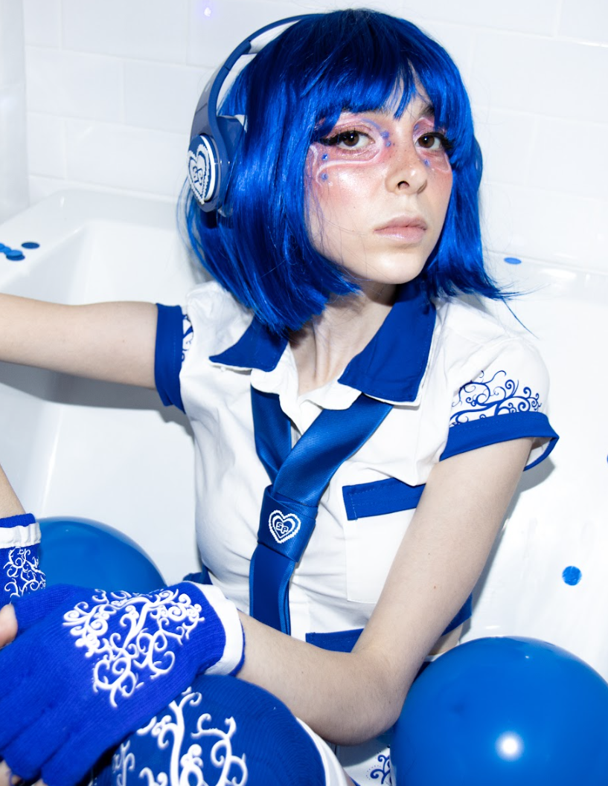

[**DOWNLOAD HI-RES PRESS PHOTO(S) HERE**](https://press.atlanticrecords.com/sites/g/files/g2000014001/files/styles/artist_detail/public/2023-06/Sophie%20Bathroom%20floor%20pic_0.png?itok=GOB4wMRu)

# # #

**SOPHIE POWERS**

**TOUR 2023**

**JUNE**

10 - Phoenix, AZ - The Van Buren *

11 - San Diego, CA - The Observatory North Park *

13 - Los Angeles, CA - Fonda Theatre *

14 - Los Angeles, CA - Fonda Theatre *

**AUGUST**

4 - West Hollywood, CA - Roxy Theatre †

5 - San Francisco, CA - Brick & Mortar Music Hall †

6 - Portland, OR – Holocene †

7 - Seattle, WA – Barboza †

9 - Salt Lake City, UT - Kilby Court †

10 - Denver, CO – Marquis †

12 - Minneapolis, MN - 7th Street Entry †

13 - Chicago, IL - Beat Kitchen †

15 - Detroit, MI - The Shelter †

16 - Columbus, OH - Ace of Cups †

* w/ Waterparks

† w/ poptropicaslutz!

# # #

**CONNECT WITH SOPHIE POWERS**

[WEBSITE](https://nam04.safelinks.protection.outlook.com/?url=https%3A%2F%2Fwww.sophiepowers.com%2F&data=05%7C01%7CKeliza.Lewinson%40atlanticrecords.com%7C71e7c3e4f71248720ee508db65f2623e%7C8367939002ec4ba1ad3d69da3fdd637e%7C0%7C0%7C638215863938679146%7CUnknown%7CTWFpbGZsb3d8eyJWIjoiMC4wLjAwMDAiLCJQIjoiV2luMzIiLCJBTiI6Ik1haWwiLCJXVCI6Mn0%3D%7C3000%7C%7C%7C&sdata=xddUuzHzMGtqbzaW85%2BMLr52bXUDjdwz6HAlp%2BlBvRM%3D&reserved=0) | [INSTAGRAM](https://nam04.safelinks.protection.outlook.com/?url=https%3A%2F%2Finstagram.com%2Fsophiep0wers&data=05%7C01%7CKeliza.Lewinson%40atlanticrecords.com%7C71e7c3e4f71248720ee508db65f2623e%7C8367939002ec4ba1ad3d69da3fdd637e%7C0%7C0%7C638215863938679146%7CUnknown%7CTWFpbGZsb3d8eyJWIjoiMC4wLjAwMDAiLCJQIjoiV2luMzIiLCJBTiI6Ik1haWwiLCJXVCI6Mn0%3D%7C3000%7C%7C%7C&sdata=CEt6%2FQkdydZD6tRDrfgp74Rf30LXB8JgLssfk37Rqm0%3D&reserved=0) | [TIKTOK](https://nam04.safelinks.protection.outlook.com/?url=https%3A%2F%2Fwww.tiktok.com%2F%40sophiep0wers%3Flang%3Den&data=05%7C01%7CKeliza.Lewinson%40atlanticrecords.com%7C71e7c3e4f71248720ee508db65f2623e%7C8367939002ec4ba1ad3d69da3fdd637e%7C0%7C0%7C638215863938679146%7CUnknown%7CTWFpbGZsb3d8eyJWIjoiMC4wLjAwMDAiLCJQIjoiV2luMzIiLCJBTiI6Ik1haWwiLCJXVCI6Mn0%3D%7C3000%7C%7C%7C&sdata=WfD2nzjtPyad8S6TxOmMgGl%2BQ%2B1ld3%2Fe%2FIjVbKNyO5Q%3D&reserved=0) | [TWITTER](https://nam04.safelinks.protection.outlook.com/?url=http%3A%2F%2Ftwitter.com%2Fsophiep0wers&data=05%7C01%7CKeliza.Lewinson%40atlanticrecords.com%7C71e7c3e4f71248720ee508db65f2623e%7C8367939002ec4ba1ad3d69da3fdd637e%7C0%7C0%7C638215863938679146%7CUnknown%7CTWFpbGZsb3d8eyJWIjoiMC4wLjAwMDAiLCJQIjoiV2luMzIiLCJBTiI6Ik1haWwiLCJXVCI6Mn0%3D%7C3000%7C%7C%7C&sdata=hNAdISh2YYV%2B3yWVa2NzKF8m6bUAaFi4yqiK9zojVsA%3D&reserved=0) | [YOUTUBE](https://nam04.safelinks.protection.outlook.com/?url=https%3A%2F%2Fwww.youtube.com%2Fchannel%2FUCYmYsadpU7tL0ki2HegFd7w&data=05%7C01%7CKeliza.Lewinson%40atlanticrecords.com%7C71e7c3e4f71248720ee508db65f2623e%7C8367939002ec4ba1ad3d69da3fdd637e%7C0%7C0%7C638215863938679146%7CUnknown%7CTWFpbGZsb3d8eyJWIjoiMC4wLjAwMDAiLCJQIjoiV2luMzIiLCJBTiI6Ik1haWwiLCJXVCI6Mn0%3D%7C3000%7C%7C%7C&sdata=dB6ywLsSCT7ah6PP%2F8bUp76yW%2BSHsnnUC1uhxRWjRtA%3D&reserved=0)