FOR IMMEDIATE RELEASE
JULY 14, 2023

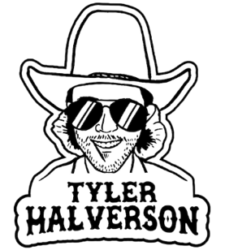

TYLER HALVERSON IS READY TO “RUN WILD”

ACCLAIMED SOUTH DAKOTA TROUBADOUR RETURNS WITH ROWDY NEW SINGLE

UPCOMING LIVE SCHEDULE INCLUDES HEADLINE DATES, FESTIVAL APPEARANCES,
AND ARENA SHOWS SUPPORTING COUNTRY STAR PARKER MCCOLLUM

LISTEN TO “RUN WILD”

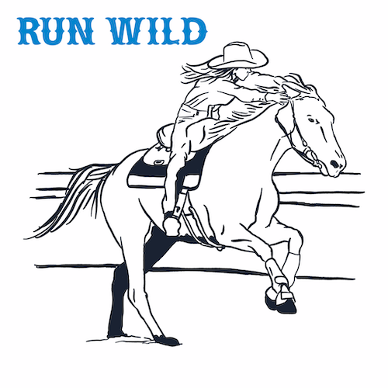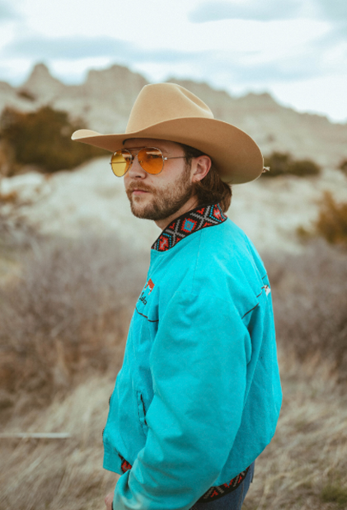
DOWNLOAD ARTWORK + PRESS PHOTO HERE
PRESS PHOTO CREDIT: WALES

“If you haven’t heard of Tyler Halverson, he needs to be on your radar.” – WHISKEY RIFF

South Dakota troubadour Tyler Halverson is back with his exuberantly boisterous new single, “Run Wild” - Listen HERE.

“Run Wild is one I wrote with me and my fed-up self,” shares Tyler. “It’s a cry for taking a chance and letting your heart run where it wants to.”

“Run Wild” marks the latest in a growing string of recent singles that includes “Her” and the emotionally charged “Cut You Loose,” both joined by official music videos – Watch HERE.

Halverson will “Run Wild” this summer with a busy live schedule that includes headline dates, festival appearances, and arena shows supporting Parker McCollum. Halverson is represented by legendary Nashville manager Erv Woolsey (George Strait, LeeAnn Womack) and Allen Mitchell of The Erv Woolsey Company. For complete details and updates, please visit tylerhalverson.com.

Born and raised in the tiny town of Canton, SD (pop. 3054), Tyler Halverson isn’t just any cowboy. He’s got the hat and the boots, but he also plays a mean guitar and writes an even meaner tune. He has no problem bouncing around the country chasing adventure (or a girl), and is telling his different kind of cowboy tale with his self-described “Amerijuana Music,” bridging honest storytelling with songcraft inspired by country powerhouses Garth Brooks, George Strait, and Hayes Carll as much as Boyz II Men, Taking Back Sunday, and The Used.

Halverson fell in thrall to music at an early age, receiving his first guitar while in middle school. A local bluegrass festival convinced him to focus on music, throwing down at 4H and FFA festivals before heading to Nashville to attend the prestigious Belmont University. Upon graduation, he decided to hit the road and spent an extended run traveling around South Dakota, Montana, and Wyoming, all the while writing and playing his songs on social media. Halverson’s original approach caught fire with a string of independent releases including “Beer Garden Baby,” “Mac Miller,” and “Your Bar Now” (with Kylie Frey), amassing tens of millions of streams. Now, with “Run Wild” and more new music still to come, Tyler Halverson is eager to take the next step on what has already proven an amazing journey.

“I’m finding myself,” says Tyler Halverson. “I feel like I’m an artist and I’m finally about to do something.”

# # #

TYLER HALVERSON
ON TOUR 2023

JULY
14 – Houston, TX – Armadillo Palace
15 – Johnson City, TX – Stone Valley Live
21 – Concan, TX – House Pasture Cattle Co.
28 – San Angelo, TX – Wild West Fest (8:30 pm)

AUGUST
4 – Fort Worth, TX – Billy Bob’s Texas
10 – Denver, CO – Mercury Café *
11 – Greeley, CO – Moxi Theater *
12 – Bosler, WY – Tom Horn Days
19 – Martell, NE – Salt Creek Summer Jam

SEPTEMBER
3 – Colville, WA – FarmJam Festival
8 – Tuscaloosa, AL – Tuscaloosa Amphitheater †
9 – Beaumont, TX – Ford Arena †

OCTOBER
8 – Ennis, TX – Stars Over Texas Music Festival 2023

w/ Ben Chapman
† w/ Parker McCollum

# # #

CONNECT WITH TYLER HALVERSON
OFFICIAL | FACEBOOK| INSTAGRAM | TIKTOK | TWITTER | YOUTUBE

PRESS CONTACT
Jessica Nall // Jessica.Nall@atlanticrecords.com

