FOR IMMEDIATE RELEASE
AUGUST 4, 2023

CORDAE RETURNS WITH “MAKE UP YOUR MIND”

FEEL-GOOD NEW SINGLE PRODUCED BY DR. LUKE

EPIC TOUR SCHEDULE INCLUDES NORTH AMERICAN DATES ALONGSIDE NF
PLUS TOP-BILLED FESTIVAL APPEARANCES ACROSS EUROPE

LISTEN TO “MAKE UP YOUR MIND”
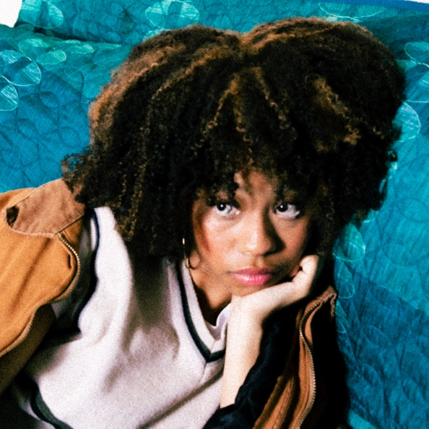
DOWNLOAD HI-RES ARTWORK

3x GRAMMY® Award-nominated and Emmy Award-winning rapper Cordae is back with his long-awaited new single, “Make Up Your Mind.” Produced by Dr. Luke (Doja Cat, Latto, Nicki Minaj) and co-written by Cordae, Lukasz Gottwald, Gamal “Lunchmoney” Lewis, Theron Thomas, and Rocco Valdes, the upbeat summer anthem is available now via ART@WAR/Atlantic Records.

“I just wanted to make a timeless song that makes people feel good,” says Cordae.

Cordae – who recently rocked the 2023 NBA All-Star Celebrity Game – is currently celebrating “Make Up Your Mind” and more new music to follow with a major North American live run supporting NF’s ongoing “Hope Tour.” Dates continue into early September. In addition, Cordae will light up a series of top European festivals including Biddinghuizen, Netherlands’ Lowlands Festival (August 18), Biel, Switzerland’s Royal Arena Festival 2023 (August 19), Kiewit-Hasselt, Belgium’s Pukkelpop (August 20), Oberhausen, Germany’s Hype Festival (August 25), Reading, UK’s Reading Festival (August 26), and Leeds, UK’s Leeds Festival (August 27). For complete details and remaining ticket availability, please visit www.cordaemusic.com.

CORDAE
ON TOUR 2023

AUGUST
4 – Glendale, AZ – Desert Diamond Arena
5 – Anaheim, CA – Honda Center
6 – San Francisco, CA – Bill Graham Civic Auditorium
8 – Portland, OR – Veterans Memorial Coliseum
9 – Seattle, WA – WAMU Theater
11 – Salt Lake City, UT – Vivint Arena
12 – Denver, CO – Ball Arena
18 – Biddinghuizen, Netherlands – Lowlands Festival *
19 – Biel, Switzerland – Royal Arena Festival 2023 *
20 - Kiewit-Hasselt, Belgium – Pukkelpop *
25 – Oberhausen, Germany – Hype Festival *
26 – Reading, UK – Reading Festival *
27 – Leeds, UK – Leeds Festival *
29 – Winnipeg, MB – Canada Life Centre

SEPTEMBER
1 – Toronto, ON – Scotiabank Arena
2 – Ottawa, ON – Canadian Tire Centre
3 – Laval, QC – Place Bell

ALL DATES W/ NF HOPE TOUR 2023 EXCEPT *

# # #

“Make Up Your Mind” follows such recent releases as “Two Tens (Feat. Anderson .Paak),” joined by an official music video currently boasting 6.3M YouTube views HERE. What’s more, Cordae is featured alongside the late Juice Wrld on Lyrical Lemonade’s “Hot 100” hit single, “Doomsday,” executive produced by Cole Bennett and accompanied by a groundbreaking companion video now approaching 9M views HERE.

ABOUT CORDAE
Cordae knows exactly what he wants to say. He chooses his words and phrases carefully. He speaks from a place of truth. That’s why the 3x GRAMMY® Award-nominated and Emmy Award-winning gold-selling Maryland-raised rapper has quietly become one of the modern generation’s most trusted narrators. A remarkable life has given him a lot to say. He went from trailer parks and public housing with his mom to stratospheric success. After a series of buzzing singles, he reached critical mass with his milestone 2019 debut album, The Lost Boy. Now boasting more than 430M worldwide streams and counting, the full-length project bowed among the top 15 on the Billboard 200 and includes the RIAA gold-certified singles, “Have Mercy,” “RNP (Feat Anderson .Paak),” “Broke As F**k,” and “Kung Fu.”

Beyond unanimous praise from Billboard, Complex, High Snobiety, the New York Times, Pitchfork, and Stereogum, Cordae garnered a pair of GRAMMY® Award nominations in the categories of “Best Rap Album” for The Lost Boy and “Best Rap Song” for the RIAA gold certified lead single, “Bad Idea (Feat. Chance the Rapper).” The rare artist whose presence can be felt on-screen in a Super Bowl commercial alongside legendary Academy® Award-winning director Martin Scorsese and among XXL’s coveted “Freshman Class,” Cordae linked up with Roddy Ricch for “Gifted” as well as joining forces with Eminem for “Killer.”

Deeply inspired by a life-changing trip to Africa, enduring the loss of a friend gone too soon, and evolving as an artist and a man, Cordae’s acclaimed sophomore album, From A Birds Eye View, sees him telling these stories and more through technicolor imagery, nimble rhymes, and fast evolving wisdom. Among its many highlights, From A Birds Eye View includes such singles as “Chronicles (Feat. H.E.R. & Lil Durk),” “Sinister (Feat. Lil Wayne),” “C Carter,” and “Super.” Cordae followed up with the visual only From A Birds Eye View (Live), available exclusively via Facebook. Further releases include the aforementioned “Two Tens (Feat. Anderson .Paak)“ as well as Cordae & Hit-Boy’s “Checkmate,” featured on EA Sports Madden NFL 23.

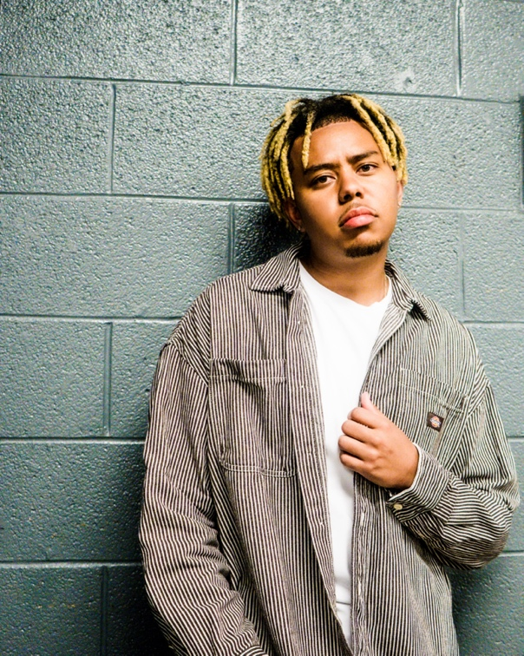
DOWNLOAD HI-RES PRESS IMAGE // PHOTO CREDIT:

CONNECT WITH CORDAE
WEBSITE | FACEBOOK | INSTAGRAM |TWITTER | YOUTUBE

PRESS CONTACT:
Brittany Bell | Brittany.Bell@atlanticrecords.com

