FOR IMMEDIATE RELEASE
JULY 26, 2023

NCOGNITA RETURNS WITH “SATURDAY (FT. COZZ)”

SOUTH CENTRAL LYRICIST LIGHTS UP SUMMER WITH ENERGIZED NEW SINGLE

“SATURDAY (FT. COZZ)” AVAILABLE NOW VIA RAEDIO/ATLANTIC RECORDS

LISTEN TO “SATURDAY (FT. COZZ)” HERE | WATCH VISUALIZER HERE

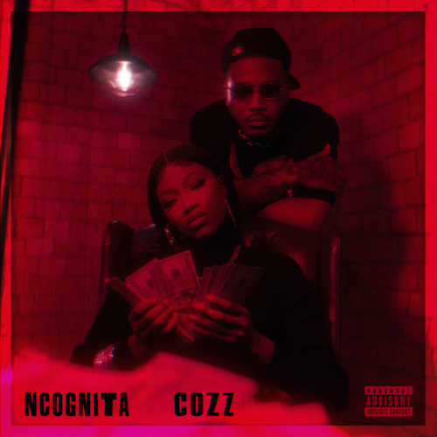
DOWNLOAD HI-RES ARTWORK HERE

Los Angeles, CA-based rapper-poet NCognita extends her 2023 run with her second single, “Saturday (Ft. Cozz),” available via Raedio/Atlantic Records at all DSPs and streaming services HERE. Watch visualizer HERE.

With fellow LA native and Dreamville artist Cozz featured on the record, NCognita continues to drive home the narrative that she is a Los Angeles rapper, and she is here to stay. Produced and originally recorded during Mardi Gras in New Orleans by legend BlaqNmilD (credits with Beyoncé, Drake, Big Freedia, and more), NCognita proves once again that she cannot be boxed in – introducing a new flow and vocal layering to her discography. At Camp Raedio for season 2 of Issa Rae’s Rap Sh!t on Max, NCognita connected with Cozz for his verse.

“This record is oxymoronic to what the title is – Saturday is usually a chill day, but this song is a reminder that even on your chill days you have to hustle… there are no days off. I was excited to try a new, melodic style for this record and am thankful that Cozz blessed me with one of his hardest verses (in my opinion).” -NCognita

“As soon as I heard the record, I immediately knew what to do. It’s rare I get that feeling when I hear a song. This song didn’t feel like work it was fun as hell to play with.” -Cozz

“Saturday (Ft. Cozz)” continues a major next chapter for NCognita, with additional new music to follow. The track arrives on the heels of the scintillating summer smash, “LA (Ft. Kalan.FrFr),” available HERE. An official visualizer is streaming at YouTube HERE.

“LA” marked the long anticipated follow-up to NCognita’s acclaimed 2022 major label debut EP, The Playbook, available now via Raedio/Atlantic Records HERE. Hailed for its raw energy and razor-sharp pen game, the EP includes the captivating single, “2x Freestyle (Ft. Tundra),” joined by a Jonathan Benavente-directed visual streaming HERE. In addition, NCognita celebrated The Playbook by showcasing her killer mic skills with explosive freestyles on Bars On I-95 and Fire In The Booth.

On the forthcoming season 2 of Max’s wildly popular series, Rap Sh!t, NCognita will appear on two releases from the soundtrack that will include multiple star power features. An official music video for “Saturday” will be landing soon, ensuring to drive the rest of NCognita’s upcoming and current catalog into the ears of new listeners.

Standing firm in the belief that words have incredible power, NCognita is a 21-year-old rapper and poet from Los Angeles. As the latest addition to Issa Rae’s music imprint under the renowned Atlantic Records umbrella, the South-Central native brings her unabashed confidence and impassioned lyrical dexterity to the consciously curated Raedio roster. With poetry as her first love, NCognita’s vibrant musical upbringing encouraged her to come into her own as a rapper. First embarking on the path of a recording artist during her senior year at the Los Angeles County High School for the Arts, NCognita decided to continue her musical education at Loyola University in New Orleans. Currently a senior in the Urban Electronic Music Production program, NCognita is grinding in every sense of the word, balancing her schoolwork and creative artistry, with new music due in the weeks and months to come.

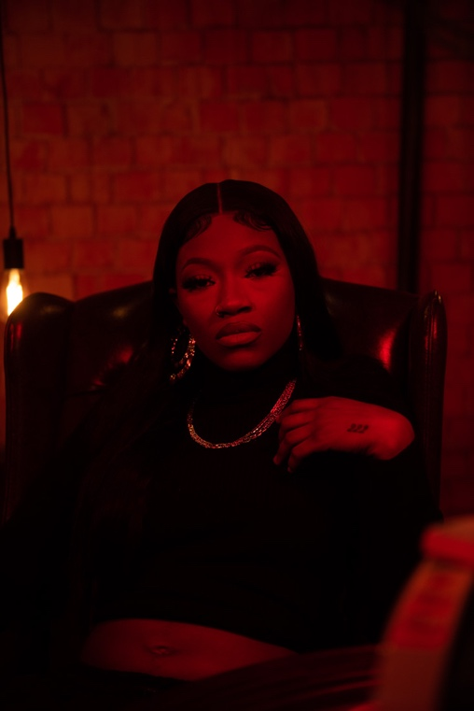
DOWNLOAD HI-RES IMAGE HERE

CONNECT WITH NCOGNITA
WEBSITE | TWITTER | INSTAGRAM | FACEBOOK | YOUTUBE

PRESS CONTACTS
Fairley McCaskill | Fairley.McCaskill@atlanticrecords.com

