FOR IMMEDIATE RELEASE
AUGUST 11, 2023

JOSH LEVI RELEASES ELECTRONIC REMIX OF STAND OUT SINGLE “EGO”
“EGO – ESTA. REMIX” AVAILABLE NOW ON ALL DSPS HERE

REMIX ARRIVES ON THE HEELS OF LEVI’S HYPNOTIC LIVE PERFORMANCE OF JAZMINE SULLIVAN’S GRAMMY® AWARD-NOMINATED “LIONS, TIGERS & BEARS” AS PART OF
THE RECORDING ACADEMY’S POPULAR “REIMAGINED” SERIES

WATCH OFFICIAL LIVE PERFORMANCE VIDEO
LISTEN TO “LIONS, TIGERS & BEARS “REIMAGINED” HERE

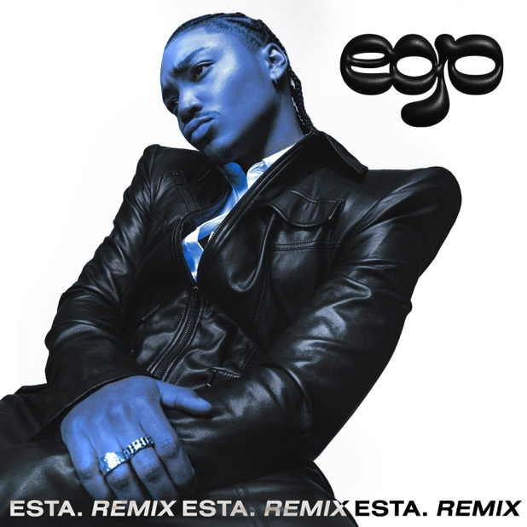
DOWNLOAD HI-RES ARTWORK

R&B sensation Josh Levi has joined forces with rising record producer and DJ, ESTA. to remix DISC TWO (SCRATCHED UP) stand out single, “EGO.” “I wanted to give “EGO” a bounce and a new energy with this remix,” says Levi. “It’s hotter than it’s ever been in the world and ESTA. (who I met at Raedio's Insecure writing camp) helped me bring the song into a new world. This one is for everyone that wants to get up and move around with their ego.” Remix available on all DSPS HERE.

“The ‘EGO’ remix came about just by pressing play on the acapella first thing in the morning and jamming on it,” says ESTA. “The drum pattern came first and led the way for the rest of the parts. Really had a blast making this and I hope you can hear it in the music.” ESTA most recently produced a handful of records alongside Mack Keane such as their joint EP, “Intersections” and their latest single, “Super.”

Levi was recently featured on The Recording Academy’s “Reimagined” series, where he performed a sublime rendition of Jazmine Sullivan’s GRAMMY® Award-nominated hit single, “Lions, Tigers & Bears”. Levi’s live performance of “Lions, Tigers & Bears (ReImagined)” is now available on DSPs HERE.

The braggadocious “EGO,” can be found on Levi’s most recent project, DISC TWO (SCRATCHED UP), a newly expanded deluxe version of his acclaimed 2022 EP, DISC TWO. Alongside “EGO,” two additional records were added to this new expanded project - “SEE LOW,” “BIRTHDAY DANCE,” and a sped-up reworking of DISC TWO’s hit single, “ALL OVER AGAIN.” To celebrate the release, not only did Levi release a steamy dance video for “EGO” streaming HERE, he also performed “EGO” and “SEE LOW” for THE EYE.

DISC TWO was released last year with a wide array of live performances as well as his first ever headline tour to date, “The VICES Tour,” highlighted by sold-out shows at Los Angeles, San Francisco, Chicago, Houston, New York, Atlanta, and other major markets across the country. Additional dates will be announced.

Levi’s 2020 debut EP, DISC ONE earned high profile media attention from the likes of Billboard, Wonderland, V, and Earmilk, which applauded the project as “an all-encompassing showcase of how much of an anomaly he is.” As a result, the gifted young artist caught the attention of Issa Rae’s label imprint, Raedio, featuring his 2021 single, “What’s The Use,” on the soundtrack to her critically acclaimed HBO Series, Insecure: Season 5.

Named by PEOPLE as one of “25 Emerging Musical Artists You Should Add to Your Playlist,” Josh Levi immediately captivates with each inhale of experience and exhale of emotion. The Houston, TX-raised and Los Angeles-based singer, songwriter, and actor developed a fervent fan base through roles on such hit series as Friday Night Lights as well as a series of viral YouTube covers, consistent touring, and of course, his featured vocal performance on the GRAMMY® Award-nominated, RIAA Gold-certified worldwide smash, “Nobody Like U,” written by GRAMMY® Award-winning singer-songwriters Billie Eilish and Finneas O’Connell for Disney/Pixar’s blockbuster Turning Red.

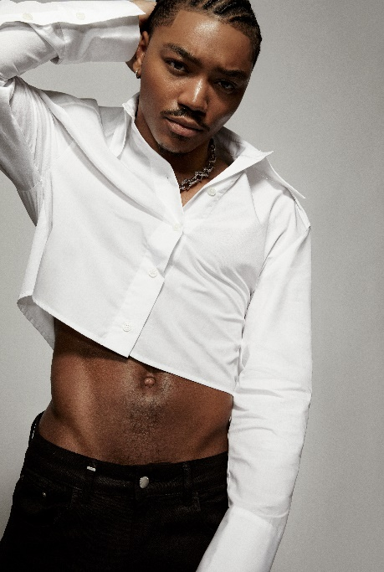
DOWNLOAD HI-RES PRESS IMAGE // PHOTO CREDIT: BLAIR CALDWELL

CONNECT WITH JOSH LEVI
OFFICIAL | FACEBOOK | INSTAGRAM | TIKTOK | TWITTER | YOUTUBE

PRESS CONTACT:
Brittany Bell | Brittany.Bell@atlanticrecords.com

