FOR IMMEDIATE RELEASE

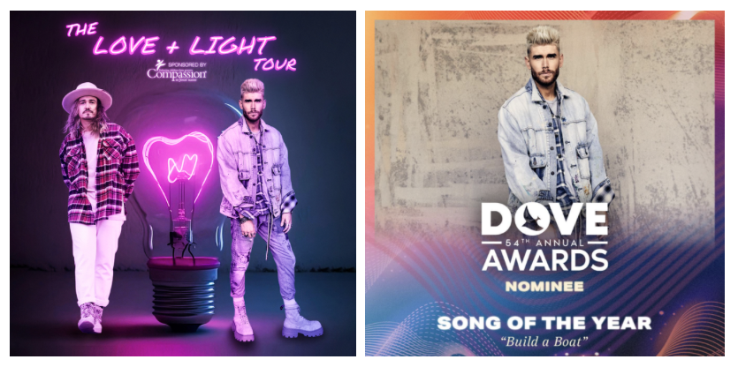

COLTON DIXON’S MASSIVE HIT
“BUILD A BOAT” DOVE AWARD-NOMINATED FOR SONG OF THE YEAR
Current success, “My Light,” hits top 10 on Mediabase Activator Chart
Dixon and Jordan Feliz drop dates for "The Love & Light Tour" hitting 28 U.S. cities this fall

Nashville, TN… August 15, 2023 – 2023 continues to propel Colton Dixon’s career, most recently receiving a GMA Dove Award nomination for Song of the Year with his massive hit “Build A Boat.” The nod for the 54th annual event follows the song’s K-LOVE Fan Award nomination for Song of the Year and what ultimately became the longest running No. 1 Mediabase Christian AC song of 2022.
Also featured on Dixon's April release of his bestselling 7-song EP, CANVAS (Atlantic) is his current single, “My Light” which continues to impact radio, rising to No. 10 on the Mediabase Activator Chart, and inching closer to such on others, currently sitting at No. 11 on Billboard's AC Monitored, at No. 12 Mediabase Christian AC, and No. 13 on Billboard's Christian Airplay chart respectively.
Earlier this spring Dixon and Jordan Feliz announced "The Love & Light Tour"coming this fall, and last week revealed where they'll be headed (see full listing below). Kicking off September 28 in Searcy, AR., the tour will hit U.S. 28 cities this fall, also including Dallas, TX., Portland, OR., Denver, CO., Cleveland, OH., and Lancaster, PA.. RSVP for on-sale alerts and limited VIP Q&A tickets are available at www.coltondixon.com.
Along with touring the festival circuit, Dixon has made several national television appearances this summer, starting with a live appearance of “My Light” on FOX & Friends outside on the FOX Plaza, followed by opening the K-LOVE Fan Awardsperforming "Build A Boat," with multi-platinum country star Gabby Barrett. On June 8, Dixon then appeared on The Kelly Clarkson show performing a special version of "My Light."

"The Love & Light Tour" (all dates subject to change):
September:
28 –Lions Arena Searcy High School– Searcy, AR
29 - Abundant Life Christian Center - La Marque, TX
30 - Hippodrome Theatre - Waco, TX*
October:
1 - Fellowship Dallas - Dallas, TX
3 - Moody Coliseum - Abilene, TX
5 - Without Walls Church - Mesa, AZ
6 - Bonita Valley Community Church - Bonita, CA
7 - Gateway Church - Visalia, CA
8 - Redding Civic Auditorium - Redding, CA
12 - Parkway Christian Center - Grants Pass, OR
13 - Sunset Church - Portland, OR
14 - Christ the King Community Church - Bellingham, WA
15 - Temple Theatre Tacoma - Tacoma, WA
18 - Riverside Baptist Church - Denver, CO
19 - Evangelical Free Church - Grand Island, NE
20 - Countryside Church - Spearfish, SD
27 - First Assembly of God - Montgomery, AL
28 - Earle May Boat Basin - Bainbridge, GA

November:
1 - Blue Gate Performing Arts Center - Shipshewana, IN
2 - Woodlands Church - Plover, WI
3 - Cuyahoga Valley Church - Cleveland, OH
4 - Timothy Christian High School - Elmhurst, IL
5 - St. Lorenz Lutheran Church - Frankenmuth, MI
10 - Harvest Church - Lexington, SC
11 - Charleston Southern University - North Charleston, SC
12 - Unity Baptist Church - Newnan, GA
16 - The Donnell Theater - Findlay, OH
17 - Lancaster Bible College - Lancaster, PA
18 - The Patriots Theater - Trenton, NJ
19 - Word of Life Ministries - Greensburg, PA
*Jordan Feliz not on this date

ABOUT COLTON DIXON:
Colton Dixon turns personal truths, stories, and experiences into universal anthems. He first emerged as a phenomenon after finishing in the top seven on Season 11 of Fox’s American Idol. Delivering a series of fan favorite albums, 2013’s A Messenger achieved “the biggest first-week sales by a new solo Christian act” and catapulted into the Top 15 of the Billboard 200 and #1 on the Billboard Christian Albums Chart, not to mention, joining the iconic company of Harry Connick, Jr. and Billy Joel as a Steinway & Sons artist. A year later, Anchor yielded his third and fourth #1 hits on Christian Hot AC with “More of You” and “Through It All.” In 2017, he returned to #1 on the Christian Albums Chart for the third time. He has collected a pair of Dove Awards in the categories of “Rock/Contemporary Album” and “Recorded Music Packaging.” Following an invite from the White House, he also shined at the 2019 National Christmas Tree Lighting Ceremony in addition to performing on Good Morning America, Entertainment Tonight and in the pages ofPeople magazine. During 2020, he embarked on a new chapter with Atlantic Records ignited by the self-titled Colton Dixon EP and runaway hit “Miracles”—one of his most popular tracks to date. 2022 saw him make his show-stopping debut at the Grand Ole Opry in the midst of kicking off another era, and experiencing a creative breakthrough with “Build A Boat.” Between the original and duet version with multiplatinum country songstress Gabby Barrett, it has reeled in nearly 100 million streams. It stood out as “the longest running Mediabase Christian AC #1 song of 2022” and locked down #1 on the Billboard Hot Christian Songs Chart and Christian AC Airplay Chart. People premiered the accompanying music video and hailed it as “inspiring” for its depiction of the work of medical charity Mercy Ships. Now, Dixon captivates once again on his 2023 EP, Canvas [Atlantic Records], introduced by the top ten single “My Light.”
GET CONNECTED WITH COLTON DIXON:
WEBSITE | TWITTER | FACEBOOK | YOUTUBE | TIKTOK | INSTAGRAM
Media Collective Contact:
Velvet Kelm
the media collective
velvet@themcollective.com
(615) 591-7989
www.themcollective.com

