DEATH CAB FOR CUTIE RELEASES “AN ARROW IN THE WALL” 12” SINGLE –
WITH B-SIDE REMIX BY CHVRCHES

LISTEN HERE | ORDER ON VINYL HERE

20TH ANNIVERSARY CO-HEADLINE TOUR WITH THE POSTAL SERVICE KICKS OFF SEPT. 5

EXTREMELY LIMITED TICKETS AVAILABLE FOR THIRD HOLLYWOOD BOWL SHOW ONLY – MORE INFO HERE

DEATH CAB FOR CUTIE’s TRANSATLANTICISM OFFICIALLY RIAA PLATINUM-CERTIFIED
ORDER BAND-EXCLUSIVE VINYL VARIANT HERE

COLLABORATION WITH THE SEATTLE MARINERS SET FOR AUGUST 30

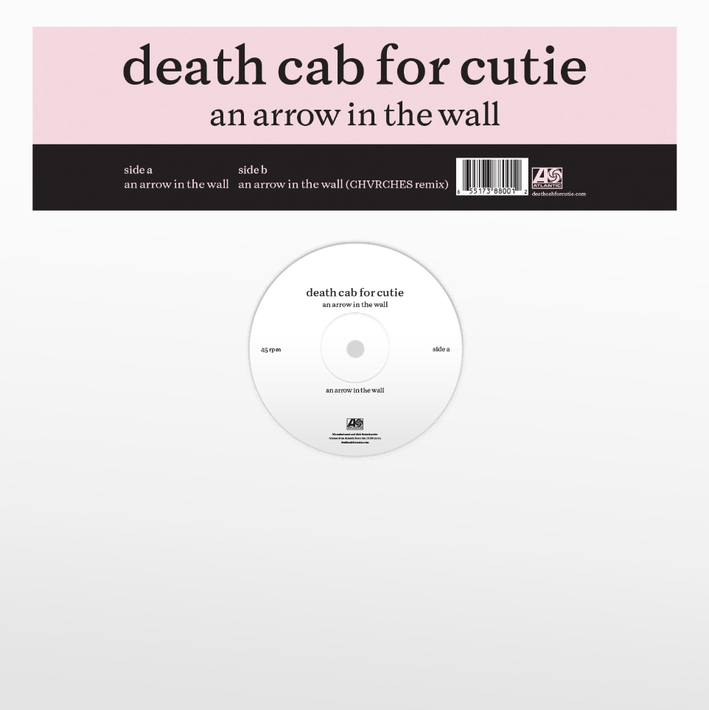
download hi-res artwork

8x GRAMMY® Award-nominated rock band Death Cab for Cutie has shared new two-sided, 12” single, “An Arrow in the Wall” (buy/stream here + order on vinyl here).

With an original recording produced by John Congleton, today’s release also includes a remix by synth-pop band CHVRCHES and visualizers courtesy of frequent collaborator Juliet Bryant (Justin Vernon, Japanese Breakfast, Laura Jane Grace) – watch the original visualizer here + remix visualizer here.

Of today’s release, lead vocalist and guitarist Ben Gibbard shares:

“‘An Arrow In the Wall’ is about the warning signs all around us in the 21st century that society-at-large is in decay. The arrow lodged in the wall might have missed this time, but it would be naive to assume the next one won’t also.

We have been good friends with CHVRCHES since touring together in 2019. They took our maudlin little dance track and turned it into a major key club banger.”

“An Arrow in the Wall” follows a series of exciting announcements from the band, who is gearing up to embark upon their highly-anticipated co-headline tour with The Postal Service this fall.

The tour will bring together tens of thousands of fans to celebrate the 20th anniversary of two seminal albums – Death Cab for Cutie’s Transatlanticism and The Postal Service’s Give Up (both released back in 2003 with a total recording budget of just $20k between the two LP’s).

The historic run kicks off September 5 in Washington DC and includes two sold-out nights at NYC’s Madison Square Garden, three shows at LA’s Hollywood Bowl and a recently-announced, already sold-out Chicago date at The Salt Shed, presented by Jam & Riot Fest and following both bands’ headline sets at September’s Riot Fest.

Earlier this year, the tour was named one of GQ’s “12 Pop Culture Releases We’re Most Looking Forward to in 2023” and one of the “23 concerts and albums” the Los Angeles Times is “most excited for in 2023.” Extremely limited tickets for the third and final Hollywood Bowl show can be accessed here; all other dates are entirely sold-out [full routing enclosed below].

Death Cab for Cutie is also celebrating Transatlanticism’s recent RIAA Platinum certification with a band-exclusive vinyl variant (order here).

Later this month, Death Cab for Cutie will partner with their hometown MLB team, the Seattle Mariners, for Death Cabby for Cutie day on August 30 to celebrate the 20th birthday of Transatlanticism, as well as second baseman José “Cabby” Caballero’s 27th birthday.

Fans who purchase tickets here and attend the Mariners’ August 30 game vs. the Oakland Athletics will have a chance to snag a limited edition Death Cabby for Cutie tee – based on the iconic design of the band's second studio album, We Have the Facts and We’re Voting Yes. A portion of the proceeds from ticket sales will benefit the Washington Low Income Housing Alliance.

The Postal Service and Death Cab for Cutie have also launched a limited-edition online poster series, to celebrate the upcoming tour. From August 9 through September 6, the bands will reveal a new poster available for pre-order each Wednesday, designed by a favorite artist of theirs. They’ve recruited Kozyndan, who created the artwork for three of the original Postal Service singles, as well as Jesse Ledoux, Jose Garcia of Zoca Studio, Kii Arens, and Brijean for the project. Posters will be available in both The Postal Service and Death Cab for Cutie webstores.

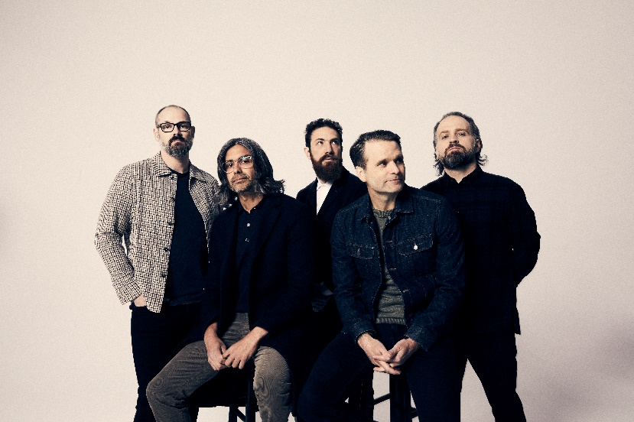
download hi-res Death Cab for Cutie press photo here; credit: Jimmy Fontaine

Death Cab for Cutie has already had a busy year, landing their 8th #1 at Triple A radio with the original studio version of “Pepper,” releasing stripped-down LP Asphalt Meadows (Acoustic) (buy/stream here) in March, and continuing to tour 2022’s Asphalt Meadows – their critically acclaimed 10th studio album – with sold-out shows throughout the US and UK/EU.

Co-produced by Andy Park (Pedro the Lion, Joseph, Noah Gunderson) and Death Cab for Cutie, Asphalt Meadows (Acoustic) was previewed by advance tracks “Foxglove Through The Clearcut (Acoustic),” “Pepper (Acoustic),” and a moving cover of “The Plan” – released in tribute to the late Mimi Parker, their close friend and drummer for the iconic band Low.

***

DEATH CAB FOR CUTIE x THE POSTAL SERVICE | 2023 CO-HEADLINE TOUR DATES

SEPTEMBER
5 – Washington, DC – The Anthem ! – SOLD OUT
6 – Washington, DC – The Anthem ! – SOLD OUT
8 – Portland, ME – Cross Insurance Arena ! – SOLD OUT
9 – Kingston, RI – Ryan Center ! – SOLD OUT
10 – New Haven, CT – Westville Music Bowl ! – SOLD OUT
12 – Boston, MA – MGM Music Hall at Fenway ! – SOLD OUT
13 – Boston, MA – MGM Music Hall at Fenway ! – SOLD OUT
14 – Washington, DC – Merriweather Post Pavilion ! – SOLD OUT
16 – Chicago, IL – Riot Fest
17 – Detroit, MI – Meadow Brook Amphitheater # – SOLD OUT
19 – New York, NY – Madison Square Garden # – SOLD OUT
20 – New York, NY – Madison Square Garden # – SOLD OUT
21 – Philadelphia, PA – Mann Center for the Performing Arts # – SOLD OUT
23 – Chicago, IL – The Salt Shed # – SOLD OUT
24 – Minneapolis, MN – The Armory # – SOLD OUT
26 – Denver, CO – Mission Ballroom # – SOLD OUT
27 – Denver, CO – Mission Ballroom # – SOLD OUT
28 – Denver, CO – Mission Ballroom # – SOLD OUT
30 – Austin, TX – Germania Insurance Amphitheater & – SOLD OUT

OCTOBER
1 – Grand Prairie, TX – Texas Trust CU Theatre & – SOLD OUT
3 – Phoenix, AZ – Arizona Financial Theatre & – SOLD OUT
4 – Las Vegas, NV – The Theater at Virgin Hotels & – SOLD OUT
6 – Seattle, WA – Climate Pledge Arena & – SOLD OUT
7 – Seattle, WA – Climate Pledge Arena & – SOLD OUT
9 – Berkeley, CA – Greek Theatre – UC Berkeley & – SOLD OUT
10 – Berkeley, CA – Greek Theatre – UC Berkeley & – SOLD OUT
11 – Berkeley, CA – Greek Theatre – UC Berkeley & – SOLD OUT
13 – Los Angeles, CA – Hollywood Bowl & – SOLD OUT
14 – Santa Barbara, CA – Santa Barbara Bowl ^ – SOLD OUT
15 – Los Angeles, CA – Hollywood Bowl % – SOLD OUT
17 – Los Angeles, CA – Hollywood Bowl @ – VERY LIMITED TIX REMAIN

! w/ Special Guest Lauren Mayberry
# w/ Special Guest Warpaint
& w/ Special Guest The Beths
% w/ Special Guest Built to Spill
@ w/ Special Guest Iron & Wine
^ w/ Special Guest Pedro the Lion

***

CONNECT WITH DEATH CAB FOR CUTIE
DEATHCABFORCUTIE.COM | FACEBOOK | TWITTER | INSTAGRAM | YOUTUBE | TIKTOK

CONNECT WITH THE POSTAL SERVICE
POSTALSERVICEMUSIC.NET | FACEBOOK | TWITTER | INSTAGRAM | YOUTUBE | TIKTOK

Death Cab for Cutie Press Contacts:
Sheila Richman | Sheila.Richman@atlanticrecords.com
Libby Kober | Libby.Kober@atlanticrecords.com

The Postal Service Press Contacts:
Steve Martin | steve@nastylittleman.com
Jillian Condran | jillian@nastylittleman.com

