FOR IMMEDIATE RELEASE
JULY 28, 2023

BROOKLYN SONGSTRESS ENISA RETURNS WITH SECOND SINGLE OF THE YEAR
“WHAT WOULD YOU DO”

ACCOMPANIED BY AN OFFICIAL COMPANION VISUAL

FOLLOW-UP TO RELEASE OF “BLAME IT ON ME”

RECENTLY OPENED FOR BEBE REXHA DURING HER BEST F’N NIGHT OF MY LIFE TOUR IN NYC

ENISA NOW THE FACE OF MTA’S ‘MUSIC UNDER NEW YORK’ PROGRAM IN
SUPPORT OF SUBWAY PERFORMERS

WATCH/SHARE “WHAT WOULD YOU DO”
DOWNLOAD/STREAM “WHAT WOULD YOU DO”

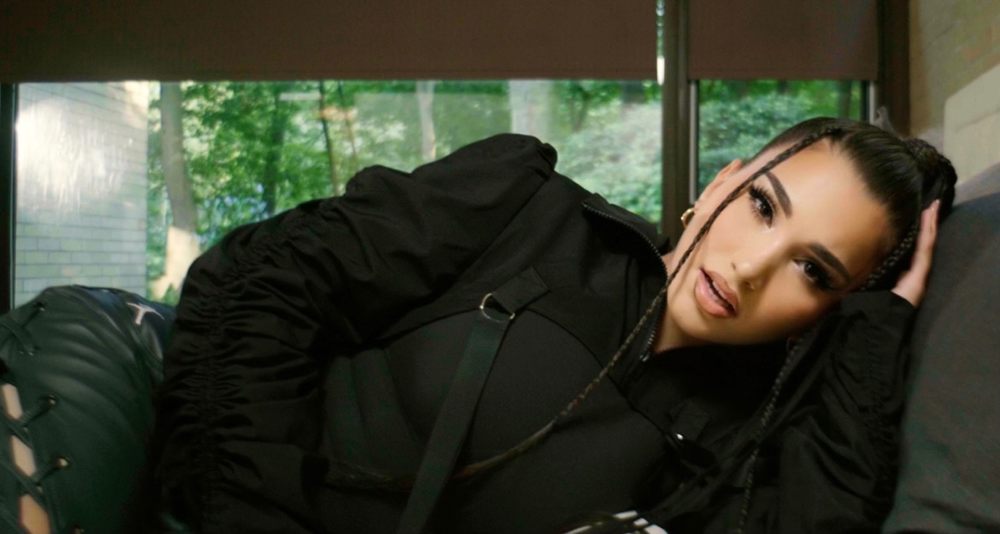

Brooklyn-based songstress Enisa has shared her latest single, “What Would You Do.” The energetic dance record is accompanied by a lively companion visual. “What Would You Do” comes on the heels of her opening for Bebe Rexha’s Best F’n Night of My Life Tour stop in NYC this past month along with her recently released single “Blame It On Me” (2.2M views) and collaboration with Galantis & JVKE on "Fool 4 U." She also recently collaborated with English electronic music DJ and producer, Riton, for “Never Knew Love.” Enisa is now also the face of the Music Under New York Program and hosts the event in partnership with the MTA. The campaign is meant to bring joy to New Yorkers and highlight all the wonderful talent that performs under the streets of NY in the subway for their version of American Idol for subway performers.

"This song is special to me because I wrote it when I was in a vulnerable spot. I didn’t want to write a sappy song, but instead a dance song with a deeper meaning that you can feel empowered listening to,” says Enisa. ‘What Would You Do’ is about realizing you have the power and won’t let anyone treat you less than you are worth. Coming after my dance collaboration with Galantis & JVKE, I was excited to share my own take of a dance record that stays true to my Middle Eastern roots! It’s a high energy summer empowerment anthem that everyone can dance to and genuinely feel good listening to!"

Enisa used 2022 to her advantage releasing a flurry of exciting singles following the release of her Fake Love EP. These releases include official visuals and in-studio performances for “Zoom” and “Just A Kiss (Muah).” She followed up these releases with her World Cup tribute song, “Olè,” which has now accumulated over 3.3M views. Enisa made her TV debut with her performance of her song “Green Light” on NBC’s American Song Contest.

With over 206M worldwide streams and more than 386M total video views, Enisa has proven a truly global favorite, earning chart-topping success in Albania, Turkey, Germany, Switzerland, France, Nigeria, Gambia, Portugal, Algeria, Tunisia, Morocco, Sri Lanka, and India, to name a few. “Get That Money” marked one of several singles in a continuing series of increasingly popular releases from the First Lady of Highbridge The Label, following “Tears Hit The Ground” (3M views), “Love Cycle” (17M views), “Dumb Boy” (17M views), and the smash hit, “Count My Blessings” (66M views).

ABOUT ENISA
Enisa has spent her whole life preparing for this journey as a first-generation American born to Albanian immigrant parents. Following her graduation from Brooklyn’s esteemed Edward R. Murrow High School, she attended Brooklyn College where she continued to develop her unique musical vision. A series of distinctive cover versions exploded across social media, earning her millions of views and critical acclaim from the likes of Complex, XXL, ThisSongIsSick, and more. With the wind at her back, Enisa continued to hone her diverse musical approach, infusing contemporary soul pop with Balkan and Middle Eastern flourishes with a touch of European pop inspired by her own Muslim heritage. Track releases like Scridge and Genda’s viral smash “Karma (Remix)” and such solo singles as “Burn This Bridge” and “Wait for Love” showcased a spectacular knack for raw soul and endless attitude, earning her more than 16M views and over 3M global streams as an independent artist.

2021 proved a milestone year for Enisa, highlighted by a cover appearance in Out Now, debut live performances at NYC’s legendary SOB’s and Sacramento, CA’s Lost In Riddim festival, and a social media explosion that now sees close to 9.7M total followers around the world, including 6.1M on TikTok and over 1.62M YouTube subscribers.

Early 2022 saw the release of Enisa’s Fake Love EP, a body of work that Enisa describes as “empowering” and “authentic” which features the standout tracks “Tears Hit The Ground” and “One Thing.” The year also brought with it, Enisa’s television debut as a contestant on the NBC musical reality competition “American Song Contest” in which she represented her home state of New York. With so many amazing highlights, it’s clear that 2022 was another blockbuster year for the Brooklyn-based songstress. Since then, Enisa has blessed fans with a flurry of releases including standout hits “Zoom” and “Just A Kiss (Muah).” She ended the year with a World Cup tribute song, “Olè,” which now boasts over 3.3M views.

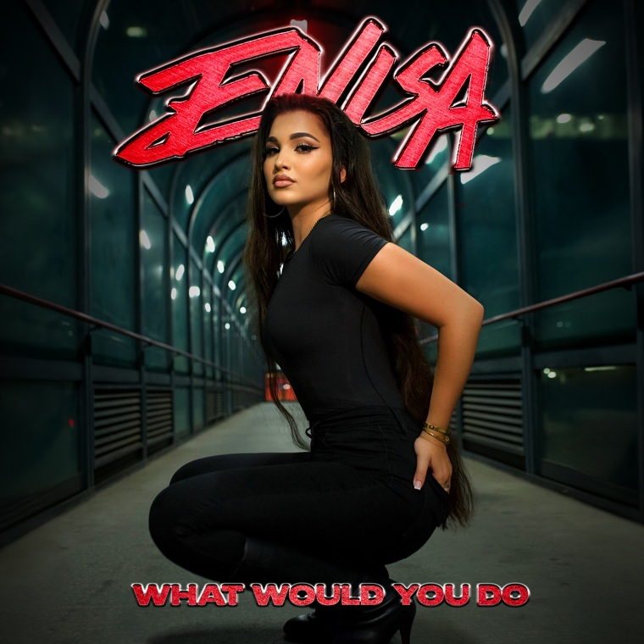
DOWNLOAD HI-RES ARTWORK

CONNECT WITH ENISA
OFFICIAL | INSTAGRAM | FACEBOOK | TWITTER | TIKTOK | YOUTUBE

FOR ALL INQUIRIES
SELAM BELAY
SELAM.BELAY@ATLANTICRECORDS.COM

