FOR IMMEDIATE RELEASE
AUGUST 11, 2023

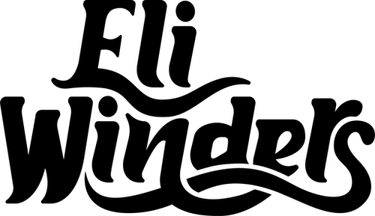

RISING COUNTRY STAR ELI WINDERS MAKES ATLANTIC RECORDS/BAD REALM RECORDS DEBUT WITH “PACK MY HOMETOWN”

19-YEAR-OLD SINGER-SONGWRITER RELEASES FIRST SINGLE
ALREADY A FAN FAVORITE WITH OVER 1M VIEWS ACROSS ELI’S PRE-RELEASE TIKTOK POSTS

LISTEN TO “PACK MY HOMETOWN” | WATCH OFFICIAL MUSIC VIDEO

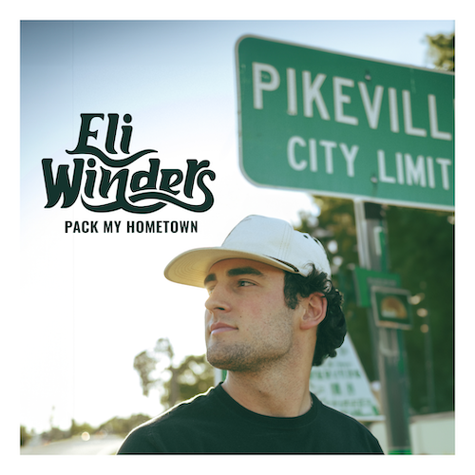
DOWNLOAD HI-RES ASSETS

Rising country singer-songwriter Eli Winders celebrates his signing to Atlantic Records/Bad Realm Records with a powerful debut single, “Pack My Hometown” – Listen HERE. Recorded in Nashville with producer/co-writer Eric Arjes (Tim McGraw, Lonestar), the deeply moving and bittersweet track – which was heralded in a series of TikTok teasers HERE that have amassed over 1M views – is joined by an official music video premiering today HERE.

“I’m excited to release ‘Pack My Hometown’ of course because it’s my first single, but also because it amazes me that a song so specific to my life resonates with other people,” says Eli. “‘Pack My Hometown’ is about leaving the place I have lived my entire life and all the memories I have there. It’s about chasing a dream, saying goodbye to everything I know and all the people who have supported me so far, and about the people I love who made it so hard for me to leave.”

Born and raised in the heartland of North Carolina, 19-year-old Eli Winders is a classic yet fresh voice in country music. After only having access to music through the radio until his teens, Winders’ musical exploration truly began when he received a phone for his 16th birthday – a gift that opened the door to streaming music for the first time. As he delved into a rich tapestry of melodies and lyrics, he found himself captivated by the timeless sounds of country music’s golden era and wanting to write songs of his own.

Throughout 2022, Winders dedicated his days to working in a feed mill, attending college classes at night, and scribbling song ideas between it all. His first breakthrough arrived when he began sharing his musical talents online. By posting heartfelt covers and soul-stirring original songs, Winders quickly gained an enthusiastic following, drawing in listeners with his genuine artistry and Carolina charm. Recognizing the young artist’s exceptional talent and commitment to his craft, Atlantic/Bad Realm Records fulfilled a dream for Winders, swiftly signing him to their roster. Now, with the arrival of “Pack My Hometown” and the promise of more music to come, Eli Winders’ musical journey has truly begun in earnest.

# # #

CONNECT WITH ELI WINDERS:
INSTAGRAM | TIKTOK | YOUTUBE

CONTACT:
Jessica Nall // jessica.nall@atlanticrecords.com

