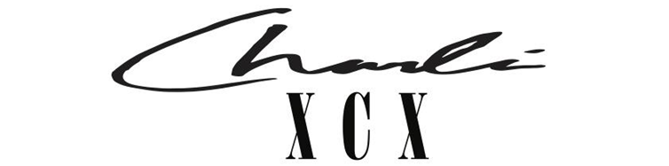
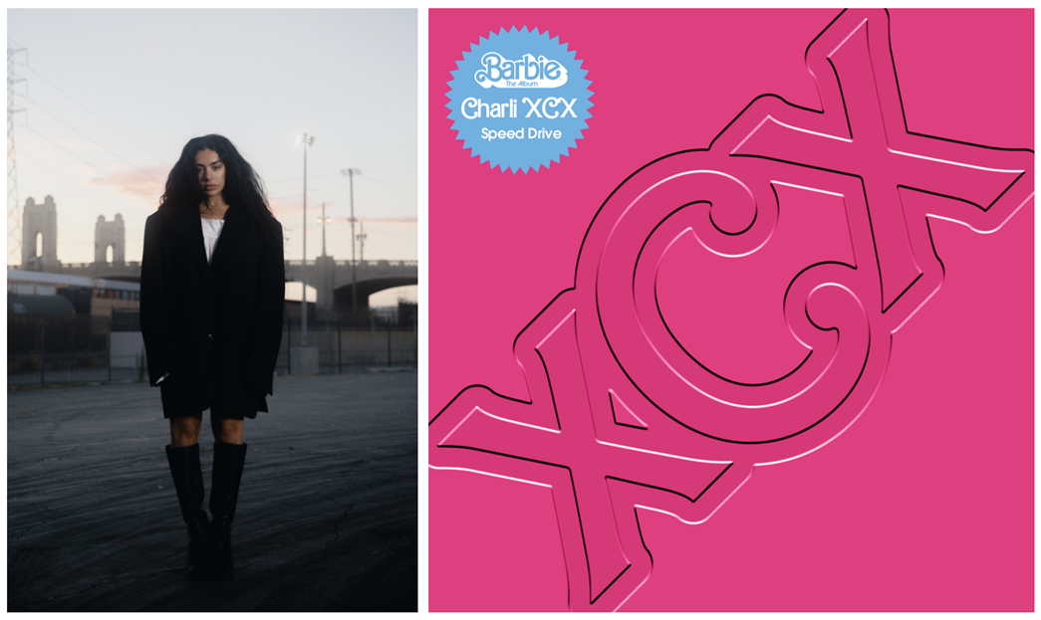

CHARLI XCX SPEEDS INTO BARBIE LAND
IN OFFICIAL MUSIC VIDEO FOR ‘SPEED DRIVE’

BARBIE THE ALBUM SURPASSES 1B+ GLOBAL STREAMS

WATCH THE VIDEO HERE
IMAGES HERE
STREAM THE TRACK HERE

Charli XCX releases her official music video for ‘Speed Drive’, her track from Barbie The Album. ‘Speed Drive’ has amassed over 70M global streams, hit #9 on the UK Official Charts and entered the Billboard Hot 100 becoming Charli’s fifth song to chart in the US.

Filmed in Los Angeles, the video was co-directed by Charli with Ramez Silyan, starring Charli and Devon Lee Carlson racing a pink Corvette convertible under the Californian sun. In the video Charli teases an upcoming project with Sam Smith when she receives a phone call from Sam on her Samsung Galaxy Z Flip5.

Charli continues to position herself as a prolific collaborator in the film space, producing original scores and tracks for feature film story-telling. Earlier this year Charli made ‘Hot Girl’, the official song for A24 teen slasher film Bodies, Bodies, Bodies directed by Halina Reijn and starring Rachel Sennott; the track instantly went down as a cult fan favorite. She has contributed to the original score of teen queer comedy Bottoms directed by Emma Seligman releasing August 25th in the US. Next up Charli is co-executive producing with Jack Antonoff the musical score for Mother Mary, David Lowry’s film which follows a fictional pop musician starring Anne Hathaway and Michaela Cole due for release in 2024. As an actress Charli has been cast in the reboot of the 1978 cult horror classic Faces of Death which is currently under production.

Atlantic Records’ Barbie The Album, the groundbreaking and star-studded musical companion to Warner Bros. Pictures’ Barbie, now surpasses over 1B global streams. Greta Gerwig’s Barbie is now officially #1 at the global box office surpassing $1B worldwide and counting.

Charli XCX image assets here.
Follow Charli XCX here.
Barbie The Album assets here.

Charli XCX press inquiries: jemma@huxley.world, emily@huxley.world, nic@huxley.world
Barbie The Album press inquiries: andrew.george@atlanticrecords.com

