FOR IMMEDIATE RELEASE
AUGUST 11, 2023

Fred again.. teams up with Obongjayar on new single
‘adore u’

LISTEN HERE

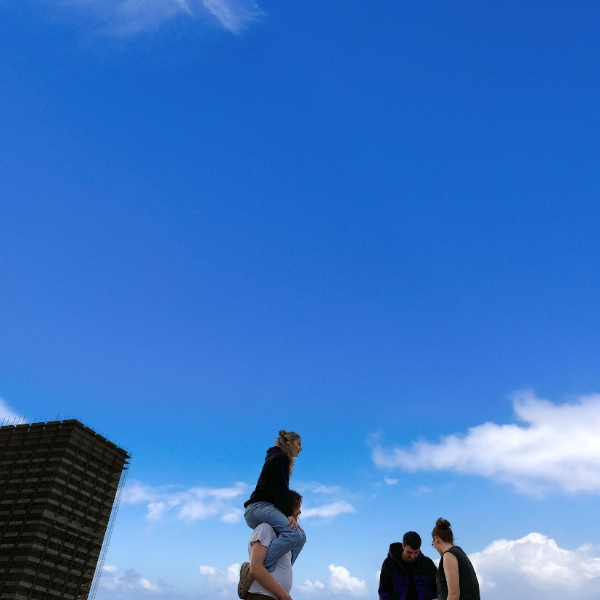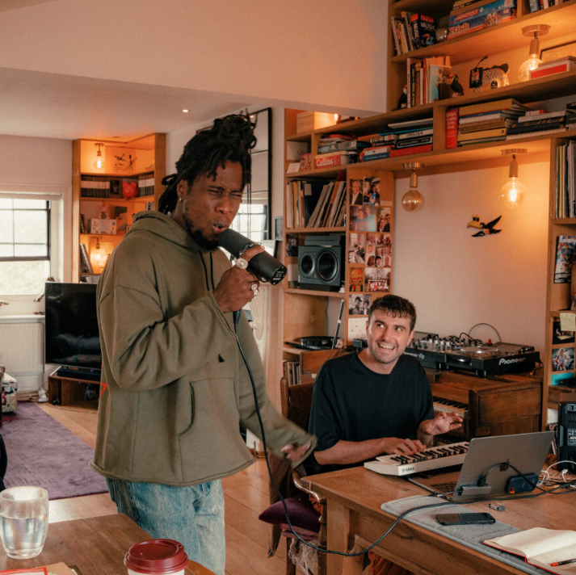
DOWNLOAD PRESS ASSETS HERE

FRED AGAIN..’S HISTORIC RUN OF LIVE SHOWS IN NEW YORK AND LOS ANGELES
COMMENCES THIS FALL

THREE NIGHTS AT NY’S FOREST HILLS STADIUM (OCT. 12-14)
AND EIGHT NIGHTS AT LA’S SHRINE EXPO HALL (OCT. 24-25, 27-29, 31, NOV. 1-2)
https://www.fredagain.com/tour/

Fresh from his headline-grabbing Lollapalooza set and after show at Byline Bank Aragon Ballroom in Chicago, plus seeing critically acclaimed album ‘Actual Life 3’ recently shortlisted for the 2023 Mercury Prize, Fred again.. has teamed up with Obongjayar on new single, ‘adore u’ – listen HERE.
A euphoric, standout moment from Fred’s Lollapalooza set, ‘adore u’ – a track dedicated to Fred’s sister that samples heartfelt lyrics lifted from Obongjayar’s 2022 debut album, ‘Some Nights I Dream Of Doors’ – lands as Fred’s first new music of the summer, with more on the horizon soon.
Performed live by Fred and Obongjayar for the first time in Chicago last weekend, ‘adore u’ is released ahead of Fred’s unprecedented run of live shows in New York and Los Angeles with three nights at Forest Hills, NY’s Forest Hills Stadium (October 12-14) and an eight-night residency at Los Angeles, CA’s Shrine Expo Hall (October 24-25, 27-29, 31, November 1-2), with tickets completely selling-out in a matter of minutes after going on sale in June.
Prior to his US run of shows, Fred will be playing a series of sold-out shows across Europe, including a four-date, sold-out headline run at London’s Alexandra Palace beginning on September 4.
For more information on Fred again..’s live dates, please visit: https://www.fredagain.com/tour/
With the release of ‘Actual Life 3’ last autumn firmly cementing Fred again.. as one of the most unique and vividly creative electronic artists in the world, 2023 has seen Fred take his career to new heights. He kickstarted the year with the release of ‘Rumble’ in January – crowning moment of his unforgettable Boiler Room debut last summer – alongside Skrillex and veteran grime MC, Flowdan.
After playing a series of pop-up shows in London alongside Skrillex and Four Tet later that month, the trio then went on to sell-out the iconic Madison Square Garden in New York in February – over 19,000 tickets were sold in less than 10 minutes – and later headline the final night of Coachella, playing to over 125,000 people and an additional 3 million who have since re-watched their set on YouTube.
Elsewhere in 2023, Fred also recorded a special Tiny Desk Concert for NPR in April, which saw him relearn the marimba, play a vibraphone, sit at a piano and loop beats on his laptop simultaneously, while in May, he joined forces with Brian Eno on ‘Secret Life’ – a surprise-drop 13 track ambient album released on Four Tet’s Text Records imprint.
If that wasn’t enough, Fred’s critically-acclaimed Glastonbury debut in June saw him pull one of the largest crowds in the Other Stage’s history – a career-defining moment only compounded by the news that ‘Actual Life 3’ has been shortlisted for the 2023 Mercury Prize.
For more information on the Mercury Prize 2023 shortlist, please visit: https://www.mercuryprize.com/2023-shortlist
‘adore u’ is out now: https://fredagain.lnk.to/adoreu

CONNECT WITH Fred again..
OFFICIAL SITE / INSTAGRAM / TIK TOK

CONNECT WITH OBONGJAYAR:
INSTAGRAM / TIK TOK / TWITTER / YOUTUBE

