FOR IMMEDIATE RELEASE
JUNE 23, 2023

GALANTIS RETURNS WITH “BANG BANG! (MY NEURODIVERGENT ANTHEM)”

NEW SINGLE KICKS OFF HOTLY ANTICIPATED 4TH ALBUM ERA

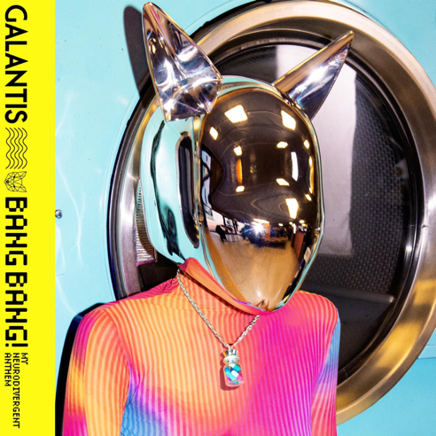
DOWNLOAD HIGH-RES IMAGES/ARTWORK

WATCH/STREAM “BANG BANG! (MY NEURODIVERGENT ANTHEM)”: LINK

Internationally-acclaimed dance music project Galantis returns with exhilarating new single “BANG BANG! (My Neurodivergent Anthem)” – available now via Big Beat Records alongside a Dano Cerny-directed video companion starring Piiper. The release kicks off their hotly anticipated fourth album era, which will mark the first full-length since 2020’s Church.

Defined as “individual differences in brain functioning regarded as normal variations within the human population” by Merriam-Webster, the term neurodiversity presents a theme of inclusion running throughout the forthcoming Galantis project. With a booming chorus echoing “BANG BANG! It’s in my head,” the pulsating anthem gives a sonic representation to different types of thought and communication that according to this concept, should exist in a non-stigmatized way.

“I wasn’t diagnosed with ADHD until I was an adult, but had known for a long time that I was wired differently. The knowledge brought clarity to the chaos, yet it also led to a period of self doubt and confusion. My brain has the motor of a Ferrari and the brakes of a bicycle, and the only way I had been able to sustain was by keeping it activated non-stop with music. I quietly began a long trial and error process of medicating, trying to find a solution that worked for me – ‘Pharmacy’ wasn’t the name of the first Galantis album by coincidence.

Eventually I learned more about neurodiversity, and found myself to be part of a community that was living through experiences similar to my own. Every day I’m learning more about who I really am and how my brain works, it’s a comfort to be connected with people who are on that same journey. Neurodiversity encapsulates all the different variations of the human mind, none of us are alone or less than.

As humans, we’re all different. We look different, we sound different, and just like that – we think different. Music is about bringing people together, and I want to make songs that unite people and promote inclusivity among all types of mental divergence. I called ‘BANG BANG!’ my neurodivergent anthem because like the chorus echoes, ‘it’s in my head.’ These thoughts, these questions, these stigmas we work to erase. Letting go of what we’ve been conditioned to perceive as ‘normal’ and embracing our own unique identities.

It’s the prescription I’ve been looking for.”

– Christian Karlsson

Galantis is the dance music project of Christian Karlsson (aka Bloodshy). Their RIAA gold-certified debut album Pharmacy reached No. 1 on the Billboard Dance album chart on the strength of gold-certified single “Peanut Butter Jelly” and 3x platinum certified smash “Runaway (U & I)” – the latter of which earned a GRAMMY nomination for “Best Dance Recording” – while 2017’s sophomore album The Aviary (featuring platinum-certified single “No Money”) saw a top 10 debut in 23 countries. The third Galantis album, 2020’s Church, featured the chart-topping gold-certified single “Faith” with country music icon Dolly Parton featuring Mr. Probz, which saw a #1 debut on Billboard’s Dance/Electronic Chart before quickly reaching #1 on the Dance/Mix Show Airplay Chart where it remained for 5 weeks. Meanwhile, gold-certified collaborative single “Heartbreak Anthem” with David Guetta & Little Mix proved a global sensation, spending 10 weeks on the Billboard Global 200 chart and 13 consecutive weeks in the top 10 on the UK Official Chart. Galantis has received over 5 billion cumulative worldwide streams and over 1.8 billion video views to date.

One of dance music's most dynamic and in-demand live performers, Galantis is set to continue an exciting slate of live performances later this month, including the second annual set of sold-out Midsommar headline shows at Brooklyn Mirage on June 29th and 30th. For full live routing and ticket information, please visit wearegalantis.com.

Christian Karlsson (also known as Bloodshy) has been at the helm of Galantis since 2009 before officially debuting the project at 2014’s Coachella Valley Music and Arts Festival. His career has spanned across the musical genres of punk-rock, hip-hop and pop – including work as one half of acclaimed production duo Bloodshy & Avant and one third of indie pop band Miike Snow. Karlsson’s songwriting/production credits have included the likes of Madonna, Kylie Minogue, Katy Perry and extensive work with Britney Spears (including “Toxic” which earned a GRAMMY for “Best Dance Recording” and her widely acclaimed 2007 album Blackout). As Galantis, he has crafted remixes for the likes of Coldplay, Selena Gomez, Ed Sheeran, Sam Smith & more. Declared “pop’s mastermind producer” by UPROXX and “eternally effervescent” by Billboard, the Swedish-born artist continues to evolve and push the boundaries of songwriting within the world of dance music and beyond.

DOWNLOAD HIGH-RES IMAGES/ARTWORK

CONNECT WITH GALANTIS:
WeAreGalantis.com | Twitter | Facebook | YouTube | Instagram | Assets

CONTACT:
Ted Sullivan | Ted.Sullivan@atlanticrecords.com

