FOR IMMEDIATE RELEASE
JUNE 16, 2023

MULTI-PLATINUM SUPERSTAR GUCCI MANE ANNOUNCES NEW ALBUM
BREATH OF FRESH AIR

NEW SINGLE “BLUFFIN” FEATURING LIL BABY ARRIVES TODAY

ACCOMPANIED BY AN OFFICIAL COMPANION VISUAL SHOT IN LAS VEGAS

TRACK WILL BE FEATURED ON UPCOMING ALBUM DUE TO RELEASE ON OCT 13TH

BREATH OF FRESH AIR AVAILABLE FOR PRE-ORDER NOW

WATCH/SHARE “BLUFFIN”
DOWNLOAD/STREAM “BLUFFIN”
PRE-ORDER BREATH OF FRESH AIR

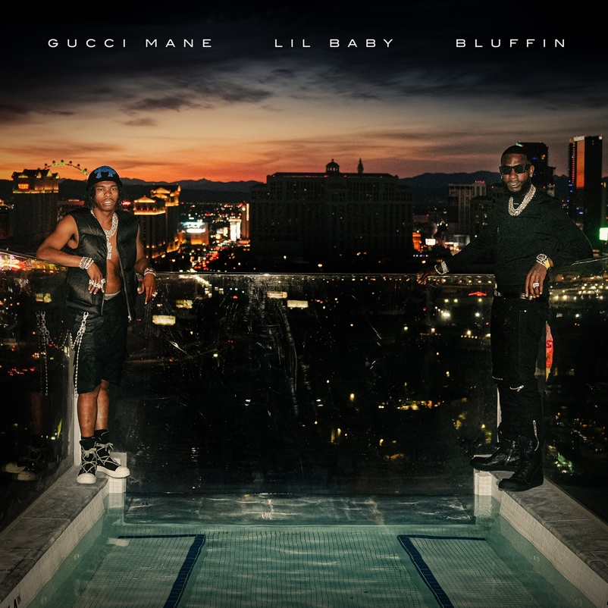
DOWNLOAD HI-RES ARTWORK

GRAMMY® Award-nominated, 13+ billion streaming superstar Gucci Mane and multi-platinum rap icon, Lil Baby, team up for Gucci’s latest single “Bluffin” via Atlantic Records/The New 1017 Records. The single is accompanied by a companion visual shot in Las Vegas and is available for streaming HERE. Arriving alongside the single and visual is the official pre-order launch and announcement of Gucci’s forthcoming album, Breath Of Fresh Air, scheduled to release on October 13th, 2023.

“I lead by example and help everybody get money…had to bet
on myself and make nothing to something…” – GUCCI MANE

“Bluffin” marks Gucci’s fourth single release of 2023 and will be included on the upcoming album, Breath Of Fresh Air. The single follows previously released “Pissy (Feat. Roddy Rich and Nardo Wick)” which has now garnered over 9M+ US streams and 2M+ YouTube views to date. Prior to these, Gucci also released “06 Gucci (Feat. DaBaby and 21 Savage)” which now boasts 7M+ US streams and 6M+ views to date. Gucci kicked off this year with “King Snipe (Feat. Kodak Black)” and it has now garnered over 20M+ US streams and 17M+ views to date.

Currently boasting over 13 billion global streams and more than 3.4 billion official views on YouTube, Gucci Mane wrapped up 2022 with his latest New 1017 compilation, SO ICY BOYZ: THE FINALE, available via Atlantic Records/The New 1017 Records. The 24-track collection sees Gucci joined by some of the most recent members of The New 1017 roster, including KATO2X, Li Rye, Mac Critter, Sett, And TLE Cinco, along with features from such certified R&B/hip-hop superstars as Jeremih, Trey Songz, 2 Chainz, and OJ Da Juiceman. Among the anthology’s undeniable highlights are such bangers as Gucci’s “Met Gala Remix (Feat. Offset, Sett, Mac Critter, KATO2X),” Li Rye’s “Too Many (Feat. Gucci Mane),” and TLE Cinco x Gucci Mane’s “Hitting,” all of which are joined by companion music videos streaming now via the official Gucci Mane YouTube channel HERE.
Widely regarded as one of the most influential rappers of the past decade, Gucci Mane has more top 10 albums on Billboard’s “Top Rap Albums” chart than any other hip-hop artist in history. Along with new releases from Gucci Mane himself, the seasoned A&R has taken his eye for the next big thing to his own record label, The New 1017, in partnership with Atlantic Records. The New 1017 showcases Gucci’s platinum-certified A&R skills with a roster that includes BiC Fizzle, Big Scarr, BigWalkDog, Enchanting, Foogiano, Hotboy Wes, KATO2X, Li Rye, Lil Zay, Mac Critter, Pooh Shiesty, Sett, and TLE Cinco.
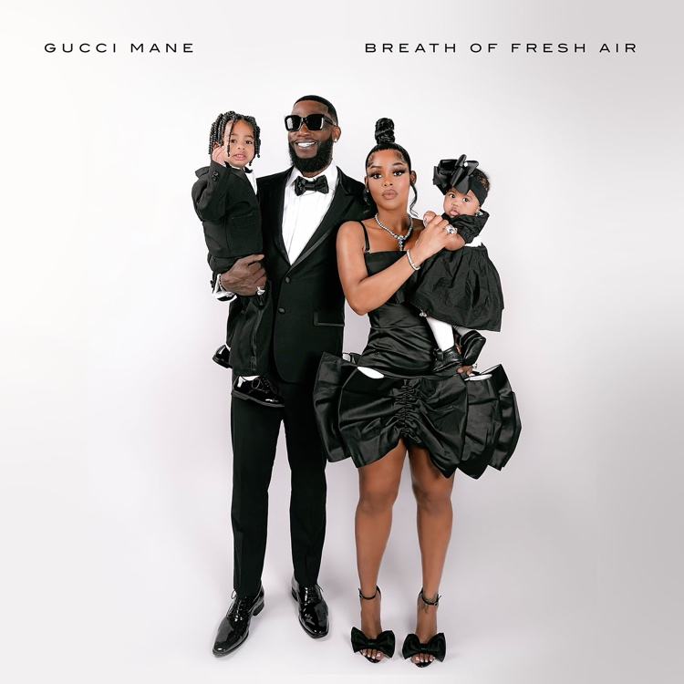
DOWNLOAD HI-RES ARTWORK

# # #

CONNECT WITH GUCCI MANE
OFFICIAL | INSTAGRAM | TWITTER I FACEBOOK I YOUTUBE

GUCCI MANE & THE NEW 1017 PRESS CONTACT
Ashley Kalmanowitz | Ashley.Kalmanowitz@atlanticrecords.com

