FOR IMMEDIATE RELEASE
AUGUST 7, 2023

JANELLE MONÁE EXPANDS THE AGE OF PLEASURE TOUR

AWARD-WINNING SUPERSTAR ADDS NEW DATES TO NORTH AMERICAN TOUR
NOW WITH STOPS IN INDIANAPOLIS, IN, COLUMBUS, OH, AND NEW ORLEANS, LA
PLUS ADDITIONAL DATE ADDED IN WASHINGTON, DC

PRESALES BEGIN TUESDAY, AUGUST 8 AT 10:00 AM (LOCAL)
GENERAL ON-SALES START FRIDAY, AUGUST 11 AT 10:00 AM (LOCAL)

PRODUCED BY LIVE NATION, THE AGE OF PLEASURE TOUR
GETS UNDERWAY AUGUST 30 IN SEATTLE, WA

ACCLAIMED NEW ALBUM, THE AGE OF PLEASURE, AVAILABLE NOW HERE
VIA WONDALAND ARTS SOCIETY/ATLANTIC RECORDS

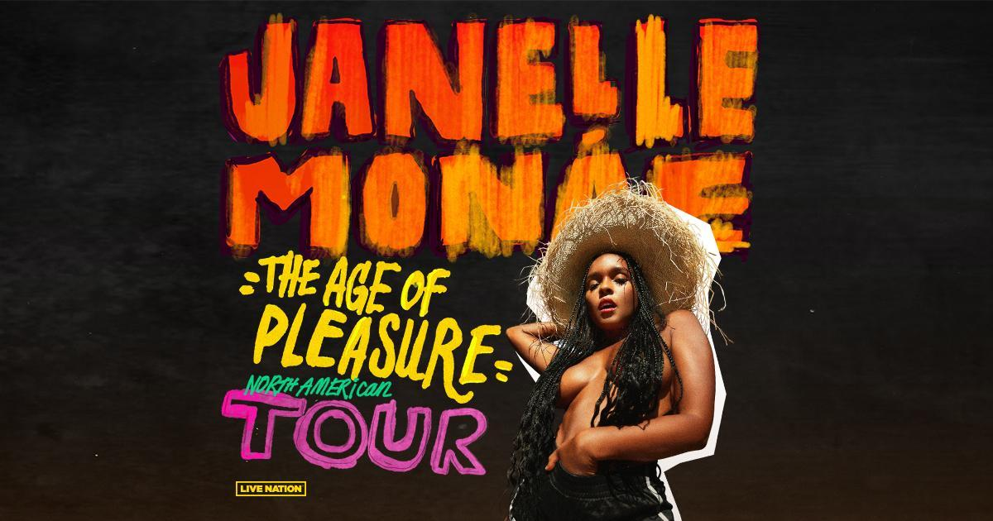

Janelle Monáe has expanded her blockbuster Age of Pleasure Tour, adding new dates at Indianapolis, IN’s Egyptian Room at Old National Centre (September 10), Columbus, OH’s Mershon Auditorium (September 15), and New Orleans, LA’s Orpheum Theatre (October 7), as well as an additional show by popular demand at Washington, DC’s The Anthem (September 25). Artist presales begin Tuesday, August 8 at 10:00 am (local). All other presales begin Wednesday, August 9 at 10:00 am (local). General on-sales begin Friday, August 11 at 10:00 am (local). For complete details, please see www.jmonae.com.

Produced by Live Nation, The Age of Pleasure Tour gets underway August 30 at Seattle, WA’s WAMU Theater and then makes stops across North America through mid-October. Highlights include visits to such historic venues as Morrison, CO’s Red Rocks Amphitheatre (September 7), Toronto, ON’s Massey Hall (September 21, 22), New York City’s Radio City Music Hall (September 26), Atlanta, GA’s Fox Theatre (October 6), and San Francisco, CA’s Bill Graham Civic Auditorium (October 17).

The Age of Pleasure Tour celebrates Monaé’s critically acclaimed new album, THE AGE OF PLEASURE, available now via Wondaland Arts Society/Atlantic Records HERE. Executive produced by Janelle Monáe, Nate Wonder, Chuck Lightning, and Sean “Diddy” Combs, THE AGE OF PLEASURE includes such scintillating new singles as “Water Slide,” “Lipstick Lover,” and “Float (Feat. Seun Kuti + Egypt 80).” Official music videos and much more are streaming now HERE.

ABOUT JANELLE MONÁE
Janelle Monáe is without question one of the most celebrated artists of the modern era, an 8x GRAMMY® Award-nominated singer, songwriter, producer, performer, actor and fashion icon known worldwide for her inimitable style and visionary sound. With multiple celebrated albums, THE ARCHANDROID (2010), THE ELECTRIC LADY (2013), and DIRTY COMPUTER (2018), numerous critically-acclaimed theatrical and television performances, and her unwavering activism for social justice and the LGBTQIA+ community, Monáe continues to be one of the most compelling and important artists of this generation.

ABOUT LIVE NATION ENTERTAINMENT
Live Nation Entertainment (NYSE: LYV) is the world’s leading live entertainment company comprised of global market leaders: Ticketmaster, Live Nation Concerts, and Live Nation Sponsorship. For additional information, visit www.livenationentertainment.com.

# # #

JANELLE MONÁE
THE AGE OF PLEASURE TOUR

AUGUST
30 – Seattle, WA – WAMU Theater
31 – Vancouver, BC – UBC - Doug Mitchell Thunderbird Sports Centre

SEPTEMBER
2 – Portland, OR – RV Inn Style Resorts Amphitheater
6 –Salt Lake City, UT – The Complex
7 – Morrison, CO – Red Rocks Amphitheatre
9 – Kansas City, MO – The Midland Theatre
10 – Indianapolis, IN - Egyptian Room at Old National Centre *
11 – Minneapolis, MN – Armory
13 – St. Louis, MO – Stifel Theatre
14 – Chicago, IL – Byline Bank Aragon Ballroom
15 – Columbus, OH – Mershon Auditorium *
17 – Boston, MA – MGM Music Hall at Fenway
18 – Philadelphia, PA – The Met
20 – Montreal, QC – Mtelus
21 – Toronto, ON – Massey Hall
22 – Toronto, ON – Massey Hall
24 – Washington, DC – The Anthem †
25 – Washington, DC – The Anthem * †
26 – New York City, NY – Radio City Music Hall
28 – Brooklyn, NY – Kings Theatre

OCTOBER
2 – Charlotte, NC – Skyla Credit Union Amphitheatre
3 – Nashville, TN – Ryman Auditorium
4 – Birmingham, AL – Avondale Brewing Company
6 – Atlanta, GA – Fox Theatre Atlanta
7 – New Orleans, LA – Orpheum Theatre*
9 – Dallas, TX – The Pavilion at Toyota Music Factory
10 – Houston, TX – Bayou Music Center
11 – Austin, TX – Moody Amphitheater
15 – Phoenix, AZ – Arizona Financial Theatre
17 – San Francisco, CA – Bill Graham Civic Auditorium
18 – Inglewood, CA – YouTube Theater

* NEW DATE
† NOT PRODUCED BY LIVE NATION

# # #
DOWNLOAD PRESS PHOTO HERE
PHOTO CREDIT: MASON ROSE

CONNECT WITH JANELLE MONÁE
OFFICIAL | FACEBOOK | INSTAGRAM | TWITTER | YOUTUBE | PRESS ASSETS

JANELLE MONÁE PR CONTACTS
Ashley Kalmanowitz // Ashley.kalmanowitz@atlanticrecords.com
Jessica Nall // Jessica.Nall@atlanticrecords.com
Kelly Bush Novak // kbushnovak@id-pr.com
Court Barrett // cbarrett@id-pr.com
Elif Mamak // emamak@id-pr.com

LIVE NATION CONCERTS
Monique Sowinski // moniquesowinski@livenation.com
Navier Grimes // naviergrimes@livenation.com
Valeska Thomas // valeskathomas@livenation.com

