JESSE® UNVEILS NEW MIXTAPE &ONE

DIAMOND-CERTIFIED SINGER/SONGWRITER/PRODUCER CONTINUES NEW SOLO CHAPTER WITH NEW 11-TRACK MIXTAPE

ATLANTIC RECORDS DEBUT ALBUM COMING SOON

DOWNLOAD/STREAM &ONE

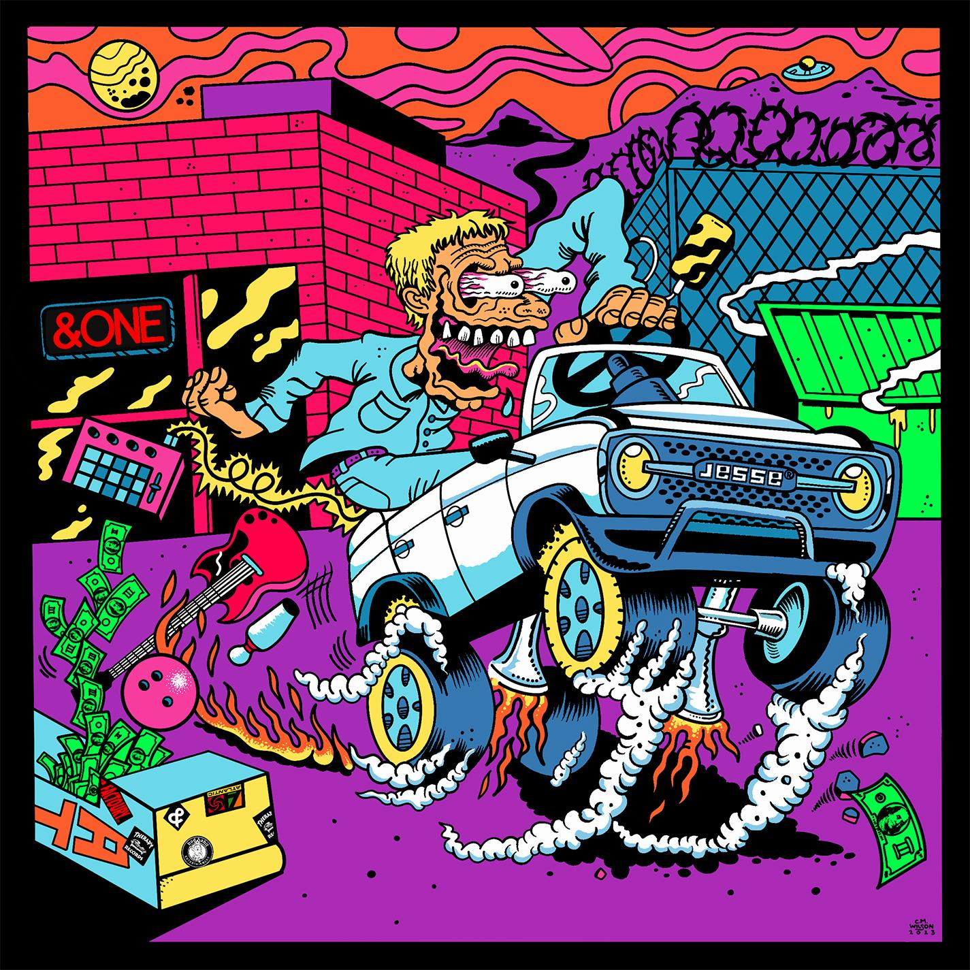
(download photos & artwork)

(August 18, 2023 – NEW YORK, NY) Acclaimed singer/songwriter/producer & creator of Diamond-certified band The Neighbourhood, Jesse® unveils new solo mixtape &ONE – out today via Atlantic Records: Download/Stream here.

With production from Jesse®, as well as Sickdrumz, Noah, William Van Zandt and more, the mixtape features 11-brand new songs. &ONE follows singles “Play” and “Joker” & “Rainbow” which kicked off the musician’s new solo chapter with Atlantic Records. “Play” and “Joker” & “Rainbow” all arrived alongside companion visuals: watch here.

&ONE TRACKLIST
1. SECOND RODEO
2. DX
3. TURN HEEL
4. AB&ON
5. LAW OF ATTRACTION
6. POV
7. #2
8. MY WAR
9. OVERWHELMING
10. LAVENDER
11. CRISIS

(download photos & artwork)

For all Jesse® press inquiries, please contact:
Jason Davis jason.davis@atlanticrecords.com

ABOUT JESSE®
Jesse® explores identity through music and has occupied a curious corner of popular culture in doing so as lead singer for multi-platinum, chart-topping alternative stalwarts The Neighbourhood, as a sought-after collaborator, and as a solo artist. However, it’s via this solo artistry that you’ll get as close to Jesse as possible. After The Neighbourhood had finished out their record contract with the delivery of 2020’s full-length LP, Chip Chrome & The Mono-Tones, it was time for a new journey. With billions of streams, multi-platinum singles and albums, and widespread critical acclaim under their collective belt, the group sold out Forest Hills Stadium in Queens, NY and enjoyed a rapturous packed-to-the-rafters homecoming at The Hollywood Bowl in Los Angeles, CA. Now, the singer, songwriter, producer and multi-instrumentalist embarks on the next chapter with an Atlantic Records debut album on the way.

# # #

