JOHNNY YUKON HEATS UP THE SUMMER WITH “WHISPERS”
RISING SINGER-SONGWRITER-PRODUCER RETURNS WITH NEW SINGLE

OFFICIAL MUSIC VIDEO PREMIERES TODAY

SET TO PERFORM AT SUNDAY SOUNDS ON JULY 9 IN LOS ANGELES

LISTEN TO “WHISPERS” | WATCH OFFICIAL MUSIC VIDEO

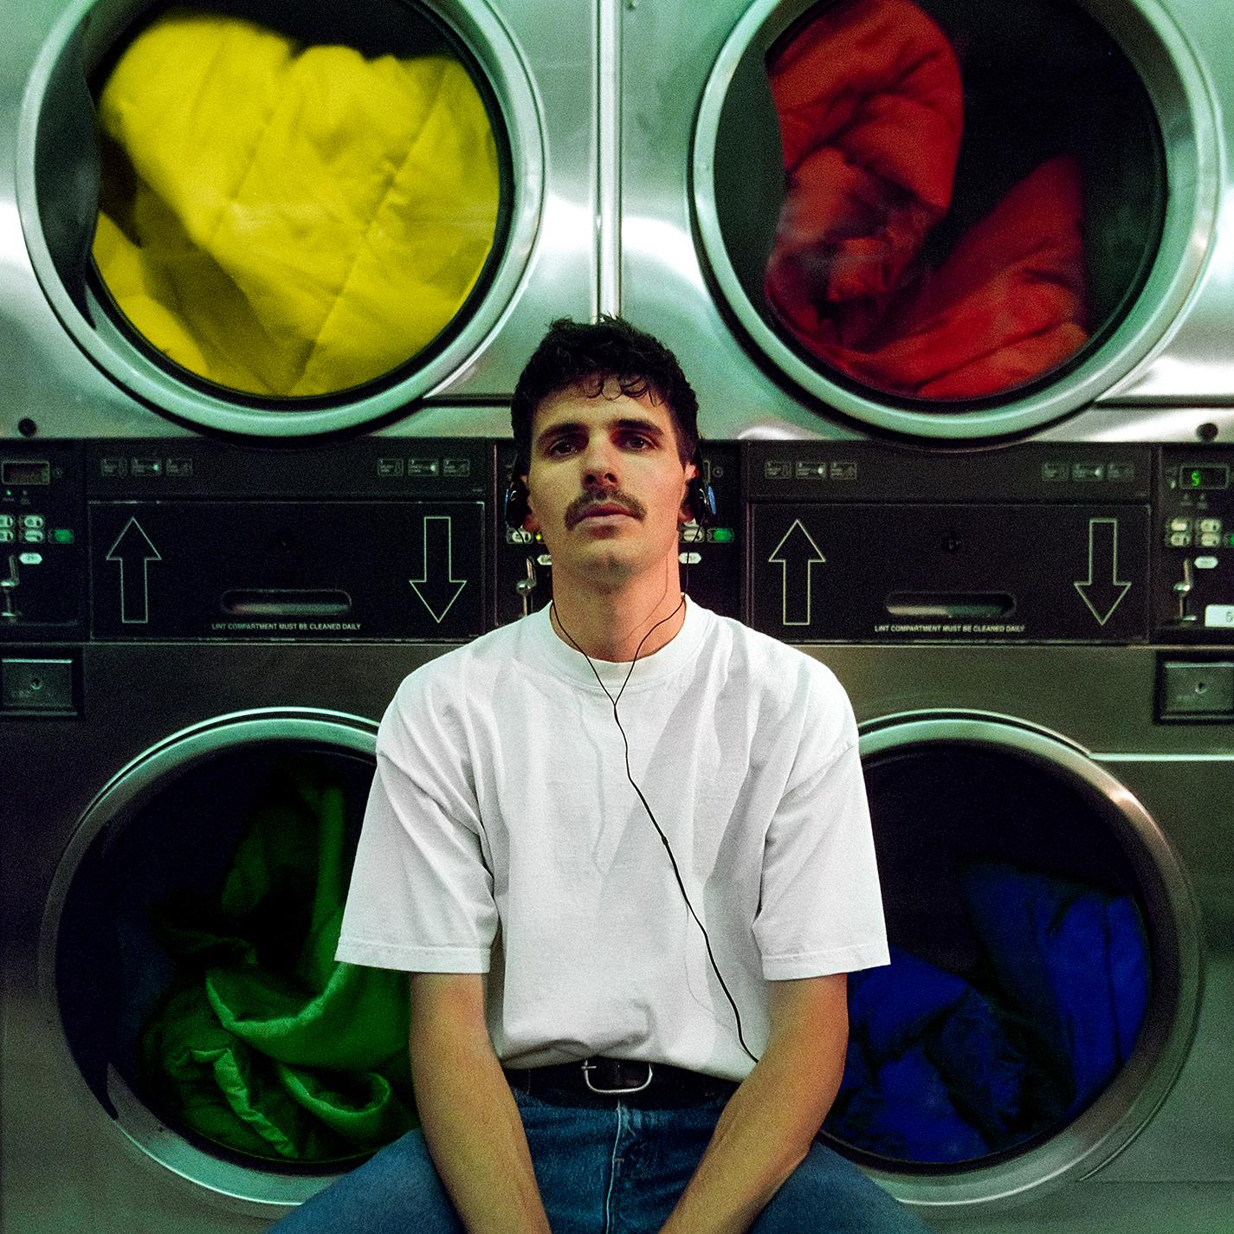
DOWNLOAD HI-RES ARTWORK

New York, NY (June 30, 2023) – Rising singer-songwriter-producer Johnny Yukon shares new single, “Whispers,” available now via Atlantic Records. An official music video, directed by frequent collaborator Griffin Olis (Lil Pump, YBN Cordae), premieres today at YouTube HERE.

“Whispers” – which was written and produced by Yukon — continues a growing string of releases from Yukon, including the glittering “Gloria !” and the energetically charged “Do You Feel It?,” the latter produced by Tiggi (Drake, Roddy Ricch, 21 Savage, DJ Khaled). Both tracks are joined by cinematic companion music videos, directed by GiRLFRIEND and streaming now at Yukon’s official YouTube channel HERE.

Yukon is set to perform at Sunday Sounds, an underground music festival in Los Angeles on July 9th. For more tickets and additional info, please visit this LINK.

Best known for pairing his projects with grainy visuals captured on Super 8 film and fashion-forward stills rooted in vintage, yet modern panache, Johnny Yukon upholds consistent cinematic motifs across sound and style. His world draws as much from Kubrickian attention to detail and Christopher Nolan-style scope as it does from unpredictable production and hazy melodicism. With a goal to “make bigger music that reaches a lot of people,” Yukon kickstarted what has proven a truly prolific creative streak with such vibrantly original tracks as “Moment” (currently boasting over 2.6M Spotify streams), “Comet,” “Whatever You Want,” and a dazzling cover of The Buggles’ timeless “Video Killed The Radio Star.”

“I really feel like I’m being myself in this music,” says Johnny Yukon. “I’m trying to make songs that either brighten your day or help you through something. Maybe, it will get your morning started right or keep your mental health okay. I love sad songs, but I don’t take myself too seriously. At the moment, I just want to encourage people to dance and have fun.”

ABOUT JOHNNY YUKON
Johnny Yukon uplifts by crafting the soundtrack to the best night of your life—whether it be for gazing at the stars, falling in love under the disco ball, or when you just need something to belt along to at drunken karaoke. The Pennsylvania-born and Los Angeles-based singer, songwriter, and producer has continued to widen his imprint across popular culture. Yukon initially established himself as a sought-after collaborator. As a songwriter and producer, his catalog has expanded with cuts for everyone from Young Thug and Ty Dolla $ign to Camilla Cabello and G-Eazy. Various highlights have included co-writing Internet Money’s 4x-Platinum, Billboard “Hot 100” Top 10 hit, “Lemonade,” Louis Tomlinson’s “Too Young,” and Lil Wayne’s “Open Letter” and “What About Me,” in addition to co-producing PARTYNEXTDOOR’s “Trauma.” Yukon further ignited the F9 Soundtrack, penning “Lane Switcha” by Skepta, Pop Smoke, A$AP Rocky, Juicy J, and Project Pat. As a solo artist, Yukon has notably served up fan favorite projects such as Installation I [2018] and Flight Plan 001 [2021]. Of the latter, Variance proclaimed, “The singer-producer is soaring into the stratosphere.” Having piled up tens of millions of streams as a solo artist, Johnny Yukon only magnifies his presence with “Whispers” and much more to come in 2023 and beyond.

CONNECT WITH JOHNNY YUKON
JOHNNYYUKON.COM | INSTAGRAM | TIKTOK | TWITTER | YOUTUBE

FOR ALL PRESS INQUIRES, PLEASE CONTACT:
Jason Davis – jason.davis@atlanticrecords.com

