FOR IMMEDIATE RELEASE
AUGUST 4, 2023

KEVIN GATES RELEASES LATEST SINGLE AND VISUAL FOR “I DON’T APOLOGIZE”

FOLLOW-UP TO RE-RELEASE OF STRANGER THAN FICTION MIXTAPE

GEARING UP TO RELEASE NEW PROJECT AHEAD OF UPCOMING TOUR

‘ONLY THE GENERALS’ NATIONAL TOUR KICKS OFF ON OCTOBER 6TH IN PORTSMOUTH, VA

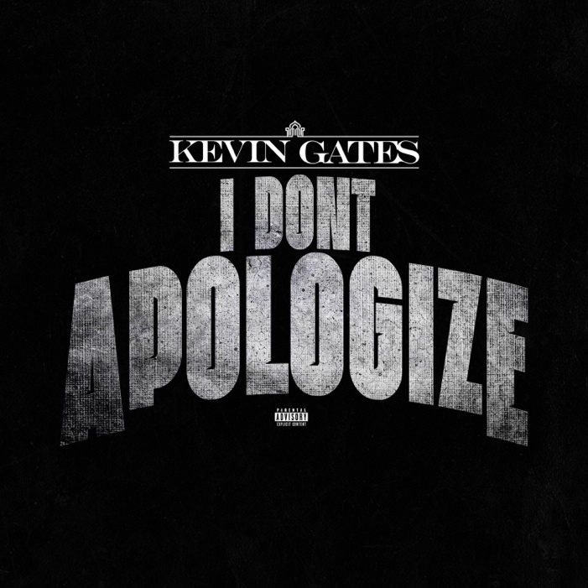
DOWNLOAD HI-RES ARTWORK
WATCH HERE | STREAM HERE

RIAA multi-platinum certified rap superstar, Kevin Gates, releases his latest single and visual for “I Don’t Apologize.” On the single, Kevin inspires his fans and takes them on a journey as he reflects on his success and self-love. The official music video was shot around this year’s BET Awards show depicting Kevin getting ready for the event and walking the carpet with his long-time partner, Dreka. “I Don’t Apologize” is the first track from the new project meant to warm fans up for the series of new music coming down the pipeline. The single also comes on the heels of the re-release of the Billboard 200 charting mixtape, Stranger Than Fiction. The newest version of the mixtape includes two new official remixes of the RIAA-certified platinum single, “Thinking With My D*ck.”

Last month, Kevin announced his new ‘Only The Generals’ national tour. The tour will span 30 shows and will kick off in Portsmouth, VA on October 6th with direct support from BigXthaPlug on select dates and Hosted by DJ Chose across all dates. Tickets are now on sale at kvngates.com. The tour announcement comes on the heels of Kevin’s previously released single and visual, “Do It Again.” Kevin kicked the year off with the single and visual “Breakfast” and the re-release of his debut mixtape, The Luca Brasi Story (A Decade of Brasi) to celebrate the 10-year anniversary of the project.

KEVIN GATES ONLY THE GENERALS TOUR

OCTOBER
6 – Portsmouth, VA – Atlantic Union Bank Pavilion
7 – Atlanta, GA – Lakewood Amphitheatre~
10 – St. Louis, MO – The Factory
11 – Indianapolis, IN – TCU Amphitheater at White River State Park
12 – Cincinnati, OH – The Andrew J Brady Music Center
13 – Sterling Heights, MI – Michigan Lottery Amphitheatre at Freedom Hill
14 – Lexington, KY – Rupp Arena16 – Grand Rapids, MI – GLC Live at 20 Monroe
17 – Minneapolis, MN – The Armory
18 – Kansas City, MO – Uptown Theater
19 – Omaha, NE – The Astro
20 – Wichita, KS – The Cotillion
21 – Colorado Springs, CO – The Broadmoor World Arena
24 – Albuquerque, NM – Revel
26 – San Antonio, TX – Boeing Center at Tech Port
27 – San Angelo, TX – Riverstage
28 – Corpus Christi, TX – Concrete Street Amphitheater
31 – Dallas, TX – Toyota Music Factory~

NOVEMBER
1 – Houston, TX – 713 Music Hall~
2 – Oklahoma City, OK – Paycom Center
4 – New Orleans, LA – UNO Lakefront Arena
11 – Columbia, SC – Townships Auditorium
30 – Knoxville, TN – Knoxville Civic Coliseum

DECEMBER
1 – Birmingham, AL – Legacy Arena at The BJCC
2 – Mobile, AL – Mobile Civic Center Arena
7 – Fayetteville, AR – JJ’s Live
8 – Nashville, TN – Bridgestone Arena
9 – Little Rock, AR – Simmons Bank Arena
14 – Tampa, FL – Yuengling Center
15 – Augusta, GA – James Brown Arena
16 – Greensboro, NC – Greensboro Coliseum

~Without BigXthaPlug

ABOUT KEVIN GATES
Kevin Gates transformed into one of the game's most impactful and inimitable rappers by simply being Kevin Gates. Nearly 15 years into an unbelievable career, he doesn’t chase trends. He doesn’t censor himself. He doesn’t hold back. Instead, he speaks his mind and fulfills every promise. It’s why the Baton Rouge, LA native has racked up over 6 billion streams, 6 billion views, and dozens of multiplatinum, platinum, and gold certifications. It’s why his 2013 song “Thinking With My Dick” reached Billboard’s Hot 100 for the first time in 2022 and became #1 overall sound on TikTok. It’s why he’s logged four Top 5 entries on the Billboard Top 200 in addition to seven Top 5 entries on both the Top Rap Albums Chart and the Top R&B/Hip-Hop Albums Charts. It’s why he’s sold-out successive headline tours, delivered show-stopping sets at Rolling Loud and JMBLYA, and ignited arenas with Cardi B. It’s why he’s received various high-profile award nominations. It’s why he’s reached rarified air, emerging as the second best-selling hip-hop artist of 2016 only behind Drake. It’s why he’s also spawned countless think pieces. Among those, Pitchfork described 2019’s gold-certified I’m Him as “another showcase for the Baton Rouge rapper’s fully formed and gloriously weird personality” and praised, “The hooks are magnificent, his most boisterous and fine-tuned since Islah.” As always, he doesn’t compromise on 2021’s Only The Generals Part II [Bread Winner Alumni/Atlantic Records] and more music on the horizon. He’s only gotten better at being Kevin Gates. Kevin continues his reign with the release of his third full-length LP, KHAZA. Since the album’s release Kevin has released several singles to keep the momentum building including: “Big Lyfe,” “Bad For Me,” “Intro,” “Metro,” “Major League,” and his explosive “Super General (Freestyle).” His KHAZA national tour supported the album with several sold-out dates across the country first kicking off in Dallas, TX.

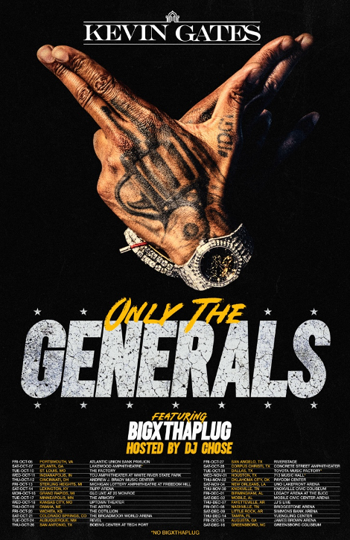

CONNECT WITH KEVIN GATES
WEBSITE | TWITTER | TIKTOK | INSTAGRAM | FACEBOOK | SOUNDCLOUD | YOUTUBE

FOR KEVIN GATES INQUIRIES, CONTACT
ARIANA.WHITE@ATLANTICRECORDS.COM

