ELECTRONIC PRODUCER ANYMA FLIPS PORTUGAL. THE MAN’S “TIME’S A FANTASY (FEAT. JEFF BHASKER)”

DOWNLOAD/STREAM HERE

ANYMA’s HIGHLY-ANTICIPATED DEBUT ALBUM GENESYS OUT NOW

LISTEN TO PORTUGAL. THE MAN’S NEW ALBUM CHRIS BLACK CHANGED MY LIFE HERE

INFECTIOUS LEAD SINGLE “DUMMY” BECAME BAND’S FOURTH
TOP 5 SINGLE AT ALT RADIO

LISTEN TO “DUMMY” | WATCH OFFICIAL MUSIC VIDEO

CURRENT SINGLE “SUMMER OF LUV (FEAT. UNKNOWN MORTAL ORCHESTRA)” TOP 30 AT ALT RADIO + QUICKLY RISING

LISTEN TO “SUMMER OF LUV”

LEARN MORE ABOUT THE FRANCES CHANGED MY LIFE + CHRIS BLACK CHANGED MY LIFE CAMPAIGNS HERE

COMING OFF EXCLUSIVE SUMMER HEADLINE SHOWS AT RADIO CITY MUSIC HALL, HOLLYWOOD BOWL, RED ROCKS + MORE

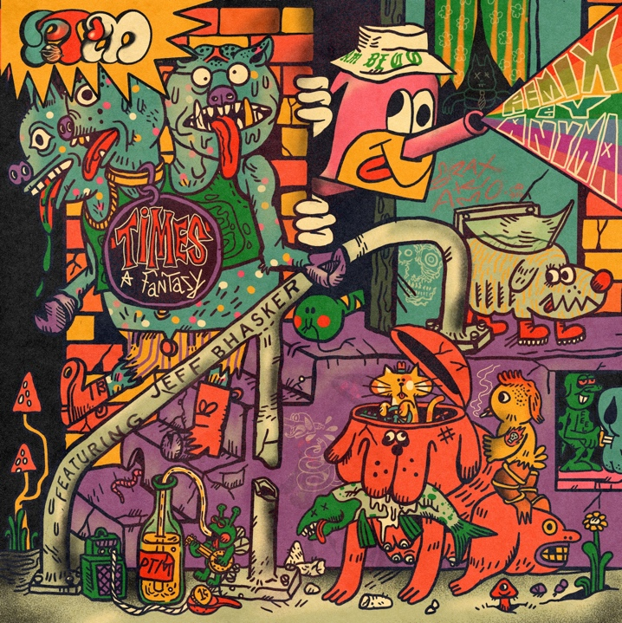
DOWNLOAD REMIX ARTWORK HERE
Artist: Wooden Cyclops

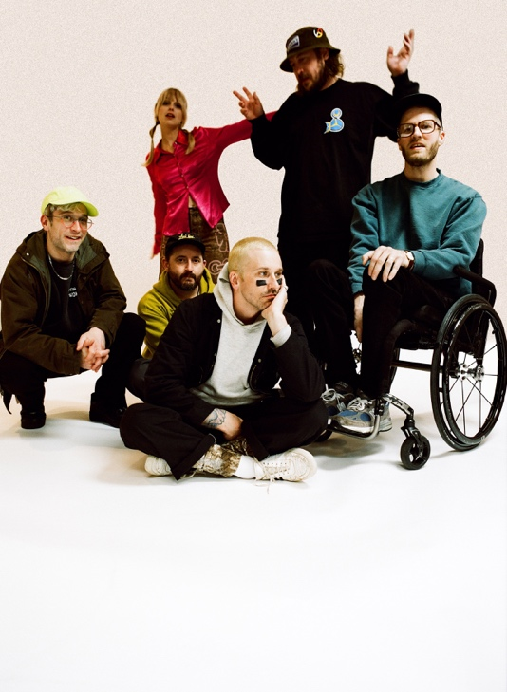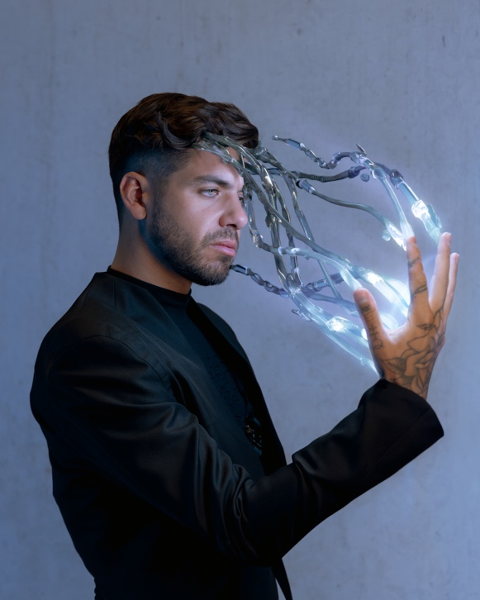
Download PTM Press Photo (L) HERE | Credit: Maclay Heriot
Download Anyma Press Photo (R) HERE

CHRIS BLACK CHANGED MY LIFE TRACKLIST:
Heavy Games II (feat. Jeff Bhasker)
Grim Generation
Thunderdome [W.T.A] (feat. Black Thought & Natalia Lafourcade)
Dummy
Summer of Luv (feat. Unknown Mortal Orchestra)
Ghost Town
Time’s a Fantasy (feat. Jeff Bhasker)
Doubt
Plastic Island
Champ (feat. Edgar Winter)
Anxiety:Clarity (feat. Paul Williams)

UPCOMING LIVE SHOWS
8/27 – Columbus, OH @ Wonderbus
10/6 – Austin, TX @ Austin City Limits
10/7 – Dallas, TX @ Granada Theater
10/8 – Dallas, TX @ Granada Theater
10/13 – Austin, TX @ Austin City Limits
11/6 – Vancouver, BC – Orpheum
11/8 – Calgary, AB – Grey Eagle
11/9 – Edmonton, AB – Edmonton Convention Centre
11/11 – Winnipeg, MB – Burton Cummings Theatre
11/14 – London, ON – London Music Hall
11/15 – Toronto, ON – HISTORY
11/16 – Toronto, ON – HISTORY
11/18 – Ottawa, ON – Ey Centre
11/19 – Montreal, QC – MTELUS

DOWNLOAD ALL PRESS ASSETS

PRESS CONTACTS:
Jason Davis | Jason.Davis@atlanticrecords.com
Libby Kober | Libby.Kober@atlanticrecords.com

ABOUT PORTUGAL. THE MAN:
Over the past decade, Portugal. The Man has established themselves as one of rock’s most prized possessions and a live phenomenon, with over 1,600 shows under their belts and a storied reputation as festival favorites.

Originally heralding from Alaska, the Portland-based band soared to new heights in 2017 with the release of their now RIAA certified-Platinum album, Woodstock. The album was marked by the astounding success of their infectious single, “Feel It Still,” which earned the group a plethora of new accolades – including a GRAMMY for “Best Pop Duo/Group Performance,” a 7x RIAA Platinum certification, a record setting 20-week residency at #1 on alternative radio, and an inescapable presence on the Top 40 airwaves.

Alongside the shine of their myriad of musical accomplishments lies the group’s long-standing passion for social justice. In fact, this is precisely the intersection in which Portugal. The Man thrives; throughout their career, the band has consistently exemplified how to deeply commit to both artistry and activism. This ultimately inspired them to officially launch PTM Foundation in 2020, focused on universal issues related to human rights, community health, and the environment, with an emphasis on causes directly impacting Indigenous Peoples, including Alaska Native Health (providing the highest quality of health services for Alaska Native people) and Seeding Sovereignty (radicalizing and disrupting colonized spaces through land, body, food sovereignty work and more).

Portugal. The Man have also partnered with an array of organizations such as National Coalition Against Censorship, The Skatepark Project (helping communities build public skate parks for youth in underserved communities), March for Our Lives (Gun Reform), Keep Oregon Well (Mental Health), and Protect Our Winters (Climate Change), to name just a few. In 2022, the band furthered their passion for activism when they launched PTM’s NIGHT OUT initiative – supporting disabled fans requiring ADA access.

ABOUT ANYMA:
Anyma is the multi-disciplinary music and contemporary fine art project by Matteo Milleri, also known as founding member of highly-acclaimed duo Tale Of Us and Afterlife Recordings / Worldwide Events. At once an artist, DJ, producer, futurist and creative director, the audiovisual world created by Anyma via his releases, live shows and digital art exhibitions has captured the imaginations of audiences across the globe. ‘Genesys,’ the debut album, features a host of handpicked collaborators such as Grimes and Sevdaliza, and is out now via Afterlife / Interscope Records.

ABOUT CHRIS BLACK CHANGED MY LIFE:
We lost a very dear friend of ours on May 19, 2019. It shook us to our core. Chris was one of those people who was like glue; he brought everyone together. His passing really messed with us. The band was in shambles and this record is the first time I feel I made a complete record; a complete thought about our world crumbling around us and the journey back. While it is a very personal journey, I feel like everyone has a Chris Black in their life; at least I hope that everyone has a Chris Black in their life. That one friend who has a way of making everything right and making everything fun. The one who keeps you in check when you go off course and is always there to celebrate the good times and to support you in the bad times. Chris Black Changed My Life.

# # #

