FOR IMMEDIATE RELEASE
AUGUST 18, 2023

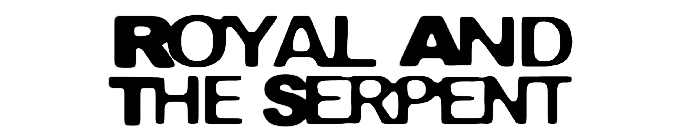

ROYAL & THE SERPENT ANNOUNCES FIRST EVER HEADLINE TOUR

TOUR KICKS OFF IN PHOENIX, AZ ON OCTOBER 14 WITH STOPS AT BROOKLYN, NY’S
MUSIC HALL OF WILLIAMSBURG AND LOS ANGELES, CA’S THE ROXY

PRESALES BEGIN TUESDAY, AUGUST 22 AT 10:00 AM (LOCAL)

GENERAL ON-SALES START FRIDAY, AUGUST 25 AT 10:00 AM (LOCAL)

LISTEN TO LATEST CHAPTER IN RAT TRAP SAGA
RAT TRAP 3: the band-aid

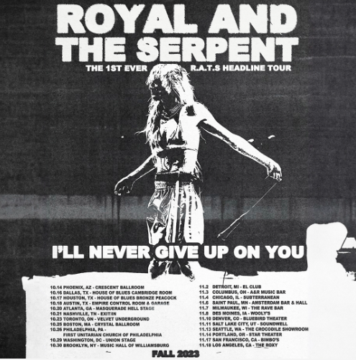
DL admat HERE

RIAA Gold-certified singer-songwriter Royal & the Serpent has announced plans for her first ever headline tour after opening for artists such as Demi Lovato and Fall Out Boy. The dates begin on October 14 in Phoenix, AZ with stops at Brooklyn’s Music Hall of Williamsburg and Los Angeles’ The Roxy. Artist presales begin Tuesday, August 22 at 10:00 am (local). Spotify presales begin Wednesday, August 23 at 10:00 am (local). Local and other presales begin Thursday, August 24 at 10:00 am (local). All presales conclude Thursday, August 24 at 10:00 pm (local). General on-sales begin Friday, August 25 at 10:00 am (local). For full details and ticket information, please see www.royalandtheserpent.com/tour.

ROYAL & THE SERPENT
TOUR 2023

OCTOBER
14 – Phoenix, AZ – Crescent Ballroom
16 – Dallas, TX – HOB Dallas Cambridge Room
17 – Houston, TX – House of Blues Bronze Peacock
18 – Austin, TX – Empire Control Room & Garage
20 – Atlanta, GA – Masquerade – Hell Stage
21 – Nashville, TN – Exit/In
23 – Toronto, ON – Valet Underground
25 – Boston, MA – Crystal Ballroom
26 – Philadelphia, PA – First Unitarian Church of Philadelphia
29 – Washington, DC – Union Stage
30 – Brooklyn, NY – Music Hall of Williamsburg

NOVEMBER
2 – Detroit, MI – EL Club
3 – Columbus, OH – A&R Music Bar
4 – Chicago, IL – Subterranean
6 – Saint Paul, MN – Amsterdam Bar & Hall
7 – Milwaukee, WI – The Rave/Eagles Club – The Rave Bar
8 – Des Moines, IA – Wooly's
10 – Denver, CO – Bluebird Theater
11 – Salt Lake City, UT – Soundwell
13 – Seattle, WA – The Crocodile – Showroom
14 – Portland, OR – Star Theatre
17 – San Francisco, CA – Bimbo's
18 – Los Angeles, CA – The Roxy

# # #

Royal & the Serpent – who recently wrapped a special guest run on Fall Out Boy’s So Much For (Tour) Dust – is currently readying the next chapter in her acclaimed RAT TRAP series of double-sided singles. The latest two-track project, RAT TRAP 3: the band-aid, includes “Utopia” and the addictive “Sweet Tooth,” both joined by official music videos streaming HERE. “The third installment is as catchy as ever,” declared Alternative Press, “with both new cuts proving that Royal has a knack for transitioning from delicate verses to booming choruses.”

Royal introduced the “royalverse” this spring with the premiere of the saga’s first chapter, RAT TRAP I: the blueprint, featuring “Astroturf” and the powerfully inspiring LGBTQ+ anthem, “One Nation Underdogs,” both joined by official music videos streaming now HERE. RAT TRAP 2: the burn followed in June, continuing the tale with “JUNKIE” and the enthusiastic “SLUG,” each of which arrived alongside official music videos streaming now HERE.

The RAT TRAP series follows last year’s explosive HAPPINESS IS AN INSIDE JOB, an intimately detailed, five-song document of Royal’s journey to self-love. The project includes such searing tracks as “IM FINE,” “No Regrets,” “Happiness 4 Dummies,” “Love Abuser (Save Me),” and “Death of Me,” all accompanied by official visuals streaming now at YouTube.

ABOUT ROYAL & THE SERPENT
Royal & the Serpent is an artist entirely unafraid to bare the deepest and darkest parts of her psyche. After making her Atlantic Records debut with the 2020 EP, get a grip – highlighted by the RIAA Gold-certified single “Overwhelmed,” which captured the chaos of sensory overload and spent 22 weeks on Billboard’s “Alternative Airplay” chart – the L.A.-based singer-songwriter revealed even more of her frenetic inner world in 2022 with IF I DIED WOULD ANYONE CARE and Happiness Is An Inside Job. This Spring she released RAT TRAP I: the blueprint, kicking off a series of double-sided singles released every month. RAT TRAP 2: the burn followed in June and RAT TRAP 3: the band-aid in July, with more to come. Her unfiltered songwriting has proved wildly resonant to her ever-growing fanbase – and led to such triumphs as touring with Demi Lovato, grandson, PVRIS, and Fall Out Boy.

Originally from New Jersey, Royal started in dance and theatre, and first took up guitar at age 14, then relocated to L.A. at age 18. While working as a bartender, Royal soon started self-releasing her music, beginning with her spellbinding 2017 single “Temperance.” Thanks to the buzz behind songs like 2019’s “Weddings & Funerals” and “Salvador Dali” – as well as her electrifying live show – she eventually inked a deal with Atlantic and released “Overwhelmed” in the early days of Covid lockdown.

Over the past few years, Royal has built a close-knit community of fans undeniably drawn to her one-of-a-kind balance of intense sensitivity and unruly self-possession. “The main reason I make music is that it’s the best therapy I could ever ask for: the process of taking everything in my brain and putting it on paper and then singing it out loud for people is so helpful and healing for me. The idea that my own expression can affect people in positive ways is such a blessing and a gift; I don’t ever take it lightly. I just want to keep telling my truth and reach as many people as I possibly can, and see where this little journey takes us.”

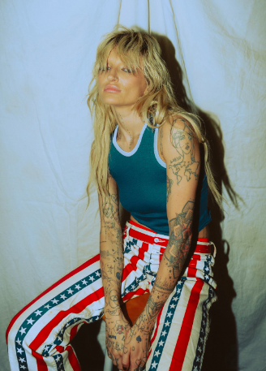
DOWNLOAD HI-RES IMAGES
PHOTO CREDIT: JUAN FLORES

# # #

CONNECT WITH ROYAL & THE SERPENT:
OFFICIAL | FACEBOOK | INSTAGRAM | TWITTER | YOUTUBE

PRESS CONTACTS:
Corey Brewer / Corey.Brewer@atlanticrecords.com
Jessica Nall / Jessica.Nall@atlanticrecords.com
Gabby Reese / Gabrielle.Reese@atlanticrecords.com

