FOR IMMEDIATE RELEASE
AUGUST 30, 2023

RAPPING A** PRODUCER SONNY DIGITAL RETURNS WITH “COULD BE WORSE”

ACCOMPANIED BY AN OFFICIAL COMPANION VISUAL DIRECTED BY DECAT

FIRST SINGLE FROM FORTHCOMING ALBUM RELEASING SOON

VISUAL WILL PREMIERE EXCLUSIVELY ON REVOLT

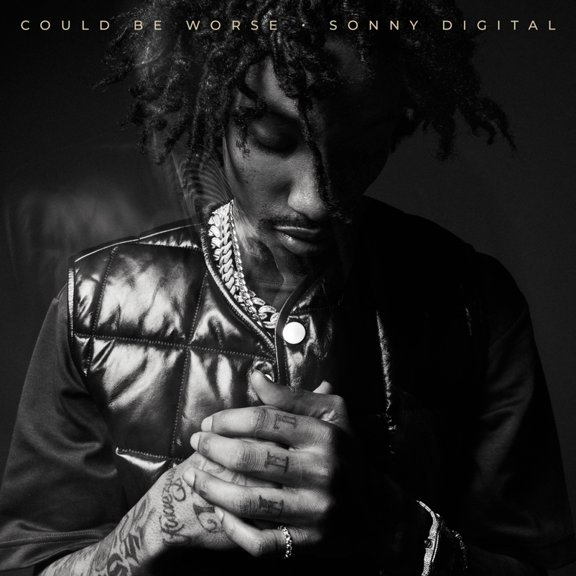
WATCH HERE | STREAM HERE

Multi-platinum rapping a** producer Sonny Digital returns with “Could Be Worse” via Generation Now/Atlantic Records. The single is accompanied by an official companion visual directed by Decat (“Guess What” ft. SSG KOBE) and will premiere exclusively on Revolt. In it, we see Sonny posing for the camera in his stylish gear interspersed with scenes of him playing with his son, Little Sonny, and humbly displaying his numerous plaques. The video also includes a clip of Atlanta-based attorney, Ken Nugent's famous, "one call, that's all" commercial. “Could Be Worse” contains a Gangsta Grillz drop from his Grammy award-winning Generation Now label head, DJ Drama, and is produced by Buddah Bless (2Chainz, Migos, Chris Brown, YoungBoy Never Broke Again). The single is the first in a continuous forthcoming stream of releases from the legend’s forthcoming album that features select tracks with drops from DJ Drama. “Could Be Worse” follows the release of his Hip-Hop at Fifty compilation displaying his top solo tracks.

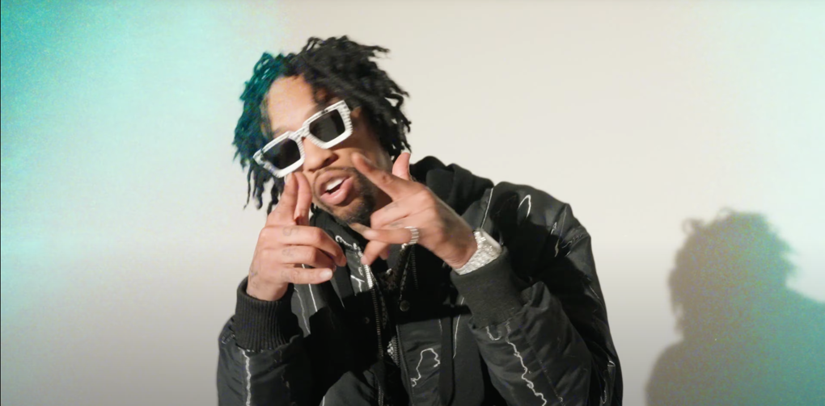

SONNY DIGITAL
Sonny Digital’s musicality not only encompasses an influential legacy as a multiplatinum producer, but it also extends to an ever-growing catalog as an artist. Originally from Africa, dad harbored a passion for music—which Sonny naturally absorbed and cooked up beats at a relentless pace. Breaking into the business, he crafted six cuts for Gorilla Zoe’s King Kong in 2011. However, his beat for YC’s “Racks” [feat. Future] changed everything. It eventually reached gold status, and UPROXX retrospectively noted, “the song that began Future’s rise to being one of hip-hop’s biggest stars only cost $300.” He transformed the game with one banger after another. Behind the board, he notably powered 50 Cent’s “I’m The Man,” Chainz’s double-platinum “Birthday Song” [feat. Kanye West], ILoveMakonnen’s GRAMMY® Award-nominated platinum-certified “Tuesday” [feat. Drake], 21 Savage’s platinum-certified “Red Opps,” Travis Scott’s platinum-certified “STARGAZING,” and Don Toliver’s “After Party,” to name a few. Earning acclaim from The FADER, XXL, and more, he amplified his voice across the 2016 G.O.A.T. EP in addition to the collaborative mixtapes Black Goat [2017] and Black Goat 2 [2020] alongside Black Boe. Now signed to Generation Now with the likes of Lil Uzi and Jack Harlow, Sonny is showing the world who he is today. Sonny maintained his momentum with singles such as “Guess What” [feat. SSGKOBE], “Since 91” [feat. $LUGG],” “Vet,” and “Back 2 Back.” Moreover, he shined on tour with the likes of Wiz Khalifa. Now, he spotlights every facet of himself on his 2023 forthcoming full-length debut [Generation Now/Atlantic Records].

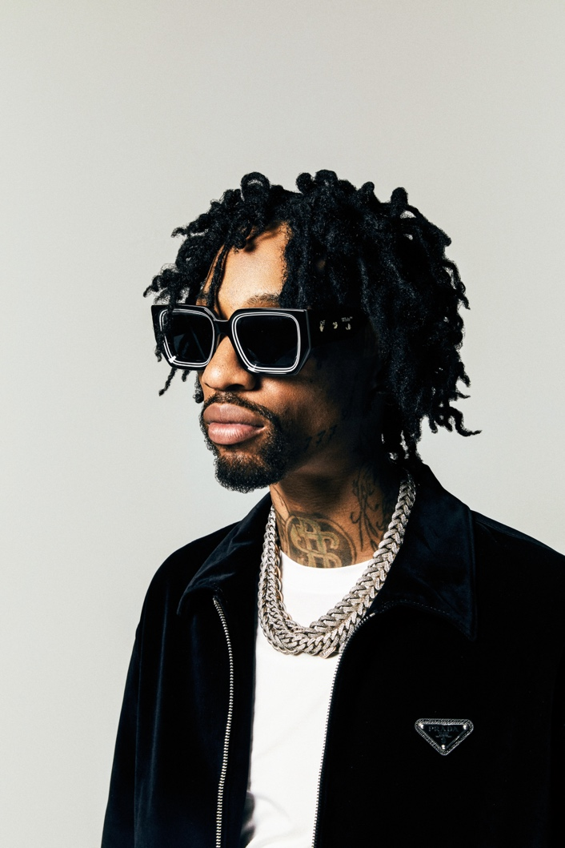

CONNECT WITH SONNY DIGITAL
OFFICIAL | TWITTER | INSTAGRAM | YOUTUBE | FACEBOOK

PRESS CONTACT
Ariana White | Ariana.White@AtlanticRecords.com

