FOR IMMEDIATE RELEASE
AUGUST 8, 2023

SURF CURSE ANNOUNCES SPECIAL LAST SHOW TO WRAP SUMMER TOUR

FINAL SHOW OF TOUR TO TAKE PLACE AT THE NOVO IN LOS ANGELES ON SEPTEMBER 26
PRESENTED BY KROQ

TICKETS ON SALE THURSDAY, AUGUST 10 AT 10 AM PT

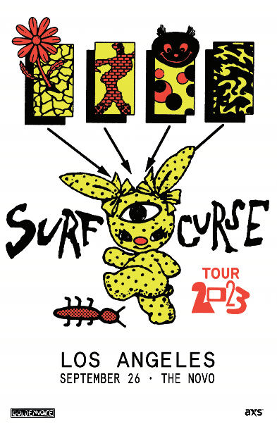

RIAA platinum certified indie rock band Surf Curse have announced their special last show of their summer tour that will take place on September 26 at The Novo in Los Angeles, CA. Tickets go on sale Thursday, August 10 at 10 AM PT. For complete details, please see https://www.surfcurse.com/tour.

The final show, presented by KROQ, will wrap up a busy summer for the band, which included touring in support of Greta Van Fleet with an upcoming stop at New York’s Madison Square Garden on September 12.

Founded in Reno, NV by Nick Rattigan (lead vocals, drums) and Jacob Rubeck (guitar), Surf Curse have been crafting a multifaceted sound informed by indie, punk, pop, psych rock, and more for nearly a decade. 2020 saw the band’s breakthrough with the surprise TikTok success of “Freaks,” which has earned over 917M worldwide streams and RIAA platinum certification more than eight years after its original release. Recorded at New York City’s iconic Electric Lady Studios, their latest album MAGIC HOUR now sees the band testing the boundaries of their seasoned indie rock approach, exploring a wide range of sonic styles and colors with founders Rattigan and Rubeck now joined by new members Noah Kohll (guitars) and Henry Dillon (bass). The newly expanded lineup allows Surf Curse to push their already ambitious songcraft even further than ever before, spanning the blistering album-opener, “Arrow,” to the somber rock of “No Tomorrows.”

CONNECT WITH SURF CURSE
WEBSITE | FACEBOOK | INSTAGRAM | YOUTUBE | PRESS ASSETS

PRESS CONTACT
Jessica Nall // Jessica.Nall@atlanticrecords.com

