FOR IMMEDIATE RELEASE
AUGUST 18, 2023

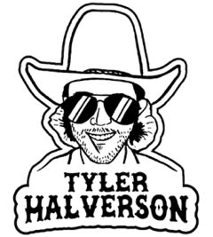

TYLER HALVERSON RETURNS WITH “AS THEY DID”

ACCLAIMED SOUTH DAKOTA TROUBADOUR SHARES NOSTALGIC NEW SINGLE

UPCOMING LIVE SCHEDULE INCLUDES HEADLINE DATES, FESTIVAL APPEARANCES,
AND ARENA SHOWS SUPPORTING COUNTRY STAR PARKER MCCOLLUM

LISTEN TO “AS THEY DID” | WATCH OFFICIAL MUSIC VIDEO

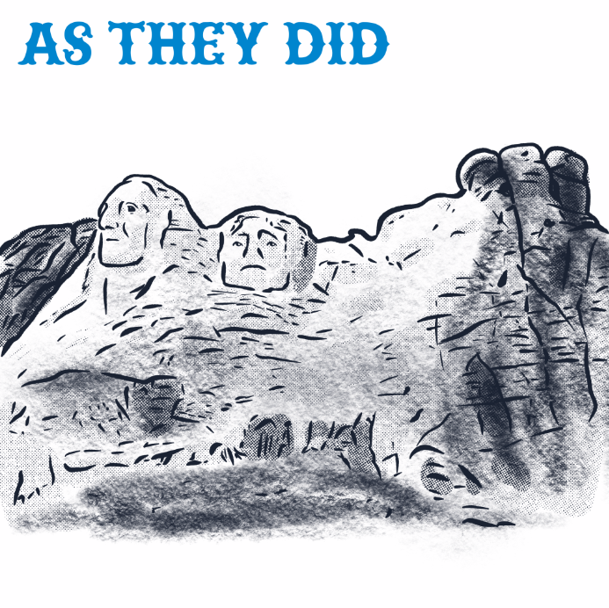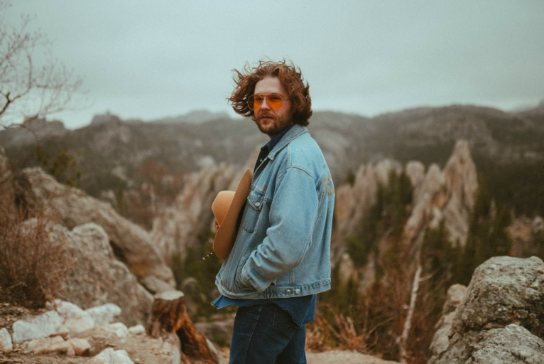
DOWNLOAD ARTWORK + PRESS PHOTO HERE

“If you haven’t heard of Tyler Halverson, he needs to be on your radar.” – WHISKEY RIFF

South Dakota troubadour Tyler Halverson continues his unstoppable run of new music with today’s premiere of the longingly nostalgic “As They Did” - Listen HERE. Written by Halverson and co-produced with Gary Stanton and Ryan Youmans, the track is joined by a companion music video – Watch HERE.

“This one’s about what life was like before interstates and fence lines,” says Halverson, “and seeing the land the way god intended it to be seen.”

“As They Did” marks the latest in a mounting string of recent singles that includes “Her,’ “Cut You Loose,” and the boisterous “Run Wild,” all joined by official music videos streaming HERE.

Halverson is currently traveling on a busy summer live schedule that includes headline dates, festival appearances, and arena shows supporting Parker McCollum. Halverson is represented by legendary Nashville manager Erv Woolsey (George Strait, LeeAnn Womack) and Allen Mitchell of The Erv Woolsey Company. For complete details and updates, please visit tylerhalverson.com.

Born and raised in the tiny town of Canton, SD (pop. 3054), Tyler Halverson isn’t just any cowboy. He’s got the hat and the boots, but he also plays a mean guitar and writes an even meaner tune. He has no problem bouncing around the country chasing adventure (or a girl), and is telling his different kind of cowboy tale with his self-described “Western Amerijuana Music,” bridging honest storytelling with songcraft inspired by country powerhouses Garth Brooks, George Strait, and Hayes Carll as much as Boyz II Men, Taking Back Sunday, and The Used.

Halverson fell in thrall to music at an early age, receiving his first guitar while in middle school. A local bluegrass festival convinced him to focus on music, throwing down at 4H and FFA festivals before heading to Nashville to attend the prestigious Belmont University. Upon graduation, he decided to hit the road and spent an extended run traveling around South Dakota, Montana, and Wyoming, all the while writing and playing his songs on social media. Halverson’s original approach caught fire with a string of independent releases including “Beer Garden Baby,” “Mac Miller,” and “Your Bar Now” (with Kylie Frey), amassing tens of millions of streams. Now, with “As They Did” and more new music still to come, Tyler Halverson is eager to take the next step on what has already proven an amazing journey.

“I’m finding myself,” says Tyler Halverson. “I feel like I’m an artist and I’m finally about to do something.”

# # #

TYLER HALVERSON
ON TOUR 2023

AUGUST
26 – College Station, TX – The Tap Bar & Grill

SEPTEMBER
2 – Bethany, MO – Northwest Missouri State Fair
8 – Tuscaloosa, AL – Tuscaloosa Amphitheater †
9 – Beaumont, TX – Ford Arena †
21 – Little Rock, AR – Revolution Music Room
22 – Oklahoma City, OK – Diamond Ballroom
23 – El Dorado, KS – City of Gold Fest 2023
28 – Omaha, NE – Slowdown
29 – Manhattan, KS – The Hat

OCTOBER
7 – New Braunfels, TX – Gruene Hall ^
8 – Ennis, TX – Stars Over Texas Music Festival 2023
12 – Denver, CO – Mercury Café ^
13 – Colorado Springs, CO – Boot Barn Hall ^
14 – Cheyenne, WY – Outlaw Saloon ^
15 – Greeley, CO – Moxi Theater ^

† w/ Parker McCollum
^ w/ Kylie Frey

# # #

CONNECT WITH TYLER HALVERSON
OFFICIAL | FACEBOOK| INSTAGRAM | TIKTOK | TWITTER | YOUTUBE

PRESS CONTACT
Jessica Nall // Jessica.Nall@atlanticrecords.com

