FOR IMMEDIATE RELEASE
AUGUST 11, 2023

gnash SHARES “WET CEMENT”

6X RIAA PLATINUM-CERTIFIED SINGER-SONGWRITER RELEASES DEEPLY AFFECTING NEW SINGLE

LISTEN TO “WET CEMENT”

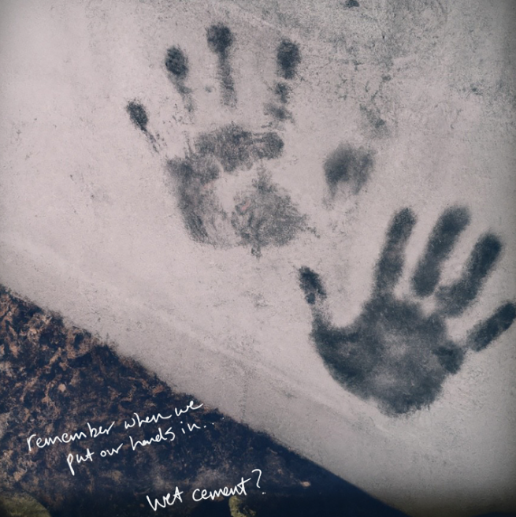
DOWNLOAD HI-RES ASSETS HERE

6x RIAA Platinum-certified singer-songwriter gnash has shared his deeply affecting new single, “wet cement,” available now via Overall Recordings/Atlantic Records. Co-written and co-produced by gnash – a.k.a. Garrett Nash – and Los Angeles-based singer-songwriter John Mark Nelson, the touching track has been heralded in recent weeks by a series of social media teasers, generating interest and intrigue among his worldwide fan following.

“after a friend told me his dad has cancer, i wrote this song as an exercise in pre-grieving,” says gnash. “my parents are older, and i’ve lost friends & uncles & grandparents along the way, but never had the perfect song to say, ‘i miss you, come back home.’ this song is for everyone i’ve ever missed (& ever will).”

“wet cement” kicks off a busy creative season for gnash, with lots more to come through year’s end. This spring saw the release of The Art of Letting Go, a 12-song collection gathering all ten tracks featured on his acclaimed series of double-sided singles along with two brand new tracks, “Balance” and the project-closing “Be Here Now.”

The monthly succession of new singles began last October with one, featuring “Seasons” backed by the previously released “Palm Trees.” November then saw the arrival of two, which includes “Family, Man” (co-written and co-produced by gnash with singer-songwriter Annika Bennett) backed with the previously released “Money, Love & Death.” Next came three, featuring two brand new songs about love in “Guiding Light” and “I Got A Lot To Lose.” The series continued into 2023 with four, featuring “Rainbow” and what proved the album’s title track, “The Art of Letting Go.” five, the fifth installment in the series, features “Time” and “Life (Everybody Dies).”

gnash has also made time for an array of collaborations, including a special surprise on-stage appearance alongside Olivia O’Brien earlier this week at Los Angeles, CA’s The Moroccan Lounge. Recent alliances include “Glass on the Shelf,” a heartfelt collaboration with acclaimed singer-songwriter Mark Diamond, as well as “granola bars,” his playfully organic duet with fellow chart-topping singer-songwriter Annika Wells. Last year also saw a stunning series of deeply personal singles released by gnash under his birth name of Garrett Nash, including “Where The Sidewalk Ends“ (a collaboration with 7x JUNO Award-nominated Canadian singer-songwriter Scott Helman), “The Middle Of Nowhere,” “Super Glue,” Shwayze x Garrett Nash’s “Breathe In,” and a nostalgic cover of his childhood favorite, Fountains of Wayne’s “Stacy’s Mom.“

ABOUT gnash
Known for his genre-blurring brand of modern pop, gnash made his global breakthrough with 2016’s multi-platform blockbuster hit single, “i hate u, i love u.” The stripped-bare track reached the top 10 on Billboard’s “Hot 100” – where it spent an impressive 39 weeks – and singles charts around the world, earning 6x RIAA platinum certification and more than 2B global streams. Furthermore, the “i hate u, i love u” companion video is an unadulterated blockbuster, now with over 710M individual views via YouTube alone.

Along with his world-straddling popular success, gnash began receiving rapt attention from worldwide media, drawing critical acclaim from such top tier publications as the New York Times, Entertainment Weekly, Billboard, Vogue, and NYLON, to name but a few. 2018 saw gnash winning the iHeartRadio Titanium Award for his collaboration with MAX on “Lights Down Low.” 2019 followed with the release of a series of EPs with his RIAA gold certified full-length debut album, we, drawing praise from such outlets as The Guardian for its “highly intimate confessionals about doubt, anxiety and insecurity…the combination of charming tunes and humbling insights are truly lovely.”

As charming and idiosyncratic on stage as in the studio, gnash traveled North America on a number of tours, including 2019’s 40-date “the broken hearts club tour,” while also finding time for high-profile TV performances on NBC’s TODAY and Late Night with Seth Meyers. A strong advocate for mental health, gnash has long been open about his struggles, publicly acknowledging the benefits of therapy while also encouraging fans to find their own unique way to express themselves.

# # #

CONNECT WITH gnash
WEBSITE | FACEBOOK | INSTAGRAM | TIKTOK | TWITTER | YOUTUBE

PRESS CONTACT
Jessica Nall // Jessica.Nall@atlanticrecords.com

