FOR IMMEDIATE RELEASE
SEPTEMBER 26, 2023

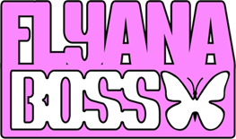

RISING CUTE-GIRL-RAP DUO FLYANA BOSS DROP
“BITCH IMMA STAR”

“BITCH IMMA STAR” AVAILABLE EVERYWHERE NOW VIA VNCLM_ X ATLANTIC RECORDS

LISTEN TO “BITCH IMMA STAR” HERE | WATCH OFFICIAL LYRIC VIDEO HERE

SPECIAL GUEST RUN ON JANELLE MONÁE’S THE AGE OF PLEASURE TOUR
CONTINUES INTO OCTOBER

FOLLOWED WITH “BIG ONE” SET TO DROP FRIDAY, SEPTEMBER 29

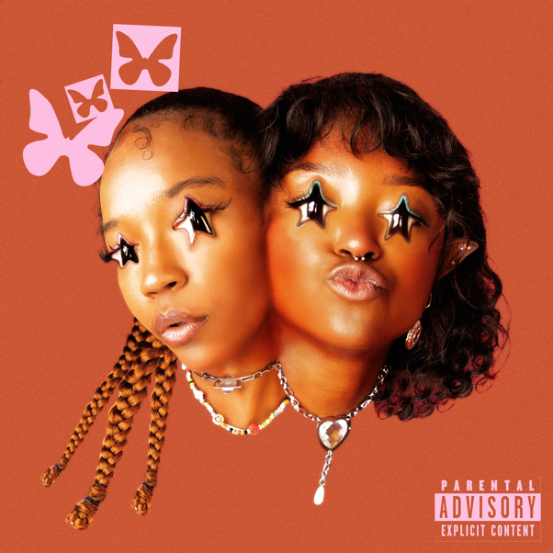
DOWNLOAD HI-RES ART HERE | CREDiT: SJ SPRENG

Breakout cute-girl rap duo Flyana Boss have given fans a special gift with today’s drop of their new track, “Bitch Imma Star,” available everywhere now via vnclm_ x Atlantic Records HERE. Watch the official lyric video HERE. They recently teased it on their wildly popular social platforms HERE. The duo are set to drop a second single on Friday, September 29 titled “Big One”. Watch the social teaser HERE.

“’Bitch Imma Star’ is about claiming your own stardom!” says the duo. “There’s been so many times when people told us we ‘weren’t ready’ or ‘couldn’t do something’, so this is us telling them ‘Bitch Imma Star’!”
“Bitch Imma Star” heralds the hugely anticipated arrival of Flyana Boss’ follow-up single to their chart-topping viral smash, “You Wish”, with more new music coming soon. In the meantime, the rising duo are lighting up the popular UPROXX Sessions with spectacular new performances of “You Wish” and “Nu Nu,” both streaming now at YouTube. Most recently, the duo made their national television debut on MSNBC’s “SYMONE” and FOX5’s “Lion Lunch Hour”.

Flyana Boss – a.k.a. multi-instrumentalist/MCs Bobbi LaNea and Folayan – are currently celebrating the explosive success of “You Wish” as special guests on Janelle Monáe’s The Age of Pleasure Tour, making stops across North America through mid-October. Highlights include visits to such historic venues as New York City’s Radio City Music Hall (September 26) and Atlanta, GA’s Fox Theatre (October 6). From there, Flyana Boss will head Down Under for Australia’s SXSW Sydney, the first-ever international edition of the famed Austin, TX music festival, taking place October 18-21. Additional dates will be announced soon.

Flyana Boss burst onto the scene with their breakout single, “You Wish,” which debuted at # 1 on Spotify’s “Viral 100” amidst worldwide attention from hip-hop legends Missy Elliott and Timbaland as well as such high-profile media outlets as Variety, Complex, NYLON, Vulture, UPROXX, Ones To Watch, and Rolling Stone, among many others. Produced by rising hitmaker Marky Style, the track – featured on the two-track single “You Wish + Trashboi” – quickly proved a sensation, earning over 25M global streams to date while rocketing the duo into the spotlight (and kickstarting a spirited viral discussion regarding the word “Kanekalon”).

“You Wish” was recently joined by an official music video, directed by Brad Wong (IV Jay Feat. Pink Sweat$) and streaming now at YouTube HERE. The colorful new visual came to life earlier this summer after Flyana Boss posted a “You Wish” TikTok while riding DoorDash-branded bikes, earning more than 10M views and the attention of fans everywhere. DoorDash delivered (pun intended) on the public response, officially joining forces with Flyana Boss for the irresistible “You Wish” visual. Entertainment Tonight recently took an exclusive “Behind The Scenes” look at the making of “You Wish,” streaming HERE.

Flyana Boss’s Black Girl Magic is further captured on a pair of spectacular “You Wish” remixes, including the star-studded “You Wish (with Missy Elliott & Kaliii) – Remix,” featuring brand new verses from Flyana Boss and their guest stars, streaming HERE. “You Wish – DJ Smallz 732 – Jersey Club Remix,” another spin on the hit track, is available HERE.

Hailing from Detroit, MI and Dallas, TX respectively, Bobbi and Folayan met at a music college in Los Angeles where they immediately hit it off and began collaborating. The fierce duo adopted the name Flyana Boss (rhymes with Diana Ross), repping the Vagina Dynasty while simultaneously embodying the spirit of flyness and bossness. Together, Bobbi and Folayan form a formidable union that pushes the boundaries of contemporary hip-hop, seamlessly blending their individual strengths to create a sound that is distinctively Flyana Boss. Bobbi brings a knack for storytelling and infuses her music with authenticity and vulnerability as Folayan effortlessly switches between different styles and genres, adding depth and dimension to Flyana Boss’ one-of-a-kind music.

Increasingly known for their unforgettable live performances – including a spectacular set at New Orleans’s Essence Festival of Culture highlighted by a twerkable onstage moment with Megan Thee Stallion – Flyana Boss are focused on creating music that reflects their experiences and resonates with their listeners, embracing their uniqueness and uplifting others through their art.
With talent, ambition, and more impossible-to-resist tracks to come, Flyana Boss is poised to leave an indelible mark on the hearts and minds of music lovers worldwide.

FLYANA BOSS
ON TOUR 2023

DOWNLOAD ADMAT HERE

ALL DATES w/ JANELLE MONÁE’S THE AGE OF PLEASURE TOUR

SEPTEMBER
25 – Washington, DC – The Anthem
26 – New York City, NY – Radio City Music Hall
28 – Brooklyn, NY – Kings Theatre

OCTOBER
2 – Charlotte, NC – Skyla Credit Union Amphitheatre
3 – Nashville, TN – Ryman Auditorium
4 – Birmingham, AL – Avondale Brewing Company
6 – Atlanta, GA – Fox Theatre Atlanta
7 – New Orleans, LA – Orpheum Theatre

# # #

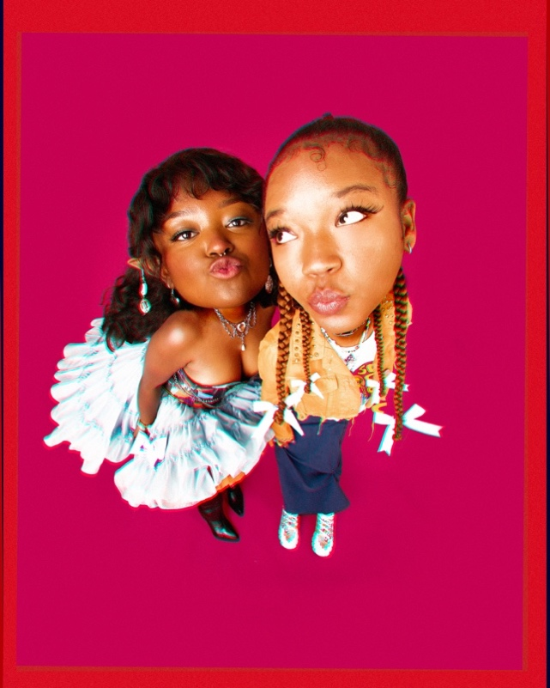
DOWNLOAD PRESS PHOTO HERE // PHOTO CREDIT: SJ SPRENG

CONNECT WITH FLYANA BOSS
FLYANABOSS.COM | INSTAGRAM | TIKTOK | TWITTER | YOUTUBE

PRESS CONTACT
FAIRLEY MCCASKILL | FAIRLEY.MCCASKILL@ATLANTICRECORDS.COM

